[Event Name]

[Location address]

[Dates from & to]

3 Star International Competition

part of CWWC World Ranking

BULLETIN NUMBER 1

International Waterski & Wakeboard Federation &
[National Federation Name]

Organiser | XXXX  Contact:  Email:
CWWC Ranking | International Waterski & Wakeboard Federation  Confederation:  Contact: info@cablewakeboard.net  Website: www.cablewakeboard.net
Location | XXXX  Tel:  Email:
Transport | Nearest Airports: (all via Car)  Train Stations  Car hire Options:
Rules | The competition will be run in accordance with the IWWF Cable  Wakeboard World Rule Book
Cable Details | Height:  Manufacturer:  Type: Straight Line / Full Cable  Full Cable Direction: Clockwise / Anti Clockwise  Normal Cable Running Speed:
Categories | All IWWF International Categories with a minimum of 3 Riders, any riders in categories with less than 3 riders will be merged into the  next appropriate age category (ride up).  With the exception of the OPEN DIVISION, as riders cannot be  merged into other categories.  PUT HERE IF YOU ARE RUNNING LESS CATEGORIES, OR IF YOU ARE RUNNING A SPLIT COMPETITION
Entry & Costs | The closing date for Entries is XXXX  €XX For Boys/Girls/Junior& Open Categories  €XX For Minis Category  If late entries are being accepted, the charge for Late Entry is €XX  You must have completed the organisers Entry form and paid for your entry to be included in the competition.  Entry on Cable Wakeboard.net must be completed in advance to allow the start lists to be completed.
Registration | Passports must be shown on registration, as Nationalities and Ages  Must be checked.  REGISTRATION WILL TAKE PLACE BETWEEN:  XX:XX – XX:XX on XXXX  You will not be allowed to start official practice until your  Registration is complete.
Accommodation
OFFICIALS PANEL | Chief Judge: XXXX  Scorer: XXXX  Judge: XXXX  Judge: XXXX  Judge: XXXX
OFFICIALS SEMINAR | Add Details of Seminar here if you are running one.
Athletes Under 18yrs of age | IWWF Cable Wakeboard Council & Officials follow the IWWF Safe Sport Policy.  All athletes under the age of 18yrs, must be accompanied at the site by a guardian over the age of 18yrs.  This guardian will accept parental responsibility for the athlete for the duration of the competition.  The IWWF and its officials DO NOT act in loco parentis for any child at an event

PROVISIONAL SCHEDULE

This will be updated after the XXXX closing date once we know how many competitors have entered, PLEASE CHECK THE UPDATED TIMETABLES before travelling.

Detail | Date | Time
REGISTRATION
Official Practice
Qualification Rounds
Minis
Girls / Boys
Veterans
Masters
Open Wakeskate
Juniors
Open Wakeboard
LCQ Rounds
Finals (inc Semis etc)
Minis
Girls / Boys
Veterans
Masters
Open Wakeskate
Juniors
Open Wakeboard
Prize Giving

The Park
Write some lovely words about your Cable, tell the participants about unique things about your park, how long you’ve been around etc.
Then add a lovely picture showing your park at its best!
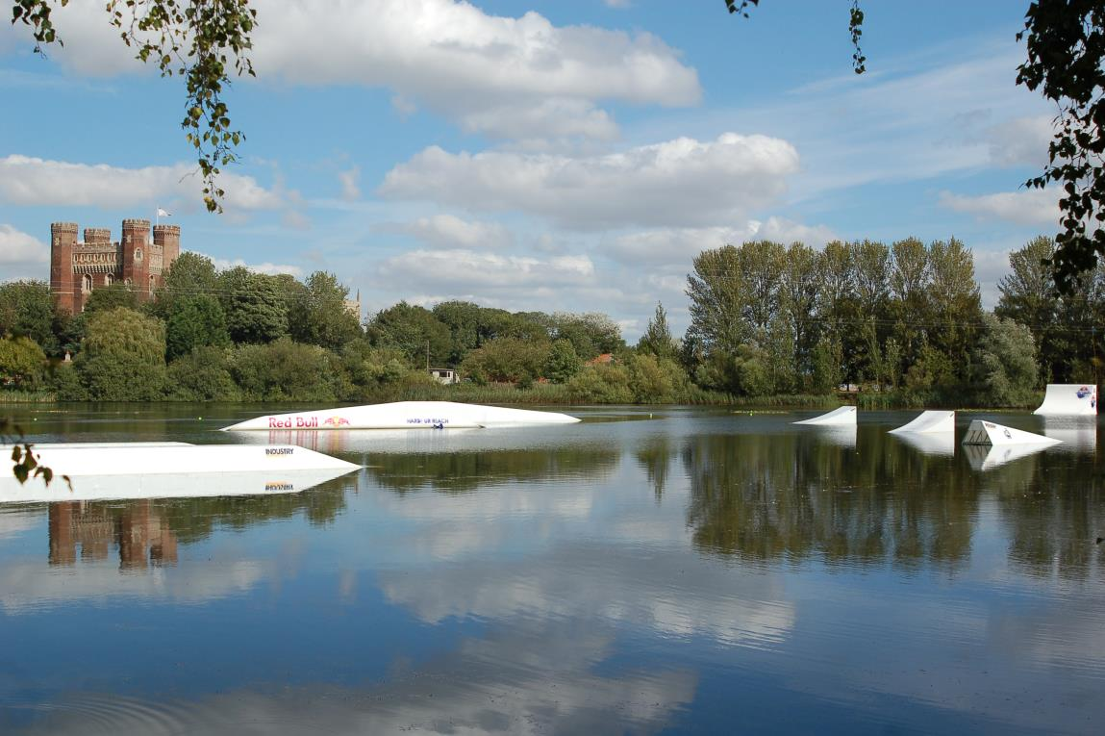
The Course Layout is as follows:
Add a picture of the course set up, showing start and end points.
Layout should include:
Start Dock, Course Start Point, Course End Point, Judging Position, Features included and location in course, Air Trick zones.
Competition Format
This is where you would put any specific information on your event. If you are running the format any different to traditional 50/50 format etc.
It is possible to run competitions as ‘Features Only’, Kicker Comps, diff rating based on park set up, this format should be agreed with the relevant confederation council before the bulletin is published, but once agreed it must be included in the bulletin.

For INT 3 Star and above Competitions, you must give details of the Prize Fund here.

