IWWF Virtual Series

Online - Worldwide

3rd October 2020

2 Star International Competition
200 INT Ranking Points

part of CWWC World Ranking

BULLETIN

Competition Page:
http://myzone.cablewakeboard.net/en/116/?sub=6&comp=2252

WAKEBOARD COMPETITION: Invert Heelside Back Roll family and Transfer Obstacle Trick

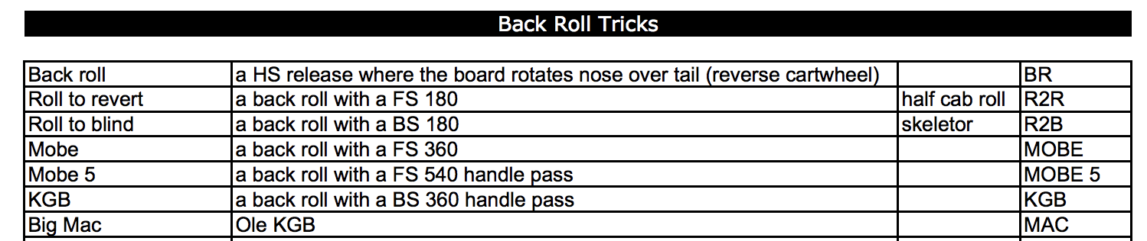
SEATED WAKEBOARD COMPETITION: Transfer Obstacle Hit

WAKESKATE COMPETITION: Best 3 Rail Hit

Organiser | IWWF Cable Wakeboard World Council  Contact: Simone Sivieri or Suzi Nightingale  Email: office@cablewakeboard.net
CWWC Ranking | International Waterski & Wakeboard Federation  Confederation: OPEN TO ALL  Contact: info@cablewakeboard.net  Website: www.cablewakeboard.net
Location | Worldwide – At your local cable park.  Any type of Cable is acceptable (Straight Line or Full Cable)
Transport | The easiest and safest way possible – try to be as close to home as possible
Rules | The competition will be run in accordance with the IWWF Cable  Wakeboard World Rule Book and the Online rules composed and ratified by the Cable Wakeboard Council – attached to the competition information page
Cable Details | Any Cable, Any Manufacturer, Any Type, Any Speed  Any direction
Categories | All IWWF International Categories with a minimum of 3 Riders, any riders in categories with less than 3 riders will be merged into the  next appropriate age category (ride up).  With the exception of the OPEN DIVISION, as riders cannot be  merged into other categories.  WAKESKATE – Is only running for the OPEN CATEGORY
Entry & Costs | The closing date for Entries on Cablewakeboard.net is:  3rd^{th} October 2020  Judging starts on 4th October  FREE TO ENTER - NO LATE ENTRIES ACCEPTED  YOU MUST ENTER ON CABLEWAKEBOARD.NET, otherwise your entry will not be Judged.
OFFICIALS PANEL | The Judging Panel is made up of Qualified Judges from the Cable Wakeboard Council – The exact panel will be notified once Judging commences.

Competition Format
Due to covid19 and the fact that many countries still have significant restrictions in place regarding travel and leisure activities, we are running a series of small events to encourage riders back onto the water at local parks.

All local Covid19 restrictions must be adhered to.
We have removed any restriction to the type of cable you can film your entry on, to make the competition accessible to as many riders as possible.

How do you enter:

- Enter the relevant competition on Cable Wakeboard. Please ensure you enter the correct category.

Competition Page:
http://myzone.cablewakeboard.net/en/116/?sub=6&comp=2252

Double check your entry is there, if you can’t see yourself in the competition, please contact us, and we will help you register.

- Film your entry – making sure your run is in-line with the competition requirements. If you send in an awesome trick, that’s not in the requirement list, it will unfortunately not be judged.
- Check your video quality, make sure we can see your approach, execution, and landing (we need to see you ride it away)
- Upload your video to the relevant category on Facebook:

Click here to go to the IWWF Cablewakeboard Facebook Page

Please note, comments will be turned off on the posts once the competition has closed for Entries

- Wait for the results the Virtual Podium!

GOOD LUCK and we are really looking forward seeing all your videos

Thank you for supporting IWWF Cable Wakeboard.

Online competition rules.

- All riders need to join the individual competitions on cablewakeboard.net
- The videos need to contain the full name of the riders, your nickname is not enough, we need to know who you are and be able to match to your Cablewakeboard.net entry.
- All Riders need to wear life jackets and helmets.
- Riders can only use a video once the same video cannot be used for multiple competitions.
- No editing of videos with slow motion on the grabs and so on, a rider can upload the video with 2 parts one not edited and the second edited to point attention on grabs or 2 different camera views.
- The video need to be of good quality, if not rider will be judged on what can be seen in the video and not what he performed in reality.
- The video need to be uploaded in the correct category, if a boy uploads a video in open men he will be judged and he will receive ranking point in open men, if an open rider uploads a video in boys he will not be judged etc
- You should ensure both tricks are included in the video uploaded. The tricks can be completed in separate runs at diff cables if you want to, but please cut tricks to upload as one video.
- If there are less than 3 riders in one category it will be combined with another category as in the rule book for international competitions. (with the exception of the Open Category)
- If a rider uploads a different trick to the one requested, that trick will not be judged.
- If a rider does not have access to Facebook, then they should send us a direct link to their video via Vimeo, and the Cable Wakeboard Council will upload the entry to Facebook.

Online Competition Series:

The IWWF International Ranking Point Competition Series gives riders the opportunity to compete virtually during the Pandemic, in a safe Covid secure way. The Series is designed to assist our athletes to maintain their competitive edge, and stay focused whilst physical competitions are currently on hold. It also ensures that there is a fair base across the world, as the different restrictions across the world make virtually impossible to hold a true physical International competition.

Athletes can also use this platform to show funding bodies and sponsors that they are still active in their sport, and it will hopefully assist them to maintain funding streams,

The Virtual Competition Series is made up of 6 Competitions, all looking at different areas of our sport.

Series No | Stars & Points | DATE | Wakeboard | Seated | Wake Skate
1 | 1 STAR – 100 Points | 4th August 2020 | Kicker 540 | - | -
2 | 1 STAR – 100 Points | 19th September | Invert: HS Raley family & Kicker Spin | Right Hand Kicker Spin | 3 Flat Tricks line
3 | 2 STAR – 200 points | 3rd October | Invert: HS Back Roll family & Transfer Obstacle Trick | Transfer Obstacle Trick | Best Rail Hit
4 | 2 STAR – 200 Points | 17th October | Invert: HS Front Family & Any Invert on Kicker | Left Hand Kicker Spin | 1 Flat & 1 Rail
5 | 3 STAR – 400 Points | 31st October | Invert: Any TS invert & Rail | Any Rail Trick | 1 Trick Regular stance & Same trick switch stance
6 | 3 STAR – 400 Points | 14th November | Invert: Whip trick & Any Kicker Spin | Any Kicker Spin | Flip Trick

This enables all riders to achieve up to 1400 Ranking Points across the year, which will also maintain point structures required for World and Confederation Championships.

