GOUNI IWWF 3-STAR International Wakeboard & Wakeskate Competition
10-11 may 2019
SLIDERS CABLEPARK – EL GOUNA -EGYPT
OFFICIAL BULLETIN nr 1

Sliders Cablepark El Gouna and the Egyptian Sailing & Water Ski Federation is pleased to invite all riders to the 3 Stars IWWF International Wakeboard & Wakeskate Competition at Sliders Cablepark on 10-11 of May, 2019.
- ORGANIZER
Sliders Cable Park El Gouna Watersport Complex
Email: office@sliderscablepark.com
Tel: +201028020227

- SITE:
Sliders Cable Park is recreational complex with wake park, aquapark and pool club, located in self-contained town on the beautiful Red Sea coast, El Gouna - built on 10 km of beach with 18 spectacular hotels, the town of 24,000 residents spreads across islands and lagoons. Boasting a superb infrastructure and excellent services.
The facility is one of the largest Olympic standard cable parks in the world. It features both a clockwise and anti-clockwise cable 2x 5.0, as well as 2x Easy Ride 2.0 System,the infrastructure was created in cooperation with Rixen Cableways - worldwide proven leader in cable park building.
Sliders features in door restaurant and a waterside bar with covered party deck , a great pool club, restaurant, serves breakfast, lunch or early dinner blended with an effortlessly relaxed vibe.
SLIDERS is immaculately maintained and offers a wide variety of activities; wake park, aqua park, an oversized leisure pool with open cabanas and sunbeds , volleyball court, tennis table, playground, bar & restaurant, shisha house and joyful hits by live dj set

- COMPETITION TYPE:
IWWF 3-star International Competition 400 World Ranking Points

- CABLE SYSTEM:
The New Cable installation was built in 2014 It is a 5 Pylons Rixen System of 460 meters long with 6 carriers 10 meters high. The competition will take place on the Smaller Clockwise Cable System. This is to minimise any potential impact from wind. The faatures set will be similar to the set used during E&A Championships in 2017

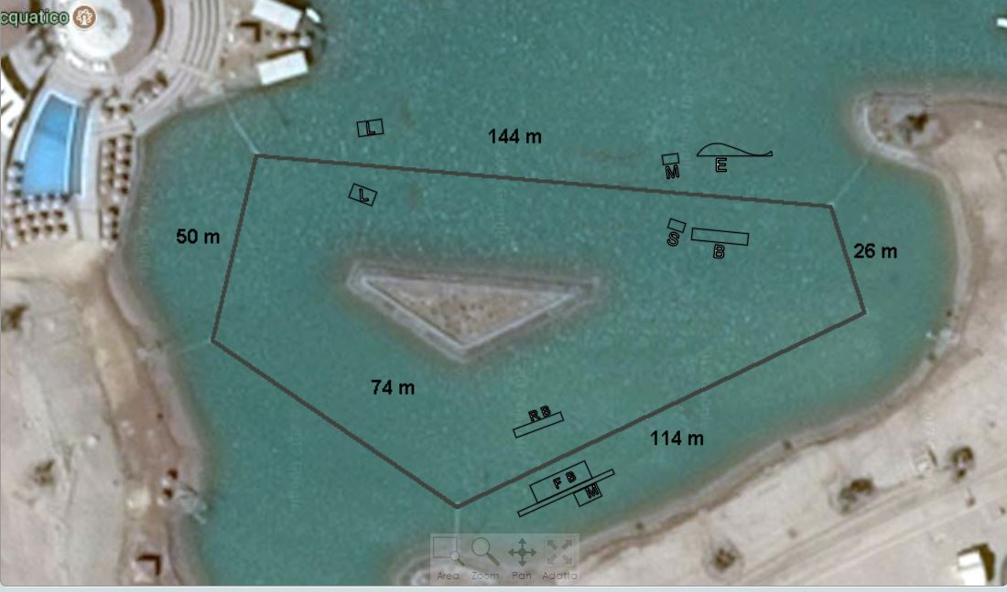
L = Large kicker
M = Medium Kicker
S = Small Kicker
FB = Funbox
RB = Rookie Box
E = Elephant
B = Box
The course will start with the 2 Large Kickers and will end after the engine towers hitting once again the 2 Large kickers.

- RULES:
The competition will be carried out according to rules of IWWF Cable Wakeboard World Council. https://www.cablewakeboard.net/userfiles/IWWF_CWWC_Rules_2018%20.pdf
There is three riders to open the category.

There are two registered competitions for this event. It is possible for a rider to start in a category (if eligible) and the Open competition.

- CATEGORIES:
Wakeboard Ladies: U15, U19, Open, +30, +40;
Wakeboard Men: U15, U19, Open, +30, +40
Wakeskate Ladies: U19, Open
Wakeskate Men: U19, Open
There are 3 riders required to open the category.

- REGISTRATION:
Riders must have IWWF registration on www.cablewakeboard.net and must be registered on competition home page.
Online registration must be finished latest 1 of May 2019 at 23:59, otherwise participants has to pay late fee of additional 10€.

- ENTRY FEE:
All categories: 50 €

IF you are eligible to start in both competitions, there will be a reduced entry of fee of €25 for the second category.
It is also possible to enter Wakeskate and Wakeboard, again, the fee for the second discipline is €25

SPECIAL OFFER !!!
Our special offer includes:
Entry fee of 50 € /for one category/ + 6 days Sliders Wakeboard Pass
Price only 175 €

- PRIZES :

400 World Ranking Points, medals, prize money, prizes from sponsors and partners. Details about prize money will be published in following bulletin.

- PRIZE MONEY:

Guaranteed prize money for the competition is 5000 €. Organizer reserves the right to distribute the prize money between categories. Details about prize money will be published in following bulletin.

- SCHEDULE:

FRIDAY 10.05.2019
12:00 -18:00 Registration
14:00 – 19:00 Official training

SATURDAY, 11.05.2019
8:00 -10:00 Training –warm up
10:00 – 10:15 Riders meeting /basic information will be published before Friday/
10:30 – 17:00 Qualifications in all categories
20.00 Evening party

SUNDAY 12.05.2018
8:00 -10:00 Training
10:30 – LCQ and Finals in all categories
Right after finals – Prize giving ceremony

20.00 Evening party

Schedule may change depending on the number of registered riders and other unexpected factors !

- ACCOMODATION SUGGESTIONS
- You can stay in one of our newly built apartments directly on the lake with big pool, view overlooking lagoon, lovely garden and fully equipped kitchen. You can choose from 1,2 and 3 bedroom apartments. We also rent double rooms with private bathroom and shared living room. You can combine it with meals package: breakfast, lunch and dinner served in our restaurant at the wake park. All apartments have a comfortable expandable sofa bed in the living room accommodating 2 extra persons.For pictures and prices check accommodation section of our website http://www.sliderscablepark.com/#accommodation-section
We will have a special offer with a discounted wake pass, entry to aqua park and meals package for all riders and their family/friends. For accommodation bookings and help finding best flights please contact daniel@sliderscablepark.com or whatsapp +201028020225.
- Alternatively you can choose from 18 hotels, 5 stars to 3 stars, different prices and locations. The whole island is 25km2, so, any hotel is more or less 5-6 km from Sliders Cable Park.
For more information please, visit El Gouna official https://elgouna.com/

- HOW TO GET THERE

Conveniently located 25 kilometers north of Hurghada, El Gouna is only a four hour flight from Europe’s major capitals.The town is easily accessed from Europe via the nearby Hurghada International Airport and boasts a superb infrastructure and excellent services as well as natural beaches and year-round sunshine.
Transportation from Airport to El Gouna takes around 40 min.
The Organizer will provide a VIP service from the airport to the Hotels, a person will wait for you in the airport, front of the arrival hall, helping with baggage and will bring you directly to the hotel, the cost is 15€ per person per way (1 € = 19 EGP)
order transfer by phone / viber / whatsapp / +2 01028020227
Uber in Hurghada works great and easy booking

- USEFUL INFORMATIONS
- Currency: The local currency is EGP (Egyptian Pound), there are banks and ATMs close to the hotels.
Major Credit Cards are accepted everywhere.
- Visa requirments: According to the Egyptian Consulate, citizens of Europe can obtain visa upon arrival at any of the Egyptian airports of entry. These are approx €25
Please check with the Egyptian Embassy in your country for specific VISA requirements. Please check this before travelling.

SAFETY

All riders must wear an approved life vest and a helmet in the course at all times. All participants ride at their own risk.

Following is the Declaration, Waiver and Release form that is required for each rider. Riders younger than 18 years are required to provide the Declaration of Parent / Guardian

Declaration, Waiver and Release Form

For, and in consideration of, the International Waterski & Wakeboard Federation (the IWWF) accepting my application, and permitting me, to participate and compete in the International registered cable wakeboard event (the International event), I, the undersigned, for and on behalf of myself, my heirs, executors and administrators, do hereby irrevocably and unconditionally warrant, represent and undertake to the IWWF as follows:

Any and all information provided and/or disclosed by, or on behalf of, myself to the IWWF (including any officers, employees and representatives thereof) for the purpose of considering and evaluating my application for participation and competition in the International event is true, correct and accurate;

I have fully read and understood the rules and regulations of participation and competition in the International event (a copy of which has been made available to me) and I do hereby covenant with, and undertake to, the IWWF to at all times fully comply with, and abide by, the same;

I am in good physical and mental health and I am physically capable of competing and participating, and fully competent to participate and compete, as a competitor in the International event and that I have not been certified and/or advised otherwise by any qualified medical practitioner;

I do hereby authorize any and all physicians, paramedics and other medical personnel and practitioners procured by, or on behalf of, the IWWF to administer first aid treatment or any medical treatment, surgery or transportation in the event of any illness, accident or injury suffered and/or sustained by me at any time during my participation and competition in the International event (or any part thereof) and hereby indemnify, and shall keep fully and effectively indemnified, the IWWF (including all officers, employees and representatives thereof) upon demand from and against any and all claims, liabilities, demands, costs and expenses of whatsoever nature incurred and/or suffered by the same (or any of them) and arising from, and/or in connection with, the procurement and administration of such medical treatment and transportation in relation to any such illness accident or injury suffered and/or sustained by me;

I acknowledge, agree and confirm that participating and/or competing as a competitor in the International event (or any part thereof) involves inherent risks and dangers of accidents, personal and bodily injury and property loss or damage and that by signing and completing this Declaration, Waiver and Release Form, I fully understand and have considered and evaluated the nature, scope and extent of the risks involved, and voluntarily and freely choose to assume these risks;

I hereby grant to the IWWF (including its lawful successors and assigns) the sole and exclusive right and license, in perpetuity and throughout the world and without any compensation whatsoever to me, to use, reproduce, publish and/or exploit, my name, nickname, likeness, image, logos, get-ups, initials, voice, slogan and signatures developed from time to time, reputation, graphical representation, electronic, animated or computer generated representation and any other representation (in any medium whatsoever), right of association, biographical information and other indicia, and any other right or property in my performances, in any media whatsoever, for any purposes whatsoever relating to, and/or in connection with, the IWWF and/or the International event (or any part thereof) and I shall do all such things (including, without limitation, the execution of appropriate legal documentation) as the IWWF may, from time to time, require to give legal and binding effect to the aforementioned grant of rights;

I irrevocably acknowledge, agree and confirm that the IWWF reserves the right, at its sole and absolute discretion, to disqualify me from participation and/or competition in the International event (or any part thereof) if I am in breach of any of the warranties, representations and/or undertakings set out in this Declaration, Waiver and Release Form and/or for any reason whatsoever the IWWF considers just and proper, and in the event of any such disqualification, I shall not be entitled to any compensation of any nature whatsoever from the IWWF.

I hereby release, hold harmless, protect, indemnify and forever discharge the IWWF (including its officers, employees and representatives), the International event and all commercial partners thereof, from and against any and all claims, demands, liabilities, costs and expenses of any nature whatsoever, whether direct or consequential, suffered and/or incurred by the IWWF (including its officers, employees and representatives), the International event and/or all commercial partners thereof and arising from, and/or in connection with:

Any breach of any of the warranties, representations and/or undertakings given by me as set out hereunder; and/or my participation and/or competition in the International event (or any part thereof).

Declaration

I, ...................................................................................................... (the Competitor), do hereby declare that I have read and fully understood the terms and conditions of this Declaration, Waiver and Release Form and that I have had the opportunity to discuss the same with my parent / guardian and that I agree to be bound by the said terms and conditions of the above agreement with the IWWF.

Place, ............................................., Date ....................................... Signature .......................................................................................

Cable Wakeboard International Event

Declaration of Parent / Guardian

(Applicable only if the Competitor is, on the date of signing the Declaration, Waiver and Release Form, under the age of 18 years)

I, the undersigned, am the parent / guardian* of ........................................................................................(the Competitor) and I do hereby irrevocably and unconditionally:

1 warrant, represent and undertake to the IWWF that I have read and fully understood the terms and conditions of the Declaration, Waiver and Release Form and have discussed with, and explained such terms and conditions to, the Competitor and I agree to, and will cause the Competitor to fully abide by, and comply with, all of the terms and conditions of the Declaration, Waiver and Release Form; and

2 covenant with, and undertake to, the IWWF not to take, nor permit to be taken, any action(s) nor omit to do anything that would assist or cause the Competitor to invalidate, renounce, negate, revoke or disclaim any part of the Declaration, Waiver and Release Form, and

3 warrant, represent and undertake to the IWWF that by signing the Declaration, Waiver and Release Form, neither the Competitor and/or myself is/are in breach of any other arrangement(s) (whether contractual or otherwise) with any third party, and

4 agree to be liable for, and will indemnify the IWWF (including its officers, employees and representatives), the International event and all commercial partners thereof from and against, any and all claims, demands, liability, loss, damages, costs, and expenses of any nature whatsoever, whether direct or consequential, suffered and/or incurred by the IWWF, the International event and all commercial partners thereof, whether direct or consequential, any arising from, and/or in connection with: (a) any breach of any of the warranties, representations and/or undertakings given by the Competitor in the Declaration, Waiver and Release Form; and/or (b) the Competitor’s participation and/or competition in the International event (or any part thereof).

Signature .....................................................................................................

Name of Parent / Guardian*: ........................................................................................................

Date: .......................................

Signed in the presence of:

Witness:

Name:

Address:

Occupation:

* Delete as appropriate

