PUNTA CANA OPEN
3 STAR INTERNATIONAL COMPETITION
November 17th – 18th 2018
AQUA PARK DOWN TOWN PUNTA CANA CABLE PARK
DOMINICAN REPUBLIC

Bulletin 1

The Dominican Republic Water Ski & Wakeboard Federation and Aqua Park Down Town Punta Cana Cable Park herewith invite all riders to the PUNTA CANA OPEN which will be held in Punta Cana from 17-18th of November 2018.

1. Location

The Dominican Republic is the second largest country in the Caribbean, after Cuba, with the highest population in the region with 10.65 million people. It became independent in 1924 from the United States and is a democratic nation. The Dominican Republic has the 9th most important economy in Latin America and is one of the most visited tourist destinations in the Caribbean. Baseball is the most popular sport, the majority of the nation is Roman Catholic, and numerous forms of currency (Dominican Pesos, US Dollars, Euros) are accepted.

PUNTA CANA
Punta Cana is a destination location for rest and relaxation. Here, the Atlantic meets the Caribbean, and large resorts line the beaches offering all of the comforts of modern living. Punta Cana is a golfer’s paradise with 11 courses located all along the strip.

Most of the resorts cater to families with entertainment parks for children and activities for adults all in one place. Punta Cana resorts make it easy with big all-inclusive deals with events, meals and drinks included, eliminating the need for excessive vacation planning.
Punta Cana is a perfect backdrop for dream weddings with white sand beaches, clear blue waters, and coconut palms. When visiting Punta Cana, everyone gets the perfect vacation.

DOWNTOWN PUNTA CANA
Down Town Punta Cana is the largest commercial and entertainment development in the Punta Cana-Bávaro area. Already recognized as a point of reference located at the intersection of the eastern tourist boulevard, and the Barceló highway. Down town Punta Cana is a large area which has had a phenomenal amount invested in the community, The area has a complex filled with several activities for the whole family that can be accessed throughout the day and the night by both the local population and tourists.

TRANSFER HOTEL-SITE-HOTEL - The organizer will provide free transportation from the Official Hotel to the Event venue every event day.
RENT-A-CAR - Alternatively, participants may choose to use any of the major rent-a-car companies that are available in Punta Cana.

2. Maps
Aeropuerto Internacional de Punta Cana X Aqua Park Punta Cana, distance 12,4km
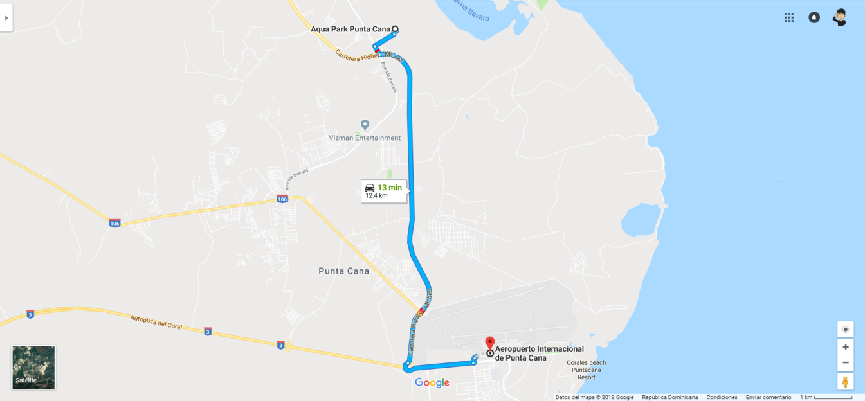

Now Larimar Punta Cana, S/N El Cortecito, Avenida Alemania X Aqua Park Punta Cana, distance 7 km

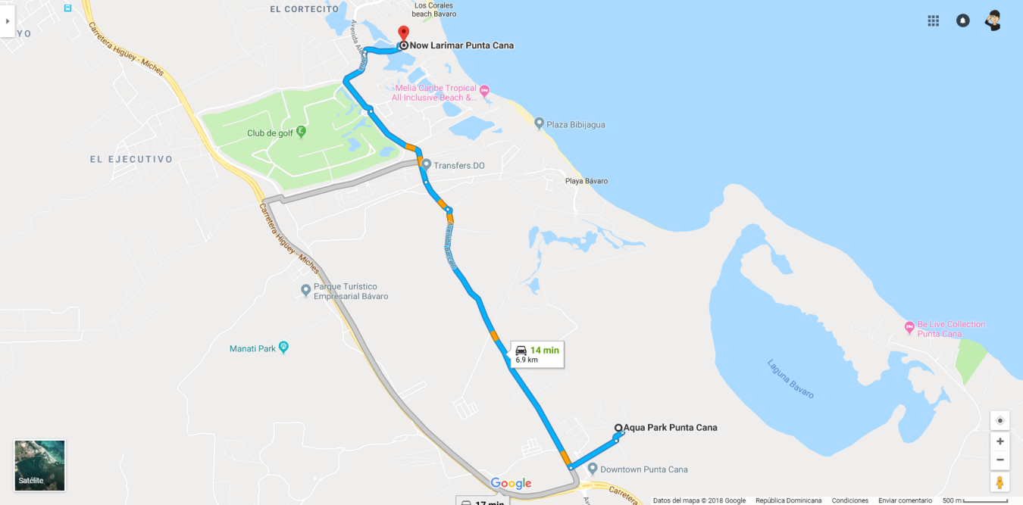

3. COMPETITION SITE

AquaPark, is located in DownTown Punta Cana. It is a water sports park suitable for the whole family. Visitors have the opportunity to participate in various activities, from the most relaxed to those of greater action and adrenaline fueled, with family participation as the main focus.

AquaPark hosts multiple activities, designed to suit adrenaline seekers or those seeking relaxation. You can participate on the Wake Park, sliding on the surface of the water, using either a Wakeboard, Water skis or a Knee board, our fantastic team can help with showing you how it’s done. There are some nice floating Obstacles on the course for the more experienced rider. We also boast a fantastic floating Inflatable Aqua Park, with a giant catapault! For those wanting something a little more sedentary, how about Paddleboarding around the Play Lake.

AquaPark is ideal for all ages and pays special attention to ensuring it’s fun for the whole family! Ensuring that both adults and children have the amazing time they are all seeking.

After all these activities, visitors will need to recharge, at AquaPark, they can find the restaurant Chozza, this fantastic restaurant offers gourmet food throughout the day to keep their visitors and family satisfied. After the park closes at sunset, Chozza stays open all night and often organizes events for fun to continue.

About AquaPark:
AquaPark is a unique destination for the whole family. Located in the new center of Punta Cana, children play with their parents and beginners play with professionals.
Inclusion is a priority with a wide range of activities, from fast to relaxed, guaranteeing a day full of action and family fun.
https://www.instagram.com/aquaparkdr/

4. Organizer

Aqua Park Punta Cana
https://www.instagram.com/aquaparkdr/
https://aquaparkdr.com
info@aquaparkdr.com
luisjosefrancis@aquaparkdr.com

5. PRICE MONEY
There will be a total amount of prize Money of 600 USD for the Open categories.

6. THE COURSE, THE FEATURES AND THE COMPETITON FORMAT

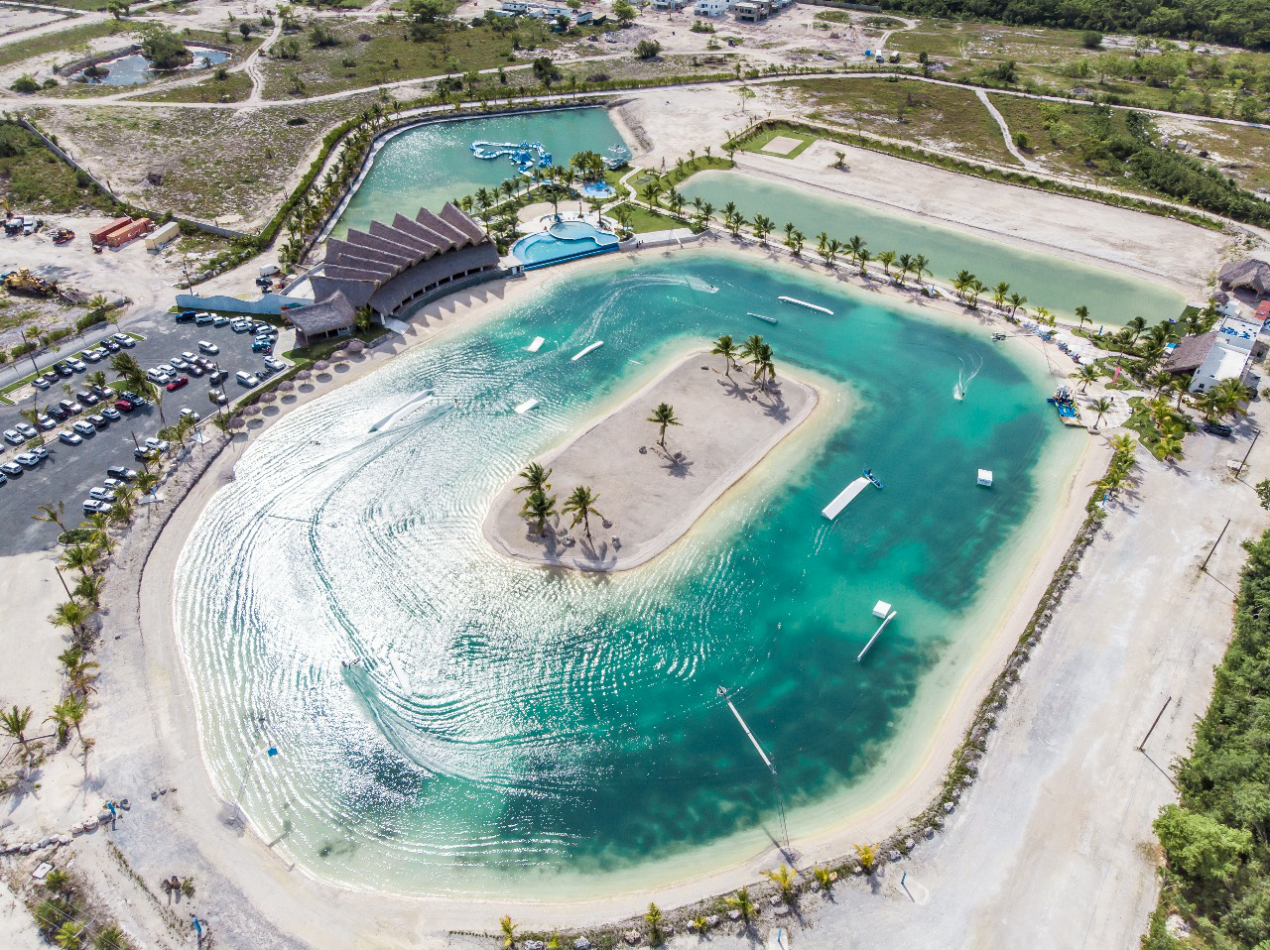

The following features will be distributed covering all the course and there will be no space for air tricks. The rider will be judged only for rail and kicker tricks.
3 kickers (1 small, 1 large, 1 XL curved)
1 Flat Edge transfer
1 A-frame transfer
1 Large Pipe
1 Rooftop
1 Incline with pipe
3 flatbar (1 box, 1 iron rail, 1 inox incline rail)
7. Official Hotel
Now Larimar Punta Cana, located 15 min drive from the park.
http://www.nowresorts.com/larimar
Price and special conditions will be announced in the Bulletin 2
8. How to Reach the Site

Organizer will provide shuttle service from hotel to competition site. For the riders, team manager, team captains and officials.
9. WEATHER
In PUNTA CANA, the month of November is characterized by an average high temperature of 33°C and an average low temperature of 23°C. The climate is moderate and all riders will enjoy the very little probability of rain.
10. CURRENCY
The Dominican local Currency is the PESO ($RD).
Visa, American Express and MasterCard are accepted in almost all hotels, shops and restaurants.
11. VISA REQUIREMENTS
Please check your country requirements.
12. REGISTRATION DEADLINE

All riders need to make their registration on www.cablewakeboard.net before November 16th.

13. ENTRY FEE
The Entry Fee is US$ 70 dollars per athlete which includes the lunches for the athletes on competition days, transport hotel-competition-hotel and also admission to all official receptions and parties. .

14. RULES
According to the IWWF CWWC WORLD RULES 2018 http://www.cablewakeboard.net/userfiles/IWWF_CWWC_Rules_2018%20.pdf
AGE CATEGORIES - Wakeboard & Wakeskate:
U11 – U11’s cannot compete in an International Competition. There will not be an U11 Category in this competition. If there is enough interest from U11 Riders, the organiser will arrange a ‘special NON Ranked Competition’ for this age group.
Age Categories
The Rider must have reached his/her 11th Birthday to be able to compete Internationally. Any rider whose DOB is after 13th November 2007, will not be able to start.
U15 (15 or under), Boys & Girls: The last year a rider is allowed to compete in this category is the year of his 15th birthday. (For 2018, it means that the rider has to be born in 2003 or later).
U19 (19 or under), Junior Men & Ladies: The last year a rider is allowed to compete in this category is the year of his 19 th birthday. (For 2018, it means the rider has to be born in 1999 or later).
Open Men, Open Ladies: No age restriction
+30: Masters Men & Ladies: The first year a rider is allowed to compete is the year of his 31st birthday. (For 2018, it means the rider has to be born in 1987 or before).
+40: Veterans Men & Ladies: The first year a rider is allowed to compete is the year of his 41st birthday. (For 2018, it means the rider has to be born in 1977 or before).
To clarify: a rider born in 2007 can compete in U15, U19 or Open categories, or a rider born in 1999 can compete in U19 or Open. It is the same for +30 and +40: a rider born in 1968 can choose to compete in +40, +30 or Open.

15. OFFICIALS

To be announced in bulletin 2.

Looking forward to seeing you all in Punta Cana

