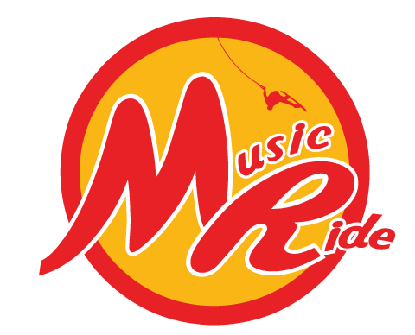 Spin Cup two * international event
On 12-13 october 2018
Powered by The Spin

Dates:
12 october (training) and 13 october 2018 (contest)
Organiser:
Musicride / The Spin Cablepark
Adress: 61 rue crossart, 6440 Boussu Lez Walcourt , Belgium
Phone : 0032 71 31 39 82
Mail : info@thespin.be

Cable :
The Spin cablepark, 61 rue crossart, 6440 Boussu Lez Walcourt, Belgium
Set up: 2 large unit kicker, 1 tube, 1 soft box, 1 wedge, 1 big slider, 1 stephen vollert signature, 1 home made fun box, 3 home made rails, 1 street serie (low to high rail), 1 felix georgii signature, 1 unit rail to rail
http://thespin.be/the-spin/les-modules/
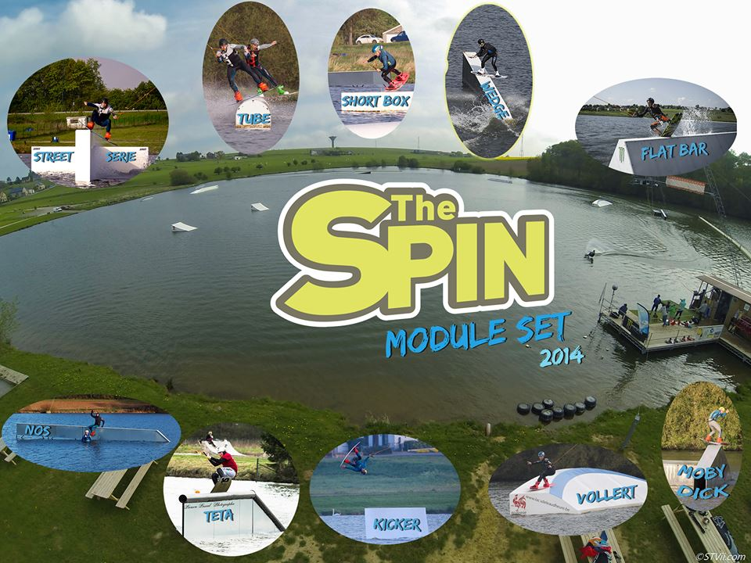

Rules, format, categories and cash prizes:
Classic IWWF contest (gifts, no cash): classic IWWF rules; two stars event
All categories are open (minimum 4 riders) in wakeboard
Wakeskate
Entry fees and costs:
Discipline
Registration fee WAKEBOARD or WAKESKATE  Registration fee wakeboard + wakeskate | □ €40 registration  55€ registration

Program:
Saturday 14: qualifications,
Sunday: 15: LCQ and finals

• RIDERS BRIEFING IS PROVIDED FOR THE WAKESKATING ON SATURDAY MORNING AT 9:00
• RIDERS BRIEFING IS PROVIDED FOR WAKEBOARDING ON SATURDAY MORNING AT 9:00
Registration form: Spin cup 2018 (13-14 october)

Registration has to be done on www.cablewakeboard.net and registration form has to be sent to: Musicride, 61 rue Crossart, 6440 froidchapelle, Belgium or by mail at info@thespin.be Death line on 11 october 2018
• Name and first name of rider:

• sex: □ male □ female

• Date of birth :

• The 2017 licence No :

• Telephone (mobile):

• Mail :

• Complete Adress:

Category the rider wishes to compete
Wakeboard/wakeskate
□ Men wakeboard | □ Women Wakeboard | □ Wakeskate
□ Junior Wakeboard | □ Junior women Wakeboard | □ Master Wakeboard
 | □ Boys wakeboard | □ Girls wakeboard

•Bulletin, discharge and the corresponding registration fee will be sent to the following address:
Musicride, 61 rue Crossart, 6440 froidchapelle, Belgium or info@thespin.be

Payment:
Musicride 363-0418995-92
BIC: BBRUBEBB IBAN: BE12 3630 4189 9592
Communication: first name, second name, category

•For more information, please contact : Cedric (Musicride): 003271 31 39 82 by phone or trough info@thespin.be
•For issues of regulation, see the organizers.

ATTENTION
2016 LICENCE MUST BE NECESSARILY PRESENTED. THE LICENCE MUST BE SUBMITTED TO THE CHIEF JUDGE OR CHIEF CALCULATOR TO THE SECRETARIAT OF THE COMPETITION IN THE FRIDAY EVENING
• IF THE RIDER PROVIDES ARRIVING AFTER THESE HOURS, THE COPY OF THE LICENCE MUST BE ATTACHED TO THE REGISTRATION FORM.

Any entry not accompanied by the entry fee will not be taken into account.

How to get there:

http://thespin.be/infos-pratiques/acces/

National airports:
Bruxelles – zaventem
Charleroi – Brussel south

Obstacles placement :

