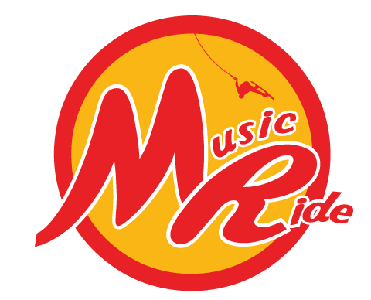 Cable wakeboard
and wakeskate nationals
On 29-30 september 2018
Powered by The Spin

Dates:
29 – 30 september 2018
Organiser:
Musicride / The Spin Cablepark
Adress: 61 rue crossart, 6440 Boussu Lez Walcourt , Belgium
Phone : 0032 475 80 91 66
Mail : info@thespin.be

Cable :
The Spin cablepark, 61 rue crossart, 6440 Boussu Lez Walcourt, Belgium
Set up: 2 large unit kicker, 1 XL unit kicker, 1 tube, 1 soft box, 1 wedge, 1 big slider, 1 stephen vollert signature, 1 home made fun box, 3 home made rail, 1 street serie (low to high rail), 1 felix signature serie, 1 unit rail to rail
http://thespin.be/the-spin/les-modules/
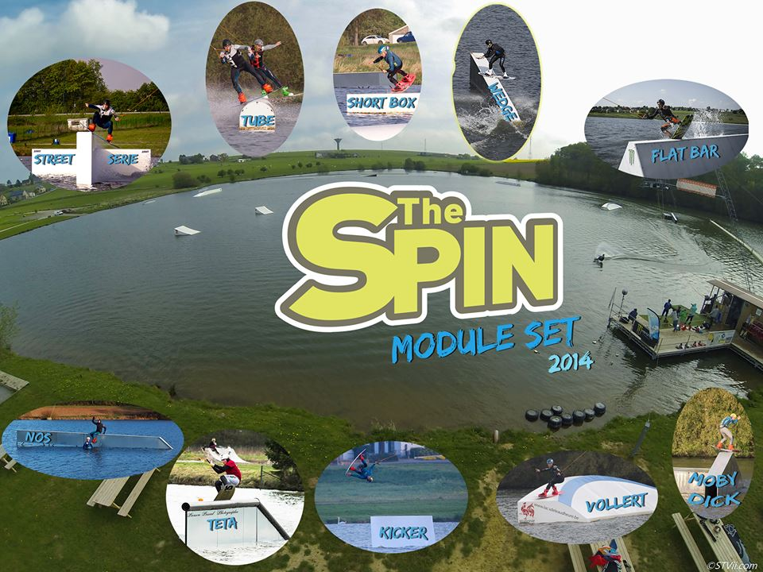

Rules, format, categories and cash prizes:
Classic IWWF contest (gifts, no cash): classic IWWF rules
All categories are open (minimum 4 riders) in wakeboard
Wakeskate
Entry fees and costs:
Discipline
Registration fee WAKEBOARD or WAKESKATE | □ €50 registration
Registration fee: 2 disciplines (wakeboard and wakeksate) | □ €60 registration

Registration
Registration on line at www.cablewakeboard.net
Registration deadline 26/09/2018

Program:
SATURDAY
9-10h training Mini-boys, Boys, Girls and Juniors.
10h qualifications mini boys
11h qualifications Boys-Girls
12h qualifications Juniors
13h training Men and Ladies
14h qualifications Ladies
15h qualifications Men
16h training Masters and Wakeskate
17h Qualifications Masters
18h Qualifications Wakeskate

SUNDAY
9h Training LCQ
10h All LCQ
11h training mini boys, boys-girls and juniors
12h Finals mini boys
12h30 Finals Boys
13u Finals Girls
13u30 Finals Juniors
14u Training Ladies, Masters, Men and Wakeskate
15u Finals Ladies
15u30 Finals Masters
16u Finals Wakeskate
16u30 Finals Men
17u30 Price giving

• RIDERS BRIEFING IS PROVIDED FOR THE WAKESKATING ON SATURDAY MORNING AT 9:00
• RIDERS BRIEFING IS PROVIDED FOR WAKEBOARDING ON SATURDAY MORNING AT 9:00

How to get there:

http://thespin.be/infos-pratiques/acces/

National airports:
Bruxelles – zaventem
Charleroi – Brussel south

Obstacles placement :

