Dear Riders,
It is our pleasure to announce that we are once again hosting the Welsh Wakeboard Open in North Wales, Great Britain. We really hope to see you here on the water at Glasfryn Parc.
In association with the International Water-ski and Wakeboard Federation (IWWF) and the British Waterski & Wakeboard Federation (BWSW), Glasfryn Parc (GP) invites you to the:
“International 3 Star Welsh Wakeboard Open”
On July 7th – 8th 2017
Glasfryn Parc | North Wales | Great Britain

400 World Ranking Points

Cable/Location: Glasfryn Wakeparc
Pwllheli | North Wales | LL53 6PG | Great Britain

The event, taking place on 7-8th July, will be an IWWF 3 Star International Wakeboard Event as part of the World Tour Stop in Great Britain. As part of the Cable Wakeboard World Council (CWWC) there will be 400 World Ranking Points awarded to the successful riders, along with a prize pot totaling £3,000 up for grabs for the highest scoring competitors.
There will be 6 categories within the Welsh Wakeboard Open, including; Junior Men, Junior Ladies, Open Men, Open Ladies and Masters Men, Masters Ladies.
The weekend will kick off with a practice on Friday 7th July where all riders will get the chance to warm up before the competition on Saturday 8th July where the riders will get to show off their tricks to the judges. Following the competition there will be an award ceremony and after party to celebrate and congratulate the riders!
The Welsh Wakeboard Open will be followed by the Industry Wakeparks Grassroots Tour Stop on Sunday 9th July.
This first bulletin should give you an overview about the upcoming event and help you to plan your trip to Wales.
We look forward to welcoming you at Glasfryn Parc.
Sincerely,
Glasfryn Wakeparc

Organizer | British Waterski & Wakeboard – Glasfryn Wakeparc  Contact: Sebastian Kearns  Email: wakeboarding@glasfryn.co.uk
CWWC Ranking | International Waterski Federation / Confederation E&A  Email: alex@cablewakeboard.net  Website: www.cablewakeboard.net
Competition Type | IWWF 3 Star International Competition  Awarding 400 points
Competition Date | 7-8 July 2017  Official Practice – Friday 7th July  Competition – Saturday 8th July
Cable Park Location | Glasfryn Wakeparc  Glasfryn Parc Activity Centre  Y Ffor  Pwllheli  North Wales  UK  LL53 6PG | Tel. +44 1766 810000  Email: wakeboarding@glasfryn.co.uk  Website: www.glasfryn.co.uk
Cable | 7m height, Sesitec System 2.0
Rules | The Competition is a part of coordinated competitions around the world. The competition will be carried out according to the rules of the IWWF Cable Wakeboard World Council.  Please note that you must wear a suitable helmet and vest in the wakeboard competition.
Disciplines & Categories | Men’s and Women’s competitions in the following categories:  Girls / Boys (U15)  Juniors (U19)  Open  Masters (30+)  Veterans (40+)  Category minimum requirement is 3 riders.  The minimum age for entry into an international event is age 11. Veterans can enter either the Open or Masters Category.

Entry and Costs | Closing Date for Entries: 30 June 2017  Cost: £35 / €42  Registrations after this date will be considered as a late registration which will incur a late fee of £10 / €11.79. A rider who misses the start time of his/her run without a good reason will be not permitted to start and will not be able to claim a refund of fees.  Entry Fee Includes:  Free official practice riding, after party, voucher for burger and chips (value of £6 can be redeemed toward the cost of a more expensive meal in the on-site café).  The entry fee can be paid in three different ways:  - By Bank Transfer before 1 July 2017 on account:  NAME: Glasfryn Parc  IBAN: GB73MIDL40373061391259  SWIFT/BIC: MIDLGB2150K  WITH TITLE: WWO, name of rider, nationality of rider  Please email the copy of transfer made to wakeboarding@glasfryn.co.uk  - Call Glasfryn Parc on +44 1766 810000 and pay via credit/debit card  - In cash at the latest one day prior to the competition, otherwise the participant will be liable to pay the additional late fee of £10 / €11.79
Prizes | International Ranking Points  This Competition is a 3 Star International Competition with 400 Ranking Points for the first place.  Prize Money  Prize money totaling £3000 / €3536 will be awarded.  Open Men Open Ladies  1st - €600 1st - €300  2nd - €450 2nd - €200  3rd - €350 3rd - €100  4th - €250  5th - €200  Junior Men Junior Ladies  1st - €300 1st - €200  2nd - €200 2nd - €150  3rd - €100 3rd - €100  Medals will be awarded.
Official Panel | Chief Judge: Sebastiaan Huizinga  Chief Scorer: Nikola Vranesic
Safety | All riders must wear an approved life vest and a helmet in the course at all times. All participants ride at their own risk. Each rider must complete the Declaration, Waiver and Release form and riders younger than 18 years are required to provide the Declaration of Parent / Guardian.

Registration | The competition is registered as part of the CWWC World Rankings. Riders must have IWWF wakeboard licenses from their national Federations. British riders will also get points for the national ranking.  All entrants must be a member of the British Waterski and Wakeboard Federation, www.bwsw.org.uk or their national federation. BWSW have agreed that this year there will be no charge for the competition license, do you do not need to apply for one if you are a BWSW member.  Please complete the online entry form to register for the completion.  Local registration at Glasfryn starts on Thursday 6th July at 10am until 5pm and on Friday 7th July from 8am until 12pm. For early local registration please contact us: wakeboarding@glasfryn.co.uk  All entrants must also join the competition at www.cabelwakeboard.net
Useful Information | We have storage on-site for all kit in locked areas of the parc. No liability will be accepted by the event organizers for any damage or loss of property.  Free WiFi is available at Glasfryn Parc.  To travel to the UK you must have a valid passport, with at least 6 months validity left at the time of entry into the country.  The official language in Wales is Welsh, but English is spoken commonly.  For driving, there is zero tolerance for alcohol. Speed limits are 30mph in town, 60mph outside the town and 70mph on the highway.  Minimum drinking age is 18.  In case of emergency, phone 999.  Time zone in Wales is GMT.  Mains electricity voltage is 240V. Socket is UK Plug (3 pins)  Weather during the competition is expected to be warm and sunny with temperatures at or above 20 degrees. Water temperature is expected to be approximately 20 degrees.  Glasfryn Wakeparc is part of Glasfryn Parc Activity Centre, a multi-activity centre featuring go-karting, quad biking, archery, ten pin bowling, licensed bar and café. Bar is open until late.

Transport | By Plane  Nearest airports are:  Liverpool Airport  Manchester Airport  Birmingham Airport  Car rental is available from all airports (2.5 hour drive). Railway services are accessible from all airports.  By Train  Nearest railway stations are:  Pwllheli Railway Station  Bangor Railway Station  The nearest train station is Pwllheli (4 miles from the competition site) 3 hours and 20 minutes from London, which comes via Birmingham Central. If coming from the North West, the nearest train station is Bangor where a bus connection to Pwllheli is available. Please see www.transportdirect.info for more information.  By Car  By Car from the North:  Take the A55 from Chester, then the A487 from Bangor to Caernarfon and then the A499 to Pwllheli. Along that road you will see our main activity centre. (post code LL53 6PG)  By Car from the South:  Follow the M54 past Telford, then join the A5 past Shrewsbury, Oswestry & Llangollen. After Corwen turn left onto the A494 following signs for Bala. As you arrive in Bala take a right onto the A4212 stay on this road for about 20 miles then turn right at a T Junction onto the A470 towards Porthmadog. Join the A487 and carry on through Porthmadog and join the A497 to Criccieth and Pwllheli, Turn right onto the B4354, Turn right onto A499 and the parc will be on you right. (post code LL53 6PG)  For general transport enquiries use: http://www.traveline.info/  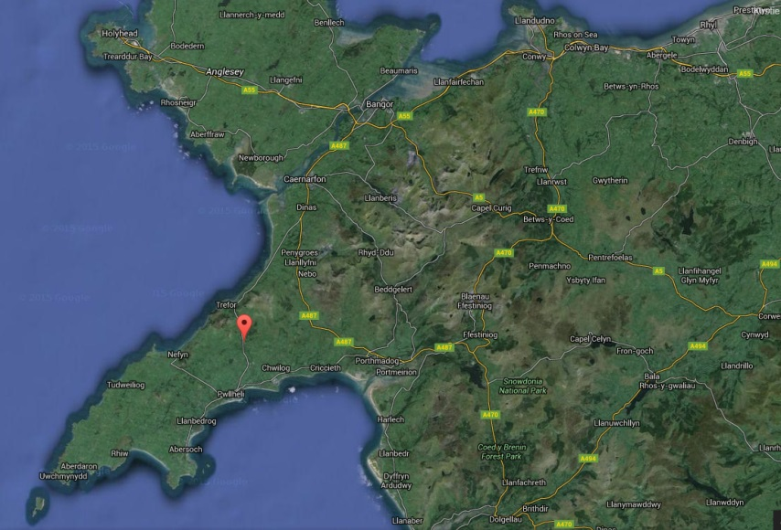

Accommodation | On-Site Camping  Competition entry fee includes camping for all registered riders +1 guest for the duration of the event. Camping spaces can be reserved on the Entry Form  Additional on-site camping available for £5 per person, per night. For camping spaces, please phone 01766 810000.  Other Accommodation Options:  Cottages:  Glasfryn Cottages: www.glasfryncottages.co.uk |01766 810688  helen@beca-tv.com  Abersoch Holiday Homes: http://www.abersochholidayhomes.co.uk/  Menai Cottages: http://www.menaiholidays.co.uk  Lleyn Farm Holidays: http://www.lleyn-farm-holidays.co.uk/  Hostels:  Cwm Pennant Hostel: http://www.cwmpennanthostel.com/  Hotels:  Bryn Eisteddfod: http://bryneisteddfod.wales/bewp/en/home-2/  Victoria Hotel: http://www.victoriahotel-pwllheli.co.uk/  Crown Hotel: http://www.hotelscombined.co.uk/Hotel/Crown_Hotel_Pwllheli.htm  Nanhoron Nefyn: http://www.nanhoronhotel.com/  Wern Fawr: http://www.wernfawr.co.uk/index.html  Plas Bodegroes: http://www.bodegroes.co.uk/  Venetia: http://www.venetiawales.com/

Provisional Schedule
Friday 7th July 09:00 – 14:00 Public Riding
14:00 – 18:00 Official Practice (Competitors Only)

Saturday 8th July 09:00 – 10:00 Riders’ Briefing
10:00 – 17:00 Competition
19:00 Medals & Award Ceremony
20:00 After Party

Cableway Information
Type: Sesitec System 20. (Two Tower System)
Overall length: 160 m
Carriers: 1
Pylons: 2
Height of Cable: 7m
Length of tow rope: 11.63m
Obstacles: 4

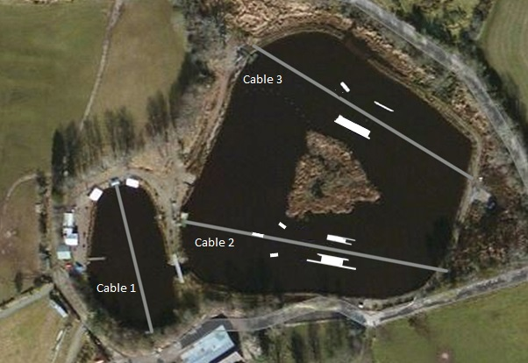

Cable 1: With the 8m towers perfect for air tricks and first time learners.
Cable 2: With obstacles including the Rooftop Funbox, Small Transfer box, Big Kickers and Slug Incline box.
Cable 3: With obstacles including the Leviathan Funbox, flat bar, small kicker and with 8m towers also ideal for air tricks.

Obstacle Park
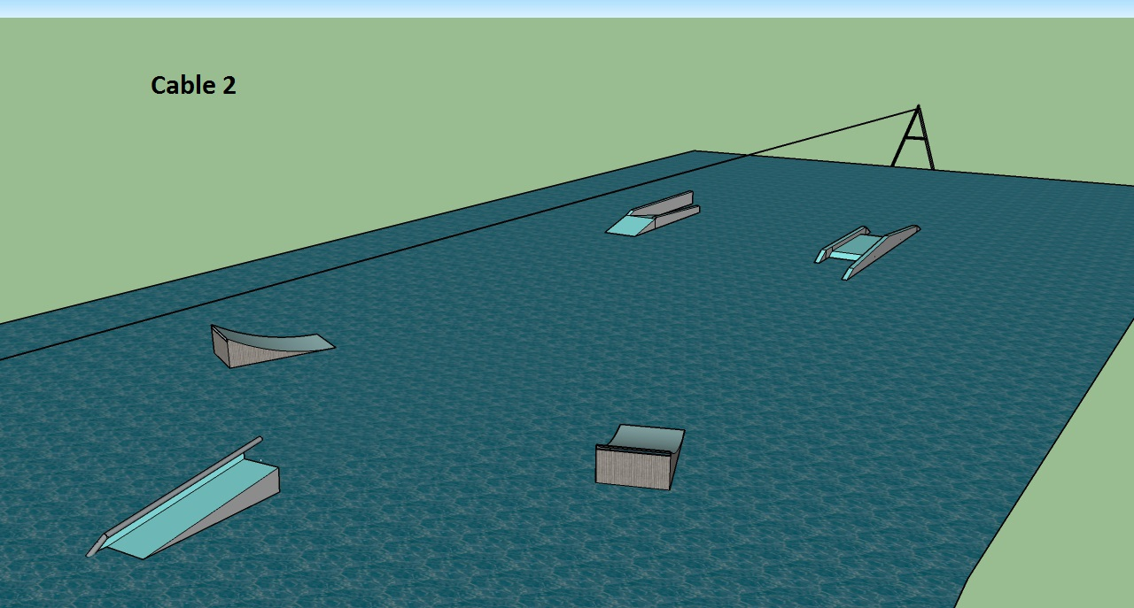

Kickerx2 Height: 1.1m Transfer Box Height: 1.25m
Length: 4.4m (transfer rail) Length: 22m
Width: 2m Width: 2.7m

Slug Rail Height: 1.1m Shotgun Rooftop Height: 1.1m
(metal pipe incline) Length: 11m (inside) Length: 18.2m
Width: 2m Width: 3.05m

The full obstacle layout will be released closer to the date of the completion.

Competition Format
The format of the competition is as follows:
1. The competition is to be run in line with the IWWF Rules 2015, the below items are specific to running this competition on a STRAIGHT LINE CABLE, and highlights some of the key differences between the Cableways.
2. A run will consist of 2 Passes of the Cable, a complete pass is 1 run and back..
3. Air Tricks can be performed either Right Foot Forward or Left Foot Forward, but may involve missing an obstacle to complete. (the slug rail) Please be aware of this when planning your runs.
4. Air Tricks must not be performed on the Corner, they must be performed before you reach the corner.
5. You can pick the speed that you will be driven on, this will then be held for the full duration of your run and the driver will not change the speed during your run.
6. Corners will be driven safely by the Cable Operator, but the operator will not be able to assist you around the corner.
7. There are No Falls or Picks up. If you fall during your run, you must move out of the competition run as quickly as possible to allow the competition to continue.
8. There will be 2 Runs for each qualifier, but LCQ’s will only include 1 Run.

For those of you who have never been on the Park before, below is a map of Glasfryn Parc Activity Centre.
We look forward to seeing you at the Welsh Wakeboard Open. If you have any questions please call 07812 712255 and ask for Sebastian Kearns.

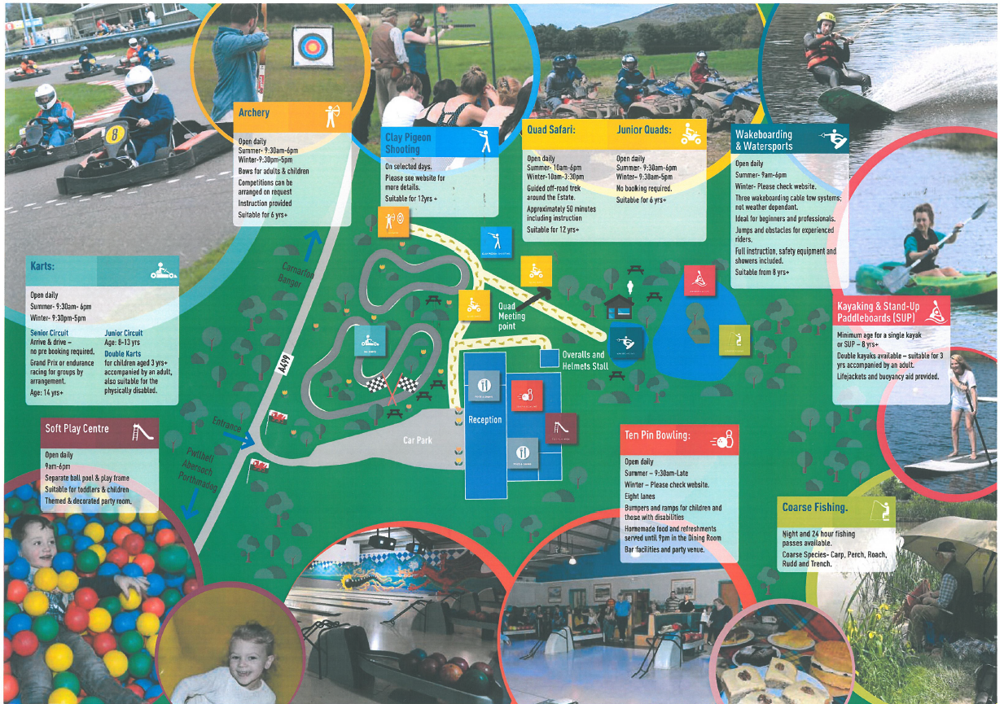

Declaration, Waiver and Release Form
For, and in consideration of, the International Waterski & Wakeboard Federation (the IWWF) accepting my application, and permitting me, to participate and compete in the International registered cable wakeboard event (the International event), I, the undersigned, for and on behalf of myself, my heirs, executors and administrators, do hereby irrevocably and unconditionally warrant, represent and undertake to the IWWF as follows
Any and all information provided and/or disclosed by, or on behalf of, myself to the IWWF (including any officers, employees and representatives thereof) for the purpose of considering and evaluating my application for participation and competition in the International event is true, correct and accurate;
I have fully read and understood the rules and regulations of participation and competition in the International event (a copy of which has been made available to me) and I do hereby covenant with, and undertake to, the IWWF to at all times fully comply with, and abide by, the same;
I am in good physical and mental health and I am physically capable of competing and participating, and fully competent to participate and compete, as a competitor in the International event and that I have not been certified and/or advised otherwise by any qualified medical practitioner;
I do hereby authorise any and all physicians, paramedics and other medical personnel and practitioners procured by, or on behalf of, the IWWF to administer first aid treatment or any medical treatment, surgery or transportation in the event of any illness, accident or injury suffered and/or sustained by me at any time during my participation and competition in the International event (or any part thereof) and hereby indemnify, and shall keep fully and effectively indemnified, the IWWF (including all officers, employees and representatives thereof) upon demand from and against any and all claims, liabilities, demands, costs and expenses of whatsoever nature incurred and/or suffered by the same (or any of them) and arising from, and/or in connection with, the procurement and administration of such medical treatment and transportation in relation to any such illness accident or injury suffered and/or sustained by me;
I acknowledge, agree and confirm that participating and/or competing as a competitor in the International event (or any part thereof) involves inherent risks and dangers of accidents, personal and bodily injury and property loss or damage and that by signing and completing this Declaration, Waiver and Release Form, I fully understand and have considered and evaluated the nature, scope and extent of the risks involved, and voluntarily and freely choose to assume these risks;
I hereby grant to the IWWF (including its lawful successors and assigns) the sole and exclusive right and license, in perpetuity and throughout the world and without any compensation whatsoever to me, to use, reproduce, publish and/or exploit, my name, nickname, likeness, image, logos, get-ups, initials, voice, slogan and signatures developed from time to time, reputation, graphical representation, electronic, animated or computer generated representation and any other representation (in any medium whatsoever), right of association, biographical information and other indicia, and any other right or property in my performances, in any media whatsoever, for any purposes whatsoever relating to, and/or in connection with, the IWWF and/or the International event (or any part thereof) and I shall do all such things (including, without limitation, the execution of appropriate legal documentation) as the IWWF may, from time to time, require to give legal and binding effect to the aforementioned grant of rights;
I irrevocably acknowledge, agree and confirm that the IWWF reserves the right, at its sole and absolute discretion, to disqualify me from participation and/or competition in the International event (or any part thereof) if I am in breach of any of the warranties, representations and/or undertakings set out in this Declaration, Waiver and Release Form and/or for any reason whatsoever the IWWF considers just and proper, and in the event of any such disqualification, I shall not be entitled to any compensation of any nature whatsoever from the IWWF.
I hereby release, hold harmless, protect, indemnify and forever discharge the IWWF (including its officers, employees and representatives), the International event and all commercial partners thereof, from and against any and all claims, demands, liabilities, costs and expenses of any nature whatsoever, whether direct or consequential, suffered and/or incurred by the IWWF (including its officers, employees and representatives), the International event and/or all commercial partners thereof and arising from, and/or in connection with:
Any breach of any of the warranties, representations and/or undertakings given by me as set out hereunder; and/or my participation and/or competition in the International event (or any part thereof).
Declaration
I, (the Competitor), do hereby declare that I have read and fully understood the terms and conditions of this Declaration, Waiver and Release Form and that I have had the opportunity to discuss the same with my parent / guardian and that I agree to be bound by the said terms and conditions of the above agreement with the IWWF.

Cable Wakeboard International Event
Declaration of Parent / Guardian
(Applicable only if the Competitor is, on the date of signing the Declaration, Waiver and Release Form, under the age of 18 years)
I, the undersigned, am the parent / guardian* of (the Competitor) and I do hereby irrevocably and unconditionally:
- warrant, represent and undertake to the IWWF that I have read and fully understood the terms and conditions of the Declaration, Waiver and Release Form and have discussed with, and explained such terms and conditions to, the Competitor and I agree to, and will cause the Competitor to fully abide by, and comply with, all of the terms and conditions of the Declaration, Waiver and Release Form; and
- covenant with, and undertake to, the IWWF not to take, nor permit to be taken, any action(s) nor omit to do anything that would assist or cause the Competitor to invalidate, renounce, negate, revoke or disclaim any part of the Declaration, Waiver and Release Form, and
- warrant, represent and undertake to the IWWF that by signing the Declaration, Waiver and Release Form, neither the Competitor and/or myself is/are in breach of any other arrangement(s) (whether contractual or otherwise) with any third party, and
- agree to be liable for, and will indemnify the IWWF (including its officers, employees and representatives), the International event and all commercial partners thereof from and against, any and all claims, demands, liability, loss, damages, costs, and expenses of any nature whatsoever, whether direct or consequential, suffered and/or incurred by the IWWF, the International event and all commercial partners thereof, whether direct or consequential, any arising from, and/or in connection with:
  - any breach of any of the warranties, representations and/or undertakings given by the Competitor in the Declaration, Waiver and Release Form; and/or
  - the Competitor’s participation and/or competition in the International event (or any part thereof).

Signature:
_________________________________________________________________________________________
Name of Parent / Guardian*: Date:
_________________________________________________________________________________________
Signed in the presence of: Witness:
_________________________________________________________________________________________
Name: Address: Occupation:
_________________________________________________________________________________________
* Delete as appropriate

