Grand Prix of Belarus – Poland First Stop
Wakeboard and Wakeskate Two-tower cable
19. 08. 2017
Minsk, Belarus

BULLETIN 2
CHANGES FROM BULETIN 1 MARKED RED

Currency: Belarusian rubles 1 USD = 1,98 BYN

Travel
- г. Минск, Цнянское водохранилище, канатная дорога, вейк парк WAKE LINE (около спасательной станции)
- Minsk, Cnianskoe lake, Wake Park WAKE LINE (near the rescue station)
- coordinates N53*95695 E27*58555

- VELCOM +375296555306 Nikolay Buyanovski
- +375296401034 Dmitry Uzki
- wake.belarus@gmail.com
https://yandex.by/maps/157/minsk/?source=serp_navig&ll=27.612309%2C53.947375&z=14&mode=routes&rtext=53.934419%2C27.651215~53.956604%2C27.585819&rtt=mt&rtm=atm
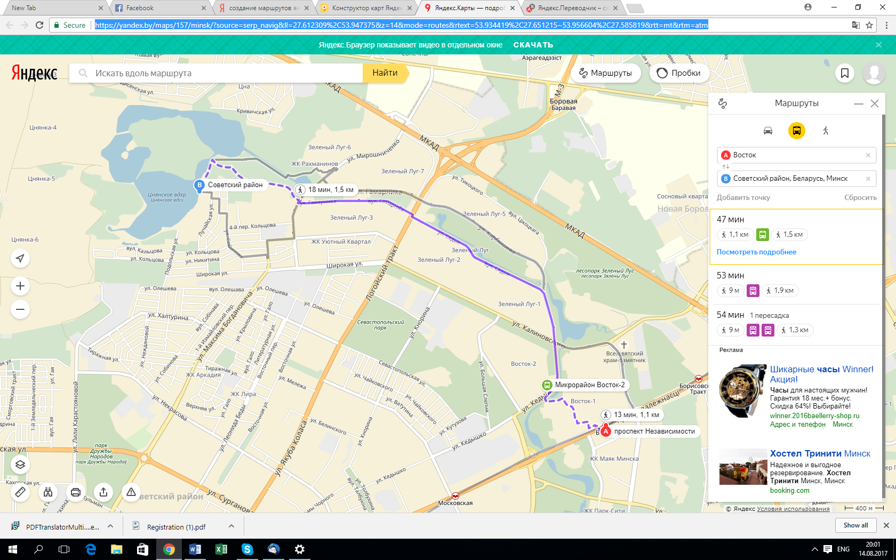

Accommodations
https://yandex.by/maps/157/minsk/?source=serp_navig&ll=27.593093%2C53.948537&z=15&mode=search&rtext=53.934419%2C27.651215~53.956604%2C27.586162&rtt=mt&rtm=atm&text=%D0%A5%D0%BE%D1%81%D1%82%D0%B5%D0%BB&sll=27.593093%2C53.948537&sspn=0.054331%2C0.018708&sctx=CQAAAAEA8eclEMCPO0AXd831x%2FNKQHsUrkfhepQ%2FexSuR%2BF6lD8AAAAABQAAAAAAAAABvoT1fOf%2F4tF2jwEAAYv%2Ffz8AAAAAAAAAAAIAAAB1YQ%3D%3D
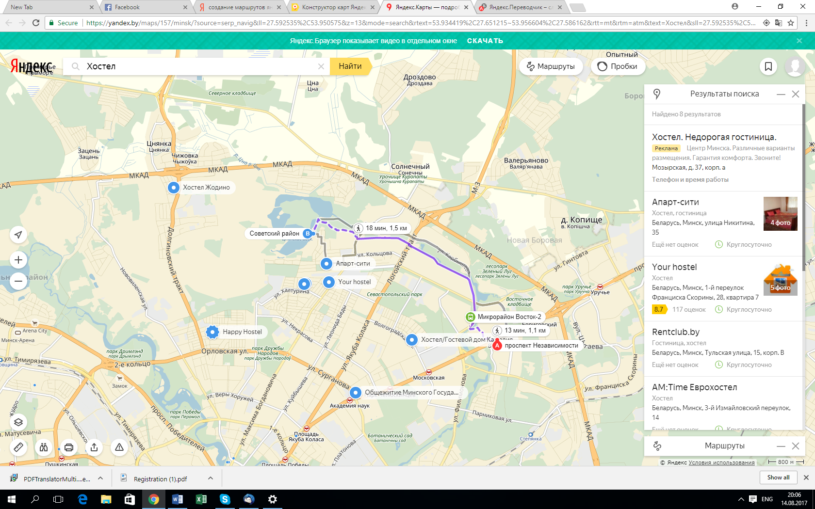

Cable System: 2.0 system Wake Point http://kanatka.by/

The course and the features

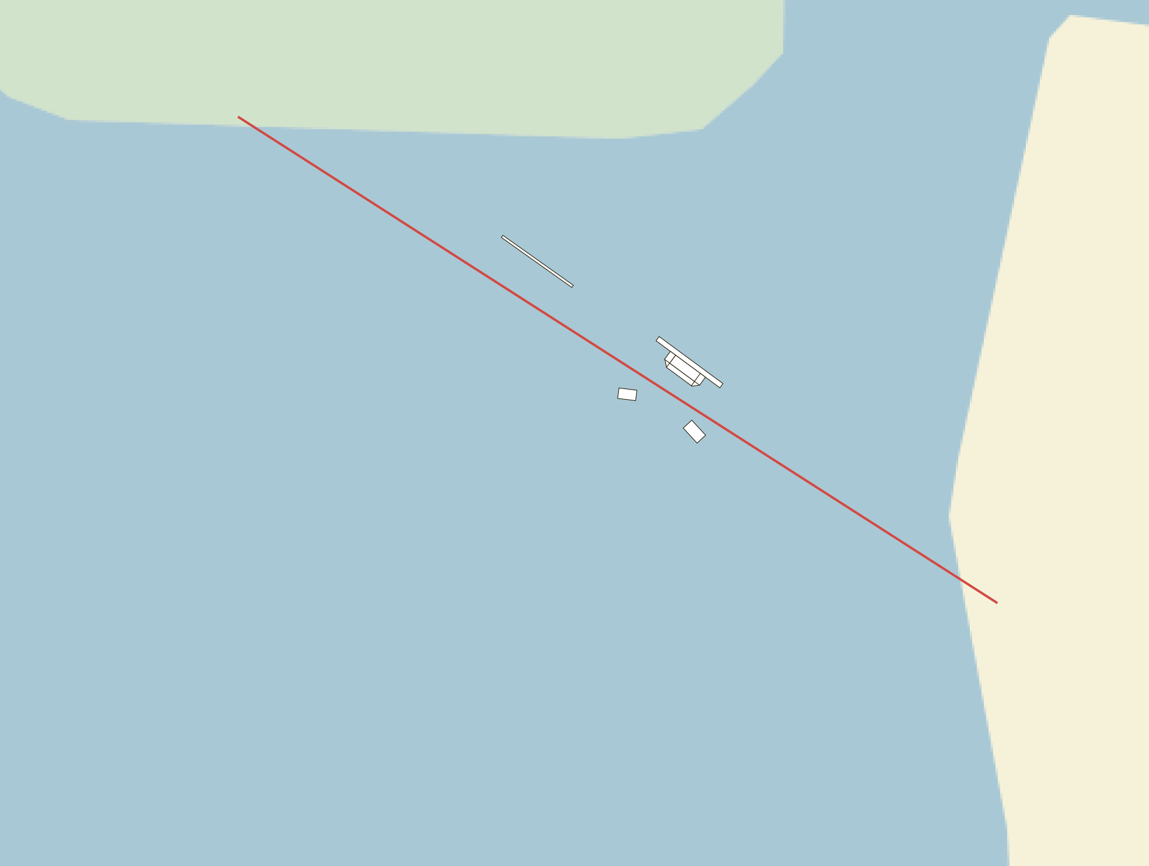

- pipe (gun) under the left leg
- two kickers under the left and right legs
- fanbox two way left-right

ENTRY REQUIREMENTS

Registration :
Riders must have IWWF registration on http://www.cablewakeboard.net and must be registered on competition home page http://myzone.cablewakeboard.net/en/116/?sub=6&comp=1466

Registration for other categories continues till 18/08 18:00

Entry fee : 20 blr rub (10 usd) per rider and category Double start is not allowed. Starting in one wakeboard and one wakeskate categories is not considered as double start.

Entry fee not includes: Official Jersey (BIB). There is 40 blr rub (20 usd) deposit for a BIB, which will be returned after competition once the BIB is turned back.

Conditions & Categories
Grand Prix of Belarus – Poland will be carried out according to the CWWC World Rules 2017. A full copy of the rules will be online available at: http://www.cablewakeboard.net/userfiles/IWWF_CWWC_Rules_2017.pdf

Schedule
Friday, 18th
9:30 – 21:00 official training (training 15 minutes per person. Payment of the registration fee
required before training ).

Saturday, 19th
SATURDAY 19 AUG 2017 | Start
Qualification WS Open Ladies | 11:00
Qualification WS Open Men | ▼
Qualification WB Boys A | ▼
Qualification WB Boys B | ▼
Qualification WB Veteran Men | ▼
Qualification WB Masters Men | ▼
Qualification WB Junior Men | ▼
Qualification WB Open Ladies | ▼
Qualification WB Open Men A | ▼
Qualification WB Open Men B | ▼
Lunch break | 14:00
LCQ WB Boys | 15:00
LCQ WB Open Ladies | ▼
LCQ WB Open Men | ▼
Final WB Veteran Men | ▼
Final WB Masters Men | ▼
Final WB Boys | ▼
Final WS Open Ladies | ▼
Final WS Open Men | ▼
Final WB Junior Men | ▼
Final WB Open Ladies | ▼
Final WB Open Men | ▼
 | 20:00
Pricegiving ceremony | 20:30

LOOKING FORWARD TO SEE YOU IN MINSK!

