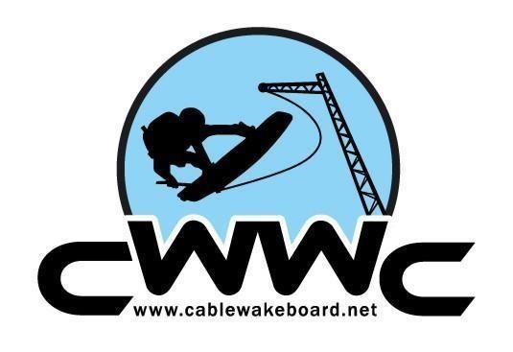
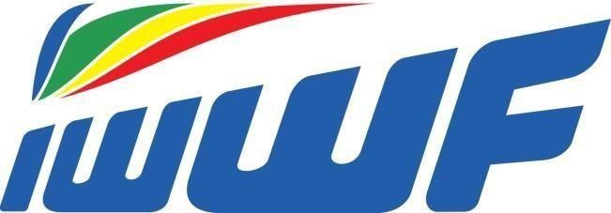
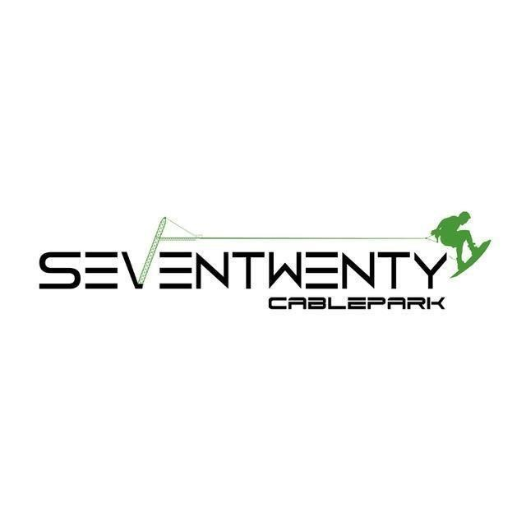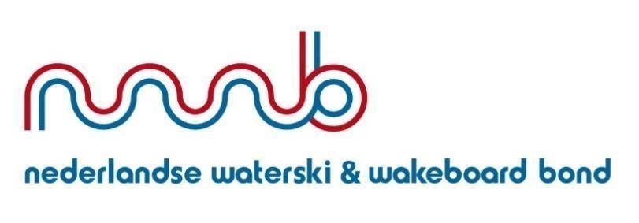
Dear Riders,

For the first time Seven-Twenty is organizing an international 3 star event at Seven-Twenty Cable park in Sevenum, the Netherlands. We invite you to come over and enjoy this ride with us!

With the permission of the International Waterski & Wakeboard Federation and the Netherlands Waterski & Wakeboard Federation, we invite you to:

INTERNATIONAL 3 STAR EVENT
CABLE WAKEBOARD
SEVEN-TWENTY CABLEPARK 17TH and 18TH JUNE 2017

Location:
Seven-Twenty Cable park
Middenpeelweg 5 5975 MZ Sevenum Netherlands
www.seven-twenty.nl
info@seven-twenty.nl
Accommodation:
For accommodation please check: www.deschatberg.nl

Organizer: Seven-Twenty Cable park
Contact: François and Cynthia 0031 (0)6-18488933 Information Cable park: Seven-Twenty Cable park
Middenpeelweg 5
5975 MZ Sevenum Netherlands
www.seven-twenty.nl
info@seven-twenty.nl
Transport: | Nearest airport is:  Flughafen Weeze Airport Eindhoven  Flughafenring 1 Luchthavenweg 25  47652 Weeze Duitsland 5657 EA Eindhoven  Approx..60 kilometer of  Sevenum Netherlands
Type competition: | International 3-star event (400 points)
Official Panel: | Chief Judge: Sebastiaan Huizinga
Event: | The event is planned on Saturday 17th June. However when there is a lot of participation the event will be split into two days. Please keep an eye on our Facebook for updated news!
 | www.facebook.com/720cable
Training: | On the 15th of June the cable will be available from 11:00 -13:00 pm, and on the 16th of June from 12:00 -13:00 pm for free training. On the 16th of June with discount for only E10,- from 19:00 - 21:00pm.
Obstacles: | At this point we have 5 obstacles at our cableway. We have an inside fun box, an outside large kicker. Outside tube, inside slider and an inside medium kicker.

Disciplines &
Categories: All wakeboard categories with a minimum of 3 riders

Boys and Girls Your year of birth must be 2002 or later.
Minimum age that you can enter Boys/Girls category is aged 11.

Junior Men/Junior
Ladies Your year of birth must be 1998 or later.

Open Men/Open Ladies No age restriction.

Masters Men/Ladies Your year of birth must be 1986 or before.
Veterans Men/Ladies Your year of birth must be 1976 or before.

Rules:
This competition will confirm to the rules of the IWWF Cable Wakeboard World council. Wearing a well fitted helmed and lifejacket is required during this contest.

The complete rules can be found here: http://www.cablewakeboard.net/news/59.html

Prizes: International Ranking Points
This Competition is the 3 star event with 400 Ranking Points for the first place, which form part of your Ranking Points for International Titled Events.

Register/entry:
For the payment of this event there will be an link when you can subscribe.
The fee is € 45,-

Dutch riders can enter via http://reg.seven-twenty.nl
Riders can only enter as members of the Netherlands Waterski & Wakeboard Federation.
Your entry online will not include the international wakeboard license of € 10,--. For questions about the international wakeboard license mail wendy@nwwb.nl. Without an internationaal wakeboard license you will not be able to participate!

You also need to register via Cablewakeboard.net http://myzone.cablewakeboard.net Without a registration on Cablewakeboard.net your ranking points will not be registered at the end of the competition and you will not be able to participate.

With the entry on www.nwwb.nl you automatically comply to the form “Declaration of participants in competitions” You will find a copy of the document with the entry on www.nwwb.nl and in this bulletin.

International riders can enter via Cablewakeboard.net and http://reg.seven-twenty.nl

The last date for entry will be closed on Friday the 9th of june. Please make sure to enter before this date to ensure your place in the competition.

A rider who misses his or her start or run without a valid reason will not be permitted to start again and will not receive any payments in return.

BBQ: The BBQ is on Saturday evening after the competition and is scheduled around 7 pm. Payment can do simultaneously with registry and entry.

About the Cablepark: Clockwise cable way
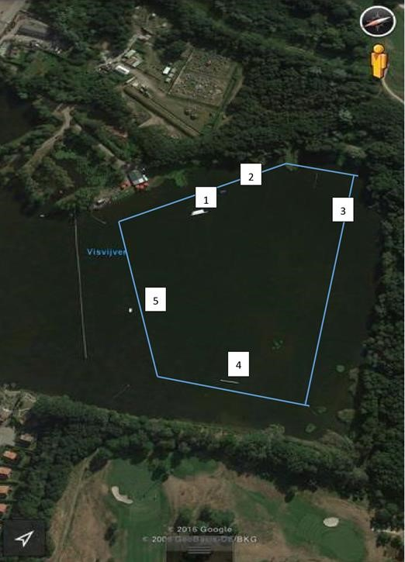

1. INSIDE FUNBOX 2. OUTSIDE LARGE KICKER
3. OUTSIDE TUBE 4. INSIDE SLIDER
5. INSIDE MEDIUM KICKER
Provisional Schedule: This will be updated with more detailed times once entries have been received.

Preliminary schedule:
Training
15th of june 11:00 -13:00 pm,
16th of june 12:00 -13:00 pm
16th of June for free training. with discount for only E8,- from 19:00-21:00 pm.

Riders Briefing: 9:30 am 17-06-2017

Time Table: 10:00 am Girls
(Pre schedule Saturday) 10:30 am Boys
11:00 am Junior Ladies
11:30 am Junior Men
12:30 pm Open Women
13:00 pm Open Men
13:30 pm Masters Ladies
14:00 pm Masters Men
15:00 pm Finals
18:00 pm Party en BBQ

REMEMBER
The deadline for entry form is 5pm 9st June 2017 - NO late entries will be accepted.

We hope to see you the 17th of june at Sevenum!
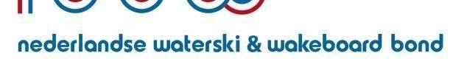
Dutch Waterski & Wakeboard Federation
Postbus 2271
2002 CG HAARLEM backoffice@nwwb.nl www.nwwb.nl

Declaration of participants in competitions.

- I declare that the data filled in at my registration and on the General contest roster are correct. I declare me to comply with the regulations of my country, of the Dutch Waterski Federation & wakeboard Federation and of the competition. The organizers, the National Federation, the NWWB and their delegates are not responsible for any fact, incident or accident happen to you on the occasion of a match. I declare no job to do on the Court for
any dispute arising from match incidents, the full right to decide at the arranging Committeebased.

- Participants, referees and officials who participate in competitions under the auspices of the NWWB recognize the competition rules of the NWWB and the Technical Rules and the additional Rules of the IWWF and the E&A and adhere to the doping regulations of the ISR and submit to rules and the sanctions laid down therein.

- The organizing TC/Association/cable car is t.o.v. participants are not responsible for material, personal or consequential damages. The contest participants take part in the competition at their own risk. The participant is aware of the risks of water skiing/wakeboarding behind the boat or on a cable car. The athlete accepts these risks itself. The undersigned sees with participation in the contest from all liability claims that in conjunction with this damage be incurred in respect of the cause or the organizing Association/course screwdriver.

- The participants on the order of the Organizer undertakes certain advertising on clothing or on other materials. The participant agrees that what is awarded to advertising on clothing or materials during the match.

- The participant undertakes, set start money to pay and accept that the deposited nonrefundable entry fee if the participant does not start ... or is disqualified by the jury of participation.

By entry via www.nwwb.nl you will automatically agree to this declaration.

Route Description Seven-Twenty Cablepark

By car coming from the direction of Zwolle:
A28 direction Utrecht. Take the A50 toward Nijmegen. Then the A73 in the direction of Venlo. At the Zaarderheiken junction in the direction of Eindhoven (A67). Then exit (No. 38) to Helden/Ysselsteyn. At the bottom of this exit turn right.
- On the roundabout turn left. You are now driving on the driveway of Landal Domain the Schatberg.

Coming from the direction Utrecht/Eindhoven:
A2 direction Eindhoven. Then take the A67 towards Venlo. Then exit (No. 38) to Helden/Ysselsteyn. At the bottom of this exit, turn left.
- On the roundabout turn left. You are now driving on the driveway of Landal Domain the Schatberg.

Coming from the direction of Maastricht:
A2 direction Eindhoven, exit (No. 41) direction Venlo (N273). Then left the N277 on towards Venray/Eindhoven. After 10 km you will pass the A67 (viaduct).
- On the roundabout turn left. You are now driving on the driveway of Landal Domain the Schatberg.

Park cars
You park on the central parking lot of Landal Domain the Schatberg. From there it is a 5-minute walk to Seven-Twenty Cable park.

Public transport the nearest train station is Horst-Sevenum. Here take bus number 65. The bus stop is directly in front of the park. From here the route to Seven-Twenty Cable park designated.

