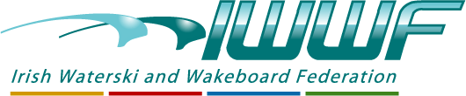

In association with

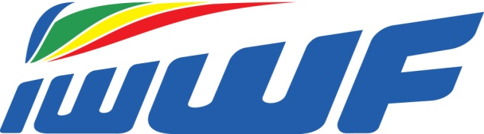 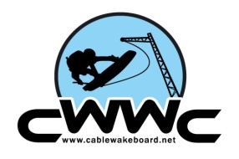

presents

### 2016 Cable Judging Seminar

### Bulletin.

### The Irish Waterski and Wakeboard Federation are proud to deliver Irelands First Ever Cable Judging Seminar.

### Venue: Morans Red Cow Hotel, Naas Road, Dublin

### Date: 5th and 6th November 2016

### Time: 9am both days

### Instructor: Norman Frank ( Ger)

### Facilitator: Paul Carroll, Irish WWF

### Contact: [paul.g.carroll@outlook.com](mailto:paul.g.carroll@outlook.com)

### 00 353 86 8281565

### Cost: €50 ( affiliated club members)

### €150 to non affiliated participants

### Payable on arrival

### Accommodation: There are several hotels of varying value on the Naas Road and further afield, There is a Conference rate available in The Red Cow, mention you are attending the event and the rate will be applied.

### This Seminar will be delivered in accordance with the Cable Wakeboard World Rules 2016, these are available on Cablewakeboard.net and are essential reading for each attendee as the exam will contain questions on the Rules.

### The course is limited to 15 participants and is on a first registered basis.

### To register please e mail Paul Carroll on above address and register on Cablewakeboard.net and join the competition ( The seminar is posted as a competition on the site)

### Each person registered will be sent necessary links, schedule and all other relevant information.

### A Preliminary Schedule is available on Irish Waterski and Wakeboard Facebook Page or on request a copy will be sent to you.

### This is a great opportunity for Riders, Cable Operators and Coaches alike to learn from an International Expert and qualify as a IWWF Official.