**Wakeboard Club**

w a k e b o a r d c l u b

w a k e b o a r d c l u b

**National 2 Star Tel - Aviv Cup**

**05/08/2016 LAKE TLV**

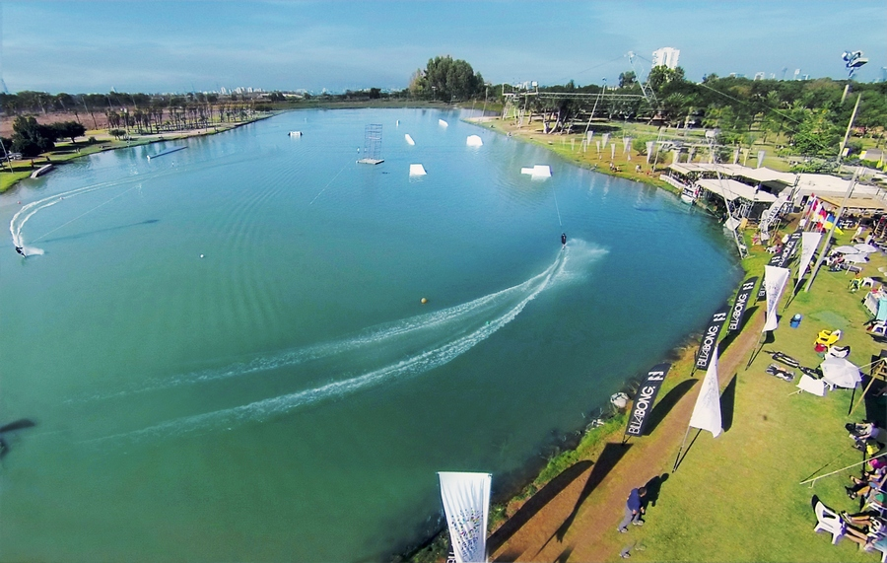

The National 2 Star Tel-Aviv Cup Open will take place on 05 August In LAKE TLV Park Begin , Tel-Aviv ,

Israel.

1. **Location**

Park Begin Tel-Aviv , LAKE TLV Located 15 minutes drive from Ben Gurion International

Airport and only 10 Minutes from the Beach.

1. **Organizer**

Israel water ski Federation and The Wakeboard Club LAKE TLV .

Tel: +972-52-3838583 Maoz Tal . Tel : +972-3-7391168 Cable ski and Wakeboard Center Tel-Aviv

1. **Cable**

2013 New Rixen Instalation 5 Masts

Height: 11m

Length: 770m

1. **Entry Requirement Registration**

Please Register online at [www.cablewakeboard.net](http://www.cablewakeboard.net) for the competition

Riders must Register before 04 August.

1. **Conditions**

The Competition will be carried out according to the IWWF Cable Wakeboard World Council rules of 2016.

A full copy of the rules can be found at : [www.cablewakeboard.net](http://www.cablewakeboard.net) .

1. **Category Wakeboard**

U 15 , U 19 Boys / Girls / Junior Men & Junior Ladies , Open Men , Open Ladies and Masters.

1. **Category Wakeskate**

Juniors U19 , Open Men & Open Ladies

1. **License / IWWF Membership**

All riders should be current member of their respective country's IWWF Affiliated Federation.

In Addition , entrants from EAME should have the EAME International Wakeboard License (National Federations register their riders license online).

1. **Entry Fee**

The Entry Fee is 10 Euro Per Competitor. (No Additional fee for riders who take part in both categories) .

The Riders registration will take place at the office of LAKE TLV Site.

**Official Practice**

Your official practice will be on Friday 05/08 15:00 – 16:00

1. **Time Schedule**

Friday 05/08 :  
 16:00-18:00 Qualifications all Categories .

18:00 – 20:00 Finals all Categories

**13. Accommodation , Please Contact the Organizer .**



**6**

**5**

**4**

**3**

**1.1**



**7**

**2**

**LAKE TLV & THE ISRAELI WATER SKI FEDERATION**