Dear Riders,

It’s a pleasure for us to announce the 2016 BRITISH NATIONALS at Sheffield Cable Waterski.

With permission of the British Waterski & Wakeboard Federation (BWSW) and the International Waterski and Wakeboard Federation (IWWF) & Sheffield Cable Waterski(SCW) We invite you to the:

GB CABLE NATIONALS
On July 22nd & 23rd 2016
Cable/Location:
Sheffield Cable Waterski,
Rother Valley Country Park,
Mansfield Road,
Wales Bar,
Sheffield,
S26 5PQ
Phone: 01142 511717
This first bulletin should give you an overview about the upcoming event and to help you to plan your trip to Sheffield. Bulletin 2 will be published on 8th July 2016 once the competition layout has been completed.

Finding Us

By Car:
You can access the cable ski either by parking inside Rother Valley Country Park or by parking outside the park and walking in. Rother Valley Country Park is two miles from Junction 31 of the M1 (well signposted, both north and southbound). Once in the park, we are located at the south end of the main watersports lake.
For pedestrian access to the site (parking outside the park) please use postcode S20 2RW and the access is on the roundabout at the top of Rother Valley Way. This is one of the easiest access points to use and is approx 10 mins walk to the cable ski (there are others inc. Forge Lane, Killamarsh).

Satalite Navigation Users:
Please note that when using our postcode S26 5PQ to park inside Rother Valley Country Park, Google (and Sat Nav Systems) will not direct you to the location shown on the map above. When you “reach your destination” it will be on Mansfield Road. You will need to continue along the road and take the turning for Rother Valley Country Park (follow the brown signs).

By Supertram:
Catch the tram indicating Halfway from Sheffield, get off the tram at the Westfield School stop near Direct Cars. From the tram stop the Park is a 1 mile walk. Walk towards Direct Cars from the tramstop, at the traffic lights and opposite Direct Cars turn left (leaving Direct Cars on your right) walk down Owlthorpe Greenway to the end to Grant and McAlin Cars. Turn left on Rother Valley Way, you will see a public right of way on the right towards Rother Valley Country Park follow the signs into the park. For further information on the supertram Tel. 0114 2728282 web site: www.supertram.com

By Bus:
See Travel South Yorkshire for up to date travel information. If you are travelling by bus from Sheffield City Centre you can catch a bus to Meadowgate Avenue, Sothall, the last stop is just outside the Sothall entrance to Rother Valley Country Park. Once in the park you will need to turn right and walk round the lake to the cable waterski but this should only take 10/15 mins. For more detail on bus travel see the Rother Valley Country Park website.

By Rail:
We are approximately 4 miles from Kiverton Bridge BR Station. It has a direct line to Sheffield station. From there we would advise getting a taxi into the park.
PLEASE BE AWARE THERE IS A £5 FEE PER CAR TO ENTER ROTHER VALLEY COUNTRY PARK, WHICH IS PAYABLE AT THE GATEHOUSE. THIS IS A FEE OUTSIDE OF OUR CONTROL AND GOES TO THE LOCAL COUNCIL.
Accommodation
We have a basic camp site for cable ski customers (please phone 01142 511717) for bookings. Alternatively, for hotels nearby, check HotelsCombined.

General information

Organizer: Sheffield Cable Waterski & BWSW

Contact: Andy Granger
07970 940293.

Cable park location: Sheffield Cable Waterski,
Rother Valley Country Park,
Mansfield Road,
Wales Bar,
Sheffield,
S26 5PQ
Phone: 01142 511717
https://www.sheffieldcablewaterski.com
Email: andy@sheffieldcablewaterski.com

Competition type: BRITISH CABLE WAKEBOARD NATIONALS
Awarded National & World Ranking 400 pts.

Competition date: 22nd -23rd July 2016

Trainings available: 3 hrs Free Practice for all categories. Friday 22nd July 9:00am-12:00 Noon.

Disciplines & categories: Wakeboard Men and Women: Minis, Juniors, Open, Masters, Veterans, Seated
Category minimum requirement is 3 riders

Rules: The competition will be carried out according to rules of the IWWF Cable Wakeboard World Council.
Please note that you have to wear a suitable helmet and vest in the wakeboard competition.
You will find full copy here: http://www.cablewakeboard.net/userfiles/file/pdf/IWWF_CWWC_Rules_2015,_vMay6_non%20marked.pdf

Ages:
Open to all ages.
Mini Boys and Girls | Your year of birth must be 2005 or later.
Boys and Girls | Your year of birth must be 2001 or later.
Junior Men/Junior Ladies | Your year of birth must be 1997 or later.
Open Men/Open Ladies | No age restriction.
Masters Men/Ladies | Your year of birth must be 1986 or before.
Veterans Men/Ladies | Your year of birth must be 1976 or before

Prizes: Medals will be awarded.

Entry fee includes: Free official Practice Riding & 1 Hog Roast meals (Saturday). Vegetarian options can be provided but only with advance notification.

Entry fee: £35
The entry fee must be paid latest by the closing date for entry of the competition, else the participant has to pay a late fee of £10.
Riders must be registered & paid by Friday 15th July 2016 5p.m. Registrations after this date will be considered as a late registration which inceases the fee to £45.
A riders who miss the start time of his/her run without a good reason will be not permited to start and will not be able to claim a refund of fees.
Online Entry Only: PLEASE ENTER VIA http://www.bwsw.org.uk/home/

Entry form available online from BWSW from 23rd June 2016.
Contact Belinda at BWSW on 01932 560007 if you have any difficulty entering.

Registration details: The competition is registered as a part of IWWF National & World Rankings.
Riders must have Competition license from their National federations.

As well as entering via BWSW, Riders must register through IWWF website on the competition home page: http://myzone.cablewakeboard.net/en/116/?sub=6&comp=1162 if you do not register on Cablewakeboard.net your ranking points will not be allocated to you on completion of the contest.

Riders must be registered before 15th July 2016 on www.cablewakeboard.net

Local Registration at Sheffield starts on Thursday 21st July at 10 a.m. until 5p.m. and on Friday 22nd July from 8 a.m. until 12:00 Noon

About Us
We are one of the most established full-size cable wake park’s in the UK. We are located in the picturesque setting of Rother Valley Country Park and offer cable kneeboarding, waterskiing and wakeboarding from beginner to advanced level. If you are new to waterskiing and wakeboarding and want to Learn, our friendly BWSW staff will be on hand to instruct and guide you, if you are an experienced cable rider you will love our extensive cable wake park stocked with 10 obstacles including kickers, wedges, sliders, funboxes, rooftop rail and wall ride.

Our Facilities
With great facilities on and off the water there is something for spectators and riders alike. We have a licensed bar overlooking the lake, a cafe serving hot and cold snacks and drinks (including freshly ground coffee) and an on site wakeboard pro shop www.tenfeethigh.com selling wakeboards and equipment.

Competition Course:

Sheffield existing layout – this is to be adjusted by 8th July in readiness for the Nationals. Look out for Bulletin 2
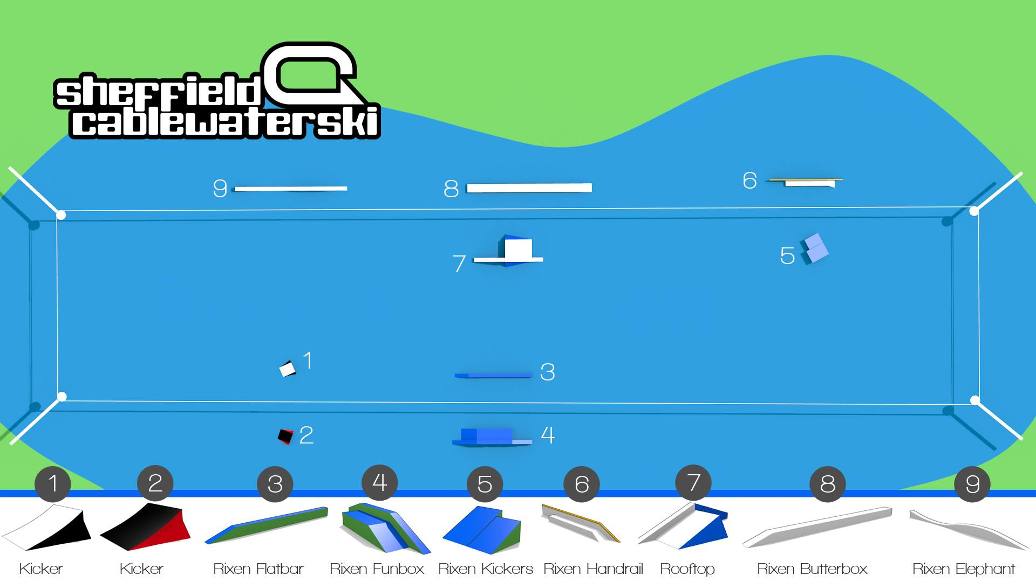

Competition Format:
The competition format is follows: (Times all subject to change once confirmed entries are available)

Official Practice Time: 3 hrs Free Practice for all categories. Friday 22nd July 9:00am-12:00 Noon.
Please ensure you arrive in time to practice. There is NO rider designated practice time, it is up to the individual to join the queue for Practice.
Outside of the free practice, you can book to ride the Competition Layout directly at Sheffield from the 8th July – 21st July

Friday 22nd July - Qualifiers: All Categories.

Friday / Saturday - LCQs: Relevant Categories

Saturday 23rd July - Finals

Each run will consist of 1Lap of the Course, there will be two runs (LCQ 1 run only), and your best run scores. Start and finish markers will be added to the diagram or ease of planning your run.
There should be a good mix of features and air tricks in your run.
:

Declaration, Waiver and Release Form

For, and in consideration of, the International Waterski & Wakeboard Federation (the IWWF) accepting my application, and permitting me, to participate and compete in the International registered cable wakeboard event (the International event), I, the undersigned, for and on behalf of myself, my heirs, executors and administrators, do hereby irrevocably and unconditionally warrant, represent and undertake to the IWWF as follows

Any and all information provided and/or disclosed by, or on behalf of, myself to the IWWF (including any officers, employees and representatives thereof) for the purpose of considering and evaluating my application for participation and competition in the International event is true, correct and accurate;

I have fully read and understood the rules and regulations of participation and competition in the International event (a copy of which has been made available to me) and I do hereby covenant with, and undertake to, the IWWF to at all times fully comply with, and abide by, the same;

I am in good physical and mental health and I am physically capable of competing and participating, and fully competent to participate and compete, as a competitor in the International event and that I have not been certified and/or advised otherwise by any qualified medical practitioner;

I do hereby authorise any and all physicians, paramedics and other medical personnel and practitioners procured by, or on behalf of, the IWWF to administer first aid treatment or any medical treatment, surgery or transportation in the event of any illness, accident or injury suffered and/or sustained by me at any time during my participation and competition in the International event (or any part thereof) and hereby indemnify, and shall keep fully and effectively indemnified, the IWWF (including all officers, employees and representatives thereof) upon demand from and against any and all claims, liabilities, demands, costs and expenses of whatsoever nature incurred and/or suffered by the same (or any of them) and arising from, and/or in connection with, the procurement and administration of such medical treatment and transportation in relation to any such illness accident or injury suffered and/or sustained by me;
I acknowledge, agree and confirm that participating and/or competing as a competitor in the International event (or any part thereof) involves inherent risks and dangers of accidents, personal and bodily injury and property loss or damage and that by signing and completing this Declaration, Waiver and Release Form, I fully understand and have considered and evaluated the nature, scope and extent of the risks involved, and voluntarily and freely choose to assume these risks;

I hereby grant to the IWWF (including its lawful successors and assigns) the sole and exclusive right and licence, in perpetuity and throughout the world and without any compensation whatsoever to me, to use, reproduce, publish and/or exploit, my name, nickname, likeness, image, logos, get-ups, initials, voice, slogan and signatures developed from time to time, reputation, graphical representation, electronic, animated or computer generated representation and any other representation (in any medium whatsoever), right of association, biographical information and other indicia, and any other right or property in my performances, in any media whatsoever, for any purposes whatsoever relating to, and/or in connection with, the IWWF and/or the International event (or any part thereof) and I shall do all such things (including, without limitation, the execution of appropriate legal documentation) as the IWWF may, from time to time, require to give legal and binding effect to the aforementioned grant of rights;

I irrevocably acknowledge, agree and confirm that the IWWF reserves the right, at its sole and absolute discretion, to disqualify me from participation and/or competition in the International event (or any part thereof) if I am in breach of any of the warranties, representations and/or undertakings set out in this Declaration, Waiver and Release Form and/or for any reason whatsoever the IWWF considers just and proper, and in the event of any such disqualification, I shall not be entitled to any compensation of any nature whatsoever from the IWWF.

I hereby release, hold harmless, protect, indemnify and forever discharge the IWWF (including its officers, employees and representatives), the International event and all commercial partners thereof, from and against any and all claims, demands, liabilities, costs and expenses of any nature whatsoever, whether direct or consequential, suffered and/or incurred by the IWWF (including its officers, employees and representatives), the International event and/or all commercial partners thereof and arising from, and/or in connection with:

Any breach of any of the warranties, representations and/or undertakings given by me as set out hereunder; and/or my participation and/or competition in the International event (or any part thereof).
Declaration

I, (the Competitor), do hereby declare that I have read and fully understood the terms and conditions of this Declaration, Waiver and Release Form and that I have had the opportunity to discuss the same with my parent / guardian and that I agree to be bound by the said terms and conditions of the above agreement with the IWWF.

Cable Wakeboard Nationals 2016

Declaration of Parent / Guardian
(Applicable only if the Competitor is, on the date of signing the Declaration, Waiver and Release Form, under the age of 18 years)

I, the undersigned, am the parent / guardian* of (the Competitor) and I do hereby irrevocably and unconditionally:

1 warrant, represent and undertake to the IWWF that I have read and fully understood the terms and conditions of the Declaration, Waiver and Release Form and have discussed with, and explained such terms and conditions to, the Competitor and I agree to, and will cause the Competitor to fully abide by, and comply with, all of the terms and conditions of the Declaration, Waiver and Release Form; and

2 covenant with, and undertake to, the IWWF not to take, nor permit to be taken, any action(s) nor omit to do anything that would assist or cause the Competitor to invalidate, renounce, negate, revoke or disclaim any part of the Declaration, Waiver and Release Form, and

3 warrant, represent and undertake to the IWWF that by signing the Declaration, Waiver and Release Form, neither the Competitor and/or myself is/are in breach of any other arrangement(s) (whether contractual or otherwise) with any third party, and

4 agree to be liable for, and will indemnify the IWWF (including its officers, employees and representatives), the International event and all commercial partners thereof from and against, any and all claims, demands, liability, loss, damages, costs, and expenses of any nature whatsoever, whether direct or consequential, suffered and/or incurred by the IWWF, the International event and all commercial partners thereof, whether direct or consequential, any arising from, and/or in connection with:

(a) any breach of any of the warranties, representations and/or undertakings given by the Competitor in the Declaration, Waiver and
Release Form; and/or
(b) the Competitor’s participation and/or competition in the International event (or any part thereof).

Signature

Name of Parent / Guardian*: Date:

Signed in the presence of: Witness:
Name: Address: Occupation:

* Delete as appropriate

