Israel National Open Wakeboard & Wakeskate Championships

w a k e b o a r d c l u b

w a k e b o a r d c l u b
14/11/2015 LAKE TLV
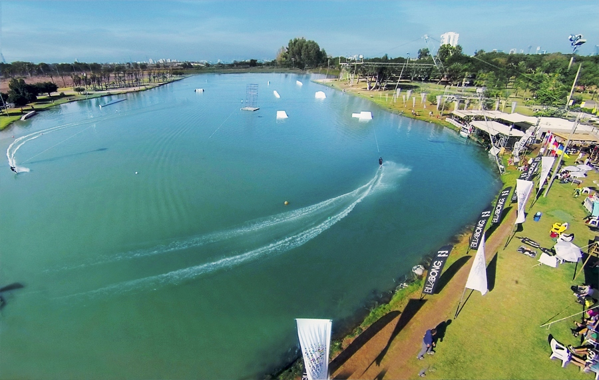
- Location
Park Begin Tel-Aviv , LAKE TLV Located 15 Minutes drive from Ben Gurion International
Airport and only 10 Minutes from the Beach.
- Organizer
Israel water ski Federation and The Wakeboard Club LAKE TLV . . http://laketlv.co.il/
Tel: +972-52-3838583 Maoz Tal . Tel : +972-3-7391168 Cable ski and Wakeboard Center Tel-Aviv
- Cable
2013 New Rixen Installation 5 Masts
Height: 10.2m
Length: 770m
- Entry Requirement Registration
Please Register online at www.cablewakeboard.net for the competition
Riders must Register before 10.11.15
- Conditions
The Competition will be carried out according to the IWWF Cable Wakeboard rules
A full copy of the rules can be found at : www.cablewakeboard.net .
- Category Wakeboard
U 12 , U15 . U19 Open & Over 30 (Masters)

- Category Wakeskate
U15 . U19 Open

- License / IWWF Membership
All riders should be current member of their respective country's IWWF Affiliated Federation.
In Addition , entrants from EAME should have the EAME International Wakeboard License (National Federations register their riders license online).
- Entry Fee
The Entry Fee is 30Euro Per Competitor. (No Additional fee for riders who take part in both categories) .
. The Riders registration will take place at the office of LAKE TLV Site . Thursday 16:00 – 18:00 .

- Official Practice
Your official practice will be on Friday 08:00 – 11:00
- Competition Time Schedule
Saturday 14th November :
11:00 – 14:00 Qualifications all Categories
14:00 – 16:00 – finals
- Time Change
Israel is one hour ahead from CET . 2 Hours ahead from UK Time.

- Mains Electricity
Voltage : 220V
Primary Socket Type: Euro Plug .

- Accommodation :
Hotel Armon Hayarkon , lockated in Tel-Aviv Beach. http://www.armon-hotel.com/
Price per night for Double Room include Breakfast = 105Euro
Price per night for Single Room include Breakfast = 90Euro
For Reservation please contact :
maoztal@012.net.il As soon as possible to ensure rooms in this hotel but no
Later than 01th October.
Type of Room: Single/ Double | Airline and Flight No | Departure Time | Airline and Flight no. | Arrival date and time | Name of Person

15. The Organizer will provide Transportation from the Airport and Back free of Charge .
16. Visa to Israel
In the link below you´ll find all details about who and how.
http://bifd2013.technion.ac.il/VisaRequirements.pdf
- Safety
All riders must wear an approved life vest and a helmet in the course at all times.
All participants ride at their own risk.
No Aluminum fins allowed.

6
5
4
3
1.1

- Obstacles Plan
7
2

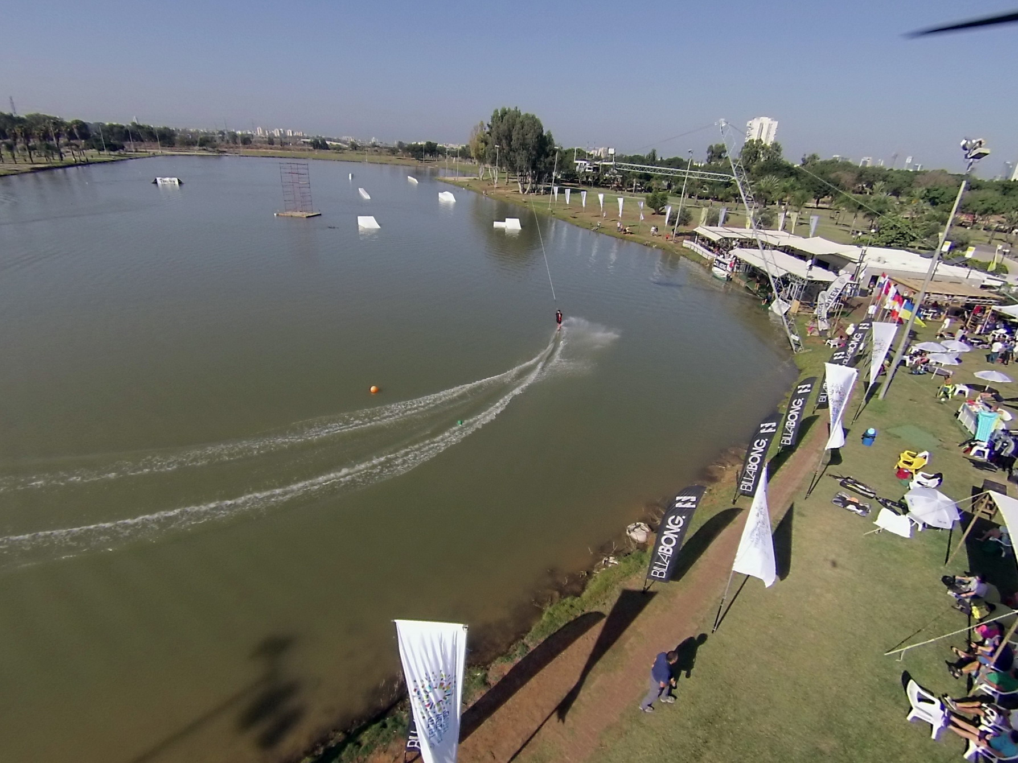

LOOKING FORWARD TO SEE YOU IN ISRAEL

