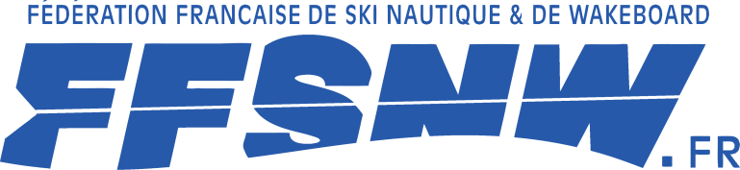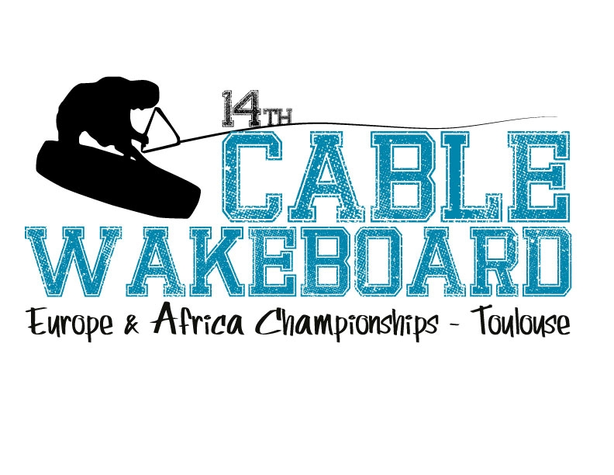
to : eurocable2012@ffsnw.fr

The ................................................................................................................ Federation intends to participate in the IWWF Cable Wakeboard Europe-Africa Championships 2012 in Toulouse (France).

Our team will consist of (number of people):

Category | Wakeboard | Wakeskate
Boys
Girls
Junior Men
Junior Ladies
Open Men
Open Ladies
Masters Men
Masters Ladies
Veterans Men
Veterans Ladies
Officials (ie Team Captain/Coach)

Team Captain
Name: |  | Telephone:
Address: |  | E-Mail:

Date of your arrival: |  | Date of your departure:

The National Federation confirms that all athletes entered by us into these European Championships are aware of, and agree to be bound by, the provisions of the IWWF Anti-Doping Rules, including but not limited to, all amendments to the Anti-Doping Rules and all International Standards incorporated in the Anti-Doping Rules.

Signature of Federation Representative:

Date:

