Cable Ties Wake Open

Just Wake, Tattershall, Lincolnshire, LN4 4LR, United Kingdom

SAT 22nd & SUN 23rd SEPTEMBER 2018

3 Star International Competition

part of CWWC World Ranking

BULLETIN NUMBER 1

International Waterski & Wakeboard Federation &
British Waterski & Wakeboard

Organiser | Just Wake & British Waterski and Wakeboard  Contact: Suzi Nightingale  Email: Suzi@justwake.co.uk
CWWC Ranking | International Waterski & Wakeboard Federation  Confederation: E&A  Contact: info@cablewakeboard.net  Website: www.cablewakeboard.net
Location | Just Wake,  Tattershall Lakes Country Park  Tattershall  Lincs  LN4 4LR  Tel: 07812 712255  Email: enquiries@justwake.co.uk
Transport | Nearest Airports: (all via Car)  Robin Hood Airport (Doncaster) – 1hr 15 – 60 miles  East Midlands Airport – 1hr 30mins – 65 miles  Luton Airport – 2hrs 20mins – 117miles  Stanstead Airport – 2-3hrs – 117 miles  ROBIN HOOD (DSA) is usually the easiest and cheapest airport  to fly in and out from mainland Europe  Tattershall is not accessible by Train or bus, we will happily collect  any riders from Doncaster airport & collection to and from both Grantham and Newark Train Stations, if you send over your details and arrange with us in advance.  Car hire will be necessary from any other airport.
Rules | The competition will be run in accordance with the IWWF Cable  Wakeboard World Rule Book
Cable | 9m height, Sesitec System 2.0 Straight Line Cable
Categories | All IWWF International Categories with a minimum of 3 Riders, any riders in categories with less than 3 riders will be merged into the  next appropriate age category (ride up).  With the exception of the OPEN DIVISION, as riders cannot be  merged into other categories.  Mini’s Category will also be run as a National 2 Star Event, on the  Smaller Cable.  The OPEN CATEGORY WILL BE SPLIT AS FOLLOWS:  Anyone wanting to compete for Prize Fund, will enter into the  PRO OPEN Category.  Anyone aged between 19-30 who wants to compete, but doesn’t want to  Compete for the prize fund or is a little intimidated by riding against  Pro riders, will enter the AMATEUR OPEN Category.  On Cablewakeboard.net – You will all enter the OPEN Category.  For ranking point purposes, the following will happen:  All riders scores will be merged into one overall file.  The winners of the Pro Category, will received the full 400 points  Going down the ranking, once all the PRO riders have been  Awarded the ranking points, the amateur riders will then collect  The next points.  Eg. If we have 10 Riders in total across both categories, (5 Pro, 5 Amateur, then positions & points 1-5 will go to the Pro Riders, 6-10 will go to the Amateur riders)
Entry & Costs | The closing date for Entries is SUNDAY 16th September 2018  £35 For Boys/Girls/Junior& Open Categories  £20 For Minis Category  You must have completed the Just Wake Entry form and paid for your  entry to be included in the competition.  Entry on Cable Wakeboard.net must be completed in advance to allow  the start lists to be completed.  Entry forms can be completed online in reception at Just Wake, or can be accessed directly on line on the following link  https://justwake.formstack.com/forms/cable_ties_entry_form  All entrants must join the competition on cablewakeboard.net at:  AGE CATEGORIES  http://myzone.cablewakeboard.net/en/116/?sub=6&comp=1756  OPEN COMPETITION AT:  http://myzone.cablewakeboard.net/en/116/?sub=6&comp=1752  MINI’s UNDER 11 COMPETITION AT:  http://myzone.cablewakeboard.net/en/116/?sub=6&comp=1755  Riders can enter an AGE CATEGORY Competition and the OPEN Competition  But the Entry Fee will be charged per competition.  Children who have not yet reached their 11th Birthday cannot enter the International Competition, and can only enter the Mini Competition. These categories will run regardless of number of entries (ie NO MINIMUM numbers)
Registration | As this is an INTERNATIONAL COMPETITION – Passports must be shown on registration, as Nationalities have to be checked.  REGISTRATION WILL TAKE PLACE BETWEEN:  17:00 – 18:00 on Friday 21st September in Reception at Just Wake  9:00 – 12:00 On Saturday 22nd September during Official Practice.  You will not be allowed to practice until your registration is  Complete & you have collected your wristband from reception.
Accommodation | TATTERSHALL LAKES COUNTRY PARK  Camping, Caravan & Lodge Hire +44 01526 348800  Tattershall Lakes Holiday Park (Click on the link to get on the site)  If you book early – then take advantage of this fabulous offer!  Please ensure you have booked into site before arrival. You cannot just park up near Just Wake, as we are part of a busy Country Park and all competitors wishing to stay on site, must book in.
OFFICIALS PANEL | Chief Judge: Sebastiaan Huizinga  Scorer: Suzi Nightingale  Judge: Simone Sivieri  Judge: TBC  Judge: TBC
OFFICIALS SEMINAR | We are looking to run an officials seminar on Friday 21st September.  10am Start.  Maximum of 6 places. Please ensure you book into the seminar.  All attending the seminar will be expected to take part in Judging  Elements of the competition as part of the seminar exam.  Refreshments will be provided for the seminar.  Cost £15pp

PRIZE FUND
The TOTAL PRIZE FUND is £3500 (GBP)

This will be split across the
OPEN PRO CATEGORY ONLY
(See above details on how the categories will be split)

THE PRIZE FUND WILL BE SPLIT DOWN ACROSS THE NUMBER OF RIDERS ENTERED IN THE CATEGORY.

E.G – 10 RIDERS ACROSS LADIES & MEN

£3500/10 RIDERS
This fund will then be split across the number of riders in each group.

5 Men, 5 Ladies, then the split 50/50 across Ladies and Men.
6 Men, 4 Ladies, then the split 60/40 across Ladies and Men.

It will then be distributed as follows:

60% - 1St Place
30% - 2nd Place
10% - 3rd Place

All other categories will receive our unique Medals and Trophies, all competitors will receive a small gift bag for supporting us.
The prize money will be paid in CASH at the Prize Giving

PROVISIONAL SCHEDULE

This will be updated after the 16th September closing date once we know how many competitors have entered, PLEASE CHECK THE UPDATED TIMETABLES before travelling.

Registration Times: Friday 21st September 17:00 – 18:00
Saturday 22nd September. 09:00 – 12:00

Official Practice (Included in Entry Fee) Saturday 22nd Sept 09:00 – 14:00

Riders Meeting Saturday 22nd Sept 14:15

Qualification Rounds Saturday 22nd Sept 14:30 – Late

Finals Sunday 23rd Sept 10:00 – Finish

The Course
Our beautiful Park opened in the summer of 2012, has attracted many riders due to its fabulous location. We have hosted a number of competitions to date, this is our 4th CABLE TIES Event.
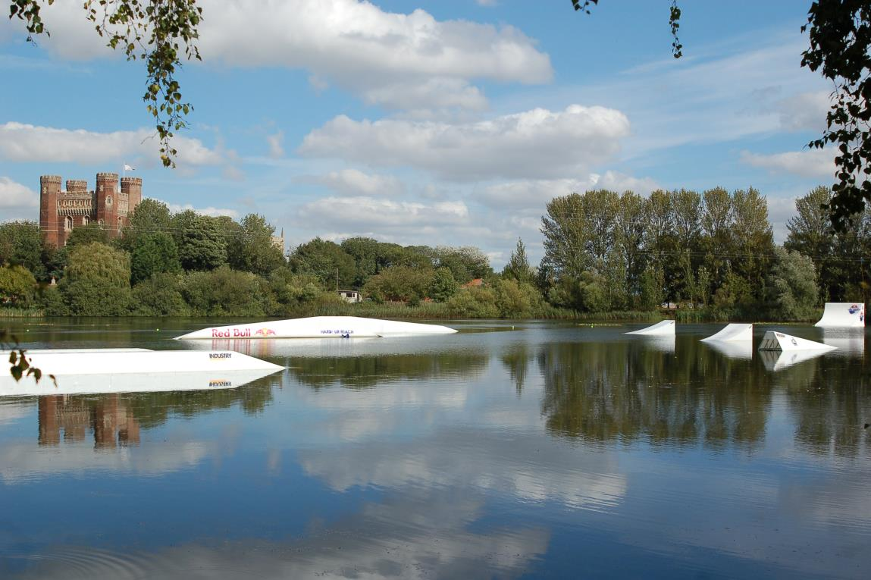

The final Course Layout is as follows:
The INT competition will run on ‘CABLE A’ our more advanced Cable System.
The MINI’s Competition will run on ‘CABLE B’ our smaller cable system.

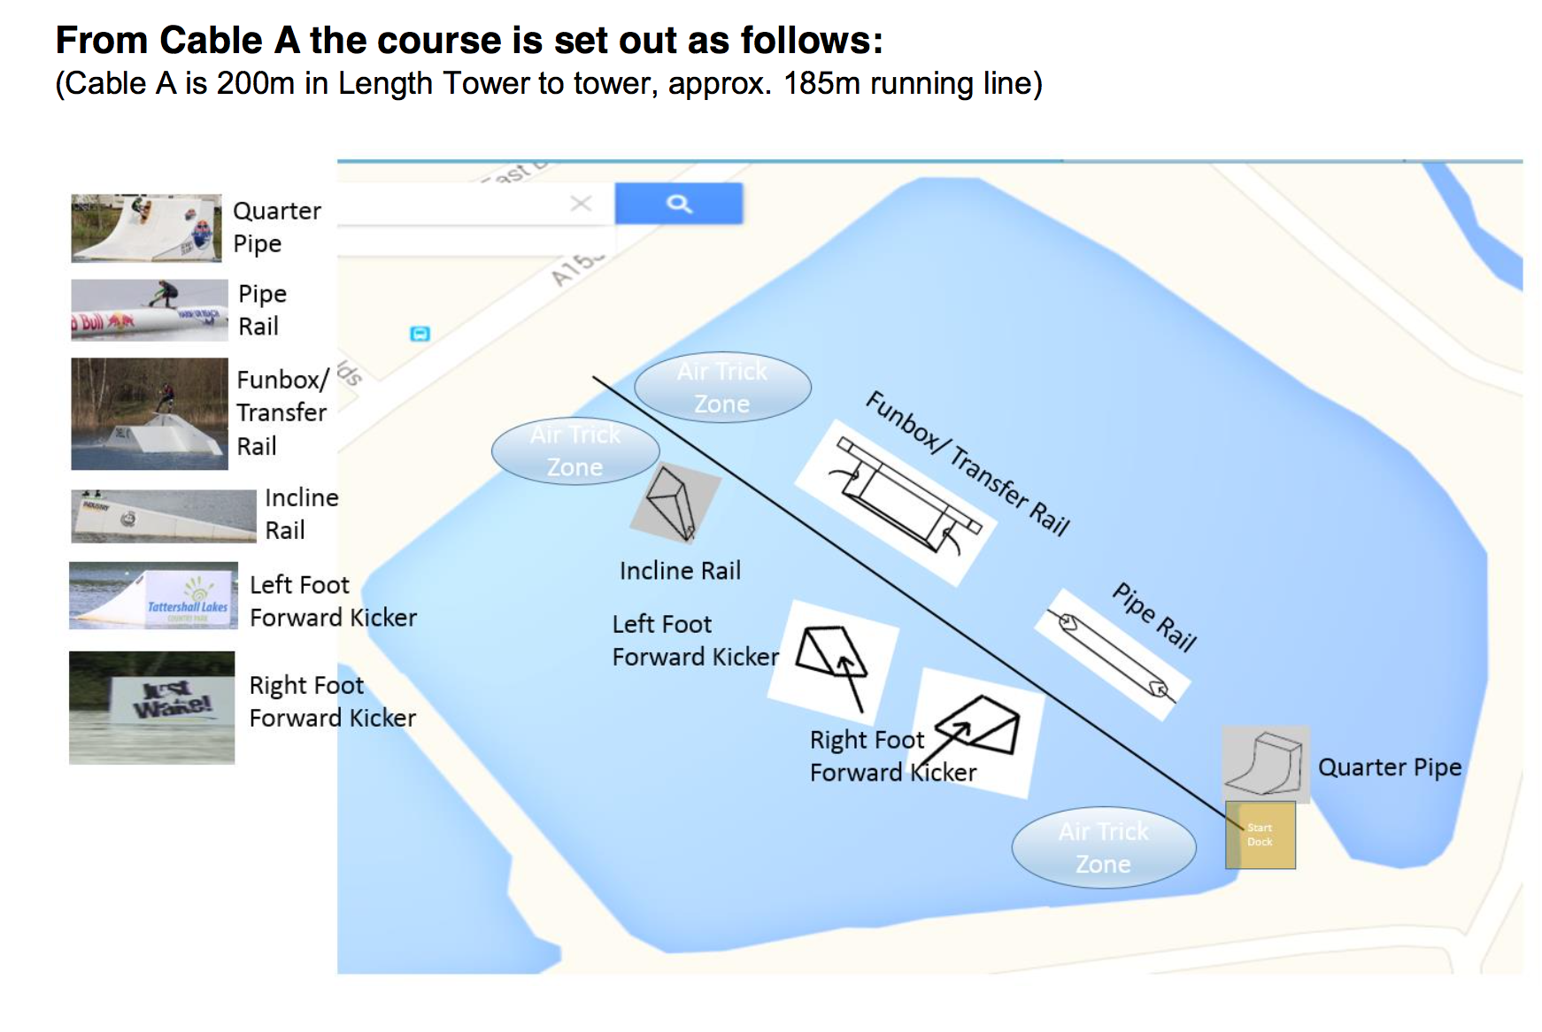
The format of the competition is as follows:
- The competition is to be run in line with the IWWF Rules 2018, the below items are specific to running this competition on a STRAIGHT LINE CABLE, and highlights some of the key differences between the Cableways.
- A run will consist of 2 Passes of the Cable, a complete pass is 1 run and back. If you choose to include the Quarter Pipe in your run, this can only be hit in between Passes 1 &2, You are NOT Allowed to Finish your run using the Quarter Pipe.
- Air Tricks can be performed either Right Foot Forward or Left Foot Forward, but may involve missing an obstacle to complete. (Left Foot Forward may require you to miss the Incline Rail, Right Foot Forward may require you to miss the Pipe Rail) Please be aware of this when planning your runs.

- Air Tricks must NOT be performed between the Pipe and the Quarter Pipe coming down back towards the start dock.
- Air Tricks must not be performed on the Corner, they must be performed before you reach the corner.
- You can pick the speed that you will be driven on, this will then be held for the full duration of your run and the driver will not change the speed during your run.
- Corners will be driven safely by the Cable Operator, but the operator will not be able to assist you around the corner.
- There are No Falls or Picks up. If you fall during your run, you must move out of the competition run as quickly as possible to allow the competition to continue.
- There will be 2 Runs for each qualifier, No LCQs, and 2 Runs in each final.
- Finals will be a maximum of 6 Riders.

For those of you who have never been on the Park before, below is a map of Tattershall Lakes. Just Wake is on the Castle Lake.

To arrive at Just Wake you need to turn Left at the mini roundabout just after the Main Guest Services check-in, follow the road around and you will come to us.

We look forward to seeing you at Cable Ties, if you have any questions please call 07812 712255 and ask for Suzi.

