In order and with permission of the Austrian Waterski and Wakeboard Federation (ÖWWV), the Austrian Federal Sports Organisation (BSO) and the International Waterski and Wakeboard Federation (IWWF), Wakebase Schwarzlsee invites you to the:
Corona Wakeboard Cup - Wakebase Open 2018
International 2 Star Cable Wakeboard Competition
May 26th, 2018 - 200 Worldranking Points

Location: Wakebase Schwarzlsee, Thalerhofstrasse 85, 8141 Premstätten
Competition Date: 26. May 2018
Organizer: ÖWWV
Local Club: WBC Schwarzlsee
Contact: Stefan Lebwohl
Phone: 0660 669 8 669
Mail: office@wakebase.at
Competition type: IWWF 2-Star International Competition – 200 World Ranking
Qualification: The contest is open for national and international athletes with an international Rider licence. IWWF is providing these licences for free to the national federations. Competition Page with all Information and Results on: http://www.cablewakeboard.net
Rules: The contest will be held in accordance to the international CWWC rules of the IWWF (Int2/DC/200 Points)
Click the following link to find a full copy: http://www.cablewakeboard.net/userfiles/IWWF_CWWC_Rules_2017.pdf

Cable: Rixen 5-pylon system
Judges: • Chief Judge: Manuel Dolzer AUT
• Judge 2: Stefan Lebwohl AUT
• Judge 3: tbc
• Calculator: Michael Murg AUT

Obstacles: • inside Taxi 20 meters
• outside Unit straight Slider 18 meters
• outside Kicker 1,5 meters high
• outside Kicker 1,15 meters high
• outside Shape Kicker L
• inside Shape Kicker M
• outside multilevel Fundbox 25 meters
• inside Shape triple kinked Steel Rail
• outside Table 20 meters
For further informations about the feature plan go to our website:
www.wakebase.at

Registration: Only on www.cablewakeboard.net
The competition is registered as a part of CWWC World Rankings. Riders must have IWWF license from their National federations. Riders register via IWWF website on the competition home page: http://myzone.cablewakeboard.net/en/116/?sub=3
Riders must be registered before May 23rd, 2018 on cablewakeboard.net
Local Registration at Wakebase Cable starts on Friday 25th of September 2018 at 17:00 and ends at 20:00.
You will only be on the starting list when you or somebody pays your Entry Fee till Saturday 08:30.

Categories:
Wakeboard:
Boys & Girls: 2003 or later (under 15)
Junior Men & Junior Ladies: 1999, 2000, 2001, 2002 (under 19)
Open Men & Open Ladies: no age restriction
Masters Men & Masters Ladies: 1987 or before (over 30)
Veterans Men: 1977 (over 40)
Wakeskate: Open class – no age restriction
Mini Kids Wakeboard (under 11):
Separate Competition Format (no international ranking points)
In case of less than 3 registrated riders in one categorie, they will be put together with the next categorie above. This will be discussed with the chief judge.
Entry fee:
Open Men / Open Women / Masters / Wakeskate: 35 €
Boys / Girls / Junior Men / Junior Ladies: 30€
For every additional category: 10€
Late registration: 45€
Entry fee includes Official training & Late comers training
Provisional Schedule:
Friday 25. May 2018
• 16.30 - 19.00 Public Riding
• 18.00 - 20.00 Official Training (with competition ropes)
Saturday 26. May 2018
• 8.00 - 9.00 Late comers training
• 9.30 - 10.00 Riders Meeting
• 10.00 Start Competition with Qualification in all categories
• 15.00 Finals all age categories
Final schedule will be provided one day before the competition.
Saftey:
Please note that you have to wear a suitable helmet and a vest in the
wakeboard & wakeskate competition. Participation is at your own risk
How to get there:
Adress: Thalerhofstraße 85, 8141 Unterpremstätten / Austria

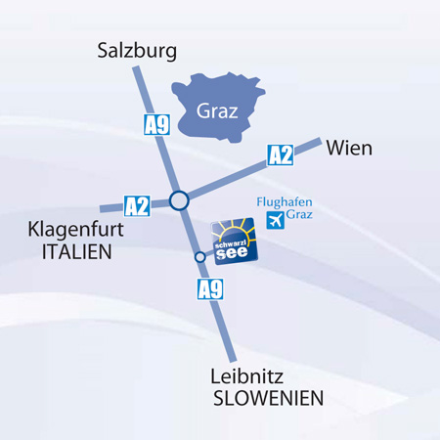
A9 Exit 192 Schachenwald
Google Earth: https://www.google.at/maps/place/ Schwarzlsee/@46.9829323,15.4173542,15z/data=!4m8!1m…

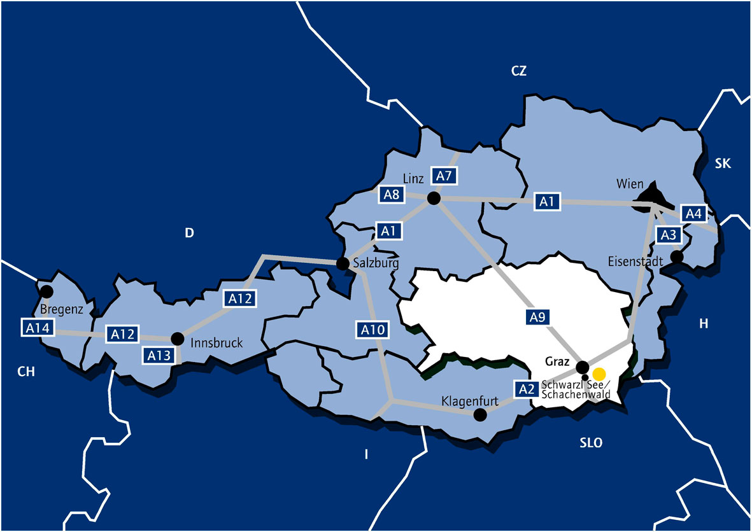

Accomodation
- Camping on the lakeside:
Please contact Tel: +43 (0) 3135 53577 - 0
E-Mail: information@schwarzlsee.at
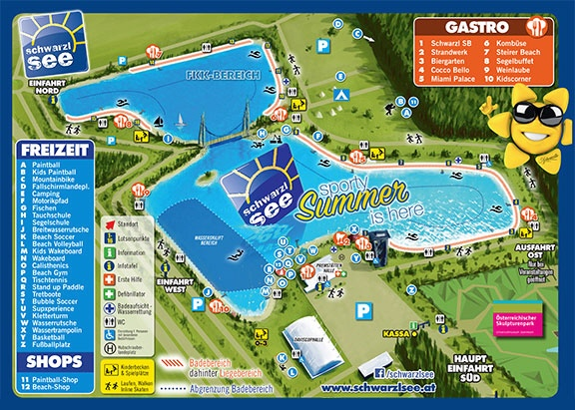
- Hotels: Please find your accommodation via booking.at
close to Schwarzlsee, Thalerhofstraße, Unterpremstätten, Österreich

Liability:
The organizer does not take over adhesion for persons -, special or financial damages opposite fighters, arbitrators, official ones, aids or third persons. All fighters participate in each relationship on own danger, even if they engage themselves outside of the match, e.g. in the master program. With the participation the runners do without any demands of requirements from all cases of damage, which result directly or indirectly from the meeting. All participants must be liability-insured accident - and/or. The requirements of the condition and the safety precautions of the match distances depend on the valid in each case regulations of the international water ski and wakeboard federation (IWWF) region Europe & Africa (E&A), the national water ski and wakeboard federation (OEWWV), the valid in each case regulation and delivering mode of the OEWWV and the valid in each case agreement (product requirement specifications) between the organizing committee (OK ONE) and the OEWWV, whereby the arrangements of the respective arbitrator are determining. Each participant commits itself to speak own objections the arbitrator. With his start the fighter gives to recognize that the given condition of the match distance and existing safety precautions are suitable as and are sufficiently recognized. An adhesion for a certain condition of the match distance or certain safety precautions, going beyond that, does not take over the organizer. All athletes get the adhesion explanation during the registration suburb to the signature submitted.

