Dear Riders,

It’s a pleasure for us to announce a brand New Event in Wales, Great Britain, We really hope to see you and your support on the water at Glasfryn Parc.

This is a 3 STAR IWWF CWWC Event to be hosted in GB.

With permission of the British Waterski & Wakeboard Federation (BWSW) and the International Water- ski- and Wakeboard Federation (IWWF) & Glasfryn Parc (GP) We invite you to the:

“IWWF Glasfryn Welsh Open“
a 3 STAR INTERNATIONAL Competition
400 World Ranking Points

On July 7th– 8th, 2018 in Glasfryn Parc, Pwllheli, North Wales, Great Britain.

Cable/Location: Glasfryn Parc, Pwllheli
North Wales, LL53 6PG Great Britain

Date: 7-8th July, 2018

The championship will be a wakeboard contest. You will have the chance to win prize money of total £3000(Sterling)

Open men |  | Open ladies
1st | £1000 | 1st | £1000
2nd | £300 | 2nd | £300
3rd | £200 | 3rd | £200
sum: | £1500 |  | £1500

This first bulletin should give you an overview about the upcoming event and to help you to plan your trip to Wales.

General information

Organizer: IWWF and Glasfryn Parc (GP)

Contact: Jonathan Williams Ellis
wakeboarding@glasfryn.co.uk
+44 1766 810000

Cable park location: Glasfryn Parc
Y Ffor
Pwllheli
Gwynedd
LL53 6PG
North Wales
Great Britain
https://www.glasfryn.co.uk
Email: wakeboarding@glasfryn.co.uk
Tel: +44 1766 810000

Competition type: IWWF 3-stars International Competition
Part of CWWC World Ranking awarded 400 pts.

Competition date: 7th - 8th July 2018 (Official Practice 7th July 2018, Comp 7th&8th)

Trainings available: Please refer to schedule.

Disciplines & categories: Wakeboard Men and Women: Juniors, Open, Masters, Veteran, Boys&Girls
Category minimum requirement is 3 riders, if less than 3 Riders in a category riders will be merged to the next available category

Rules: The competition will be carried out according to rules of the IWWF Cable Wakeboard World Council.
Please note that you have to wear a suitable helmet and vest in the wakeboard competition.
World Rules can be found here: http://www.cablewakeboard.net/userfiles/IWWF_CWWC_Rules_2018%20.pdf

Ages: For 3 Star Events all categories except Under 11’s are available

The minimum age for Entry into an International Event is AGE 11, which includes the year of the Participants 11th birthday.

Prizes: International ranking points: 400 pts. for International Ranking
Prize money for the competition: £3000 (Three Thousand Pounds Sterling)

Entry fee includes: Free official Practice Riding, Afterparty, Voucher for a £6 burger and chips, this can be redeemed for a more expensive meal.
Entry fee: £35
The entry fee must be paid by 7th July
Riders must be registered on Cablewakeboard.net by Monday 2th July 2018 5p.m.
A riders who misses the start time of his/her run without a good reason will be not permited to start and will not be able to claim a refund of fees.
DOUBLE STARTS – Riders can double start in multiple categories that they are eligable for if they pay the additional Entry Fee.
i.e A Junior Rider can Start in Junior & Open for £70
Entry fee can be paid in three different ways:
- by bank transfer before 4th July 2018 on account:
NAME: Glasfryn Parc
IBAN: GB73MIDL40373061391259
SWIFT/BIC: MIDLGB2150K
with title: EC, name of rider, nationality
Please email the copy of transfer made.
- Call Glasfryn Parc and Pay via Credit/Debit Card over the telephone +441766810000

- In cash latest on the 7th July, otherwise the participant will be liable to pay a late fee of additional £30
Registration details: The competition is registered as a part of CWWC World Rankings.
Riders must have IWWF license from their National federations. Riders register through IWWF website on the competition home page: http://myzone.cablewakeboard.net/en/116/?sub=6&comp=1667

Riders must be registered before 2nd July 2018 on www.cablewakeboard.net

Local

Accomodation options

Camping on site
Caravan(trailer):
Free for all competitors and plus 1.

Glasfryn Cottages:
www.glasfryncottages.co.uk

01766 810688
helen@beca-tv.com

Hostel (2+3 bed room):
Cwm Pennant Hostel (http://www.cwmpennanthostel.com/)

Hotel (2-bed room):
Bryn Eisteddfordd http://www.bryneisteddfod.wales/bewp/en/home-2/
Victoria hotel (http://www.victoriahotel-pwllheli.co.uk/)
Crown hotel (http://www.hotelscombined.co.uk/Hotel/Crown_Hotel_Pwllheli.htm)
Nanhoron Nefyn (http://www.nanhoronhotel.com/)
Wern fawr (http://www.wernfawr.co.uk/index.html)

Luxury hotel (2-bed room):
Plas Bodegroes (http://www.bodegroes.co.uk/)
Venetia (http://www.venetiawales.com/)

Cottages:
Abersoch holiday homes (http://www.abersochholidayhomes.co.uk/)
Menai Cottages (http://www.menaiholidays.co.uk/home?gclid=Cj0KEQjwoYi4BRDF_PHHu6rI7NMBEiQAKZ-JuCMvPuTnRKBJjBj21v_LF_WixetQWn4llposoRfyBUMaAnLt8P8HAQ)
Lleyn farm holidays (http://www.lleyn-farm-holidays.co.uk/)

Porthmadog & Abersoch TIC: for more information on accommodation.
(http://www.visitmidwales.co.uk/Porthmadog-Porthmadog-Tourist-Information-Centre/details/?dms=3&venue=0826507)
(http://abersochandllyn.co.uk/)

Transport options

By Plane Liverpool or Manchester, car rental is available at both locations. (2.5 hour drive.) or train from Manchester Airport to Bangor Station from where we would organize collection with prior notice.

By Train The nearest train station is in Pwllheli (4 miles away from the competition site), But is a slow train from London and Midlands.
Bangor Has direct fast trains London (3hr 15 min) coming from the North West the nearest train station is Bangor where a bus connection to Pwllheli is available. www.transportdirect.info

The Organisers by PRIOR arrangement will PICK UP Participants from BANGOR STATION and bring to GLASFRYN PARC or local hotel. You will have to arrange your own private shuttles back and forth to site after the initial collection.

By Car Glasfryn Parc,
By Car from the North: You’ll need the A55 from Chester, then the A487 from Bangor to Caernarfon, then A499 to Pwllheli, Along that road you will see our main activity centre. (post code LL53 6PG)
By Car from the South: You’ll need the M54 past Telford, then join the A5 past Shrewsbury, Oswestry & Llangollen. After Corwen turn left onto the A494 following signs for Bala. As you arrive in Bala take a right onto the A4212 stay on this road for about 20 miles then turn right at a T Junction onto the A470 towards Porthmadog, join the A487 and carry on through Porthmadog and join the A497 to Criccieth and Pwllheli, Turn right onto the B4354, Turn right onto A499 and the parc will be on you right. (post code LL53 6PG)

For general transport enquiries use: http://www.traveline.info/

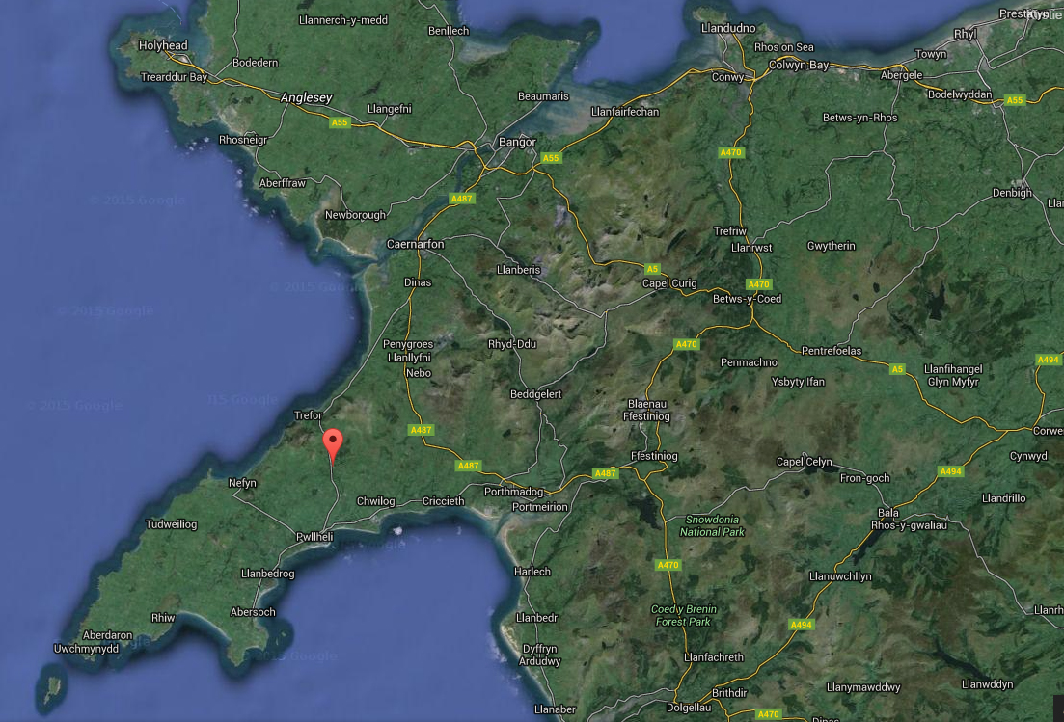
Provisional Schedule

Please note the schedule will change once we know how many participants are entering the competition

Saturday 7th July
09:00 – 12:00 Registration
09:00 – 13:00 Public Riding
13:00 – 18:00 Official Practice (Competitors Only)

Sunday 09:00 – 09:15 Riders Briefing
8th July 09:30 – 15:00 Competition
17:00 Medals & Award Ceremony

PLEASE NOTE THAT DUE TO THE SPECIFICS OF THE COMPETITION CABLE, THIS EVENT IS A FEATURES ONLY COMPETITION

Riders training times may be adjusted based on the number of present riders.
Final schedule will be provided one week before the competition.

Amateur will be encouraged to join in with the main competition.

Equipment storage: We have storage on site for all kit in locked areas of the parc. No liability will be accepted by the event organisers for any damage or loss of property.
Free WiFi available at Glasfryn Parc

Useful information

To travel to the UK you must have a valid passport, with at least 6 months validity left at the time of entry into the country.

The official language in Wales is Welsh, but English is spoken commonly.

For driving, there is zero tolerance for alcohol. Speed limits are 30mph in town, 60 mph outside the town and 70mph on the highway.

Minimum drinking age is 18. In case of emergency call 999
Time zone in Wales is GMT
Mains electricity voltage is 240V. Socket is UK Plug (3 pins).
Weather during the competition is expected to be warm and sunny with temperatures at or above 20 degrees. Water temperature is expected to be approximately 20 degrees.

Glasfryn Wakeboarding is part of a larger Activity Parc, for information on other activities and services we provide go to our website http://www.glasfryn.co.uk/

:

Declaration, Waiver and Release Form

For, and in consideration of, the International Waterski & Wakeboard Federation (the IWWF) accepting my application, and permitting me, to participate and compete in the International registered cable wakeboard event (the International event), I, the undersigned, for and on behalf of myself, my heirs, executors and administrators, do hereby irrevocably and unconditionally warrant, represent and undertake to the IWWF as follows

Any and all information provided and/or disclosed by, or on behalf of, myself to the IWWF (including any officers, employees and representatives thereof) for the purpose of considering and evaluating my application for participation and competition in the International event is true, correct and accurate;

I have fully read and understood the rules and regulations of participation and competition in the International event (a copy of which has been made available to me) and I do hereby covenant with, and undertake to, the IWWF to at all times fully comply with, and abide by, the same;

I am in good physical and mental health and I am physically capable of competing and participating, and fully competent to participate and compete, as a competitor in the International event and that I have not been certified and/or advised otherwise by any qualified medical practitioner;

I do hereby authorise any and all physicians, paramedics and other medical personnel and practitioners procured by, or on behalf of, the IWWF to administer first aid treatment or any medical treatment, surgery or transportation in the event of any illness, accident or injury suffered and/or sustained by me at any time during my participation and competition in the International event (or any part thereof) and hereby indem- nify, and shall keep fully and effectively indemnified, the IWWF (including all officers, employees and representatives thereof) upon demand from and against any and all claims, liabilities, demands, costs and expenses of whatsoever nature incurred and/or suffered by the same (or any of them) and arising from, and/or in connection with, the procurement and administration of such medical treatment and transportation in relation to any such illness accident or injury suffered and/or sustained by me;
I acknowledge, agree and confirm that participating and/or competing as a competitor in the International event (or any part thereof) involves inherent risks and dangers of accidents, personal and bodily injury and property loss or damage and that by signing and completing this Dec- laration, Waiver and Release Form, I fully understand and have considered and evaluated the nature, scope and extent of the risks involved, and voluntarily and freely choose to assume these risks;

I hereby grant to the IWWF (including its lawful successors and assigns) the sole and exclusive right and licence, in perpetuity and throughout the world and without any compensation whatsoever to me, to use, reproduce, publish and/or exploit, my name, nickname, likeness, image, logos, get-ups, initials, voice, slogan and signatures developed from time to time, reputation, graphical representation, electronic, animated or computer generated representation and any other representation (in any medium whatsoever), right of association, biographical information and other indicia, and any other right or property in my performances, in any media whatsoever, for any purposes whatsoever relating to, and/or in connection with, the IWWF and/or the International event (or any part thereof) and I shall do all such things (including, without limitation, the execution of appropriate legal documentation) as the IWWF may, from time to time, require to give legal and binding effect to the aforementioned grant of rights;

I irrevocably acknowledge, agree and confirm that the IWWF reserves the right, at its sole and absolute discretion, to disqualify me from par- ticipation and/or competition in the International event (or any part thereof) if I am in breach of any of the warranties, representations and/or undertakings set out in this Declaration, Waiver and Release Form and/or for any reason whatsoever the IWWF considers just and proper, and in the event of any such disqualification, I shall not be entitled to any compensation of any nature whatsoever from the IWWF.

I hereby release, hold harmless, protect, indemnify and forever discharge the IWWF (including its officers, employees and representatives), the International event and all commercial partners thereof, from and against any and all claims, demands, liabilities, costs and expenses of any nature whatsoever, whether direct or consequential, suffered and/or incurred by the IWWF (including its officers, employees and representa- tives), the International event and/or all commercial partners thereof and arising from, and/or in connection with:

Any breach of any of the warranties, representations and/or undertakings given by me as set out hereunder; and/or my participation and/or competition in the International event (or any part thereof).
Declaration

I, (the Competitor), do hereby declare that I have read and fully understood the terms and conditions of this Declaration, Waiver and Release Form and that I have had the opportunity to discuss the same with my parent / guardian and that I agree to be bound by the said terms and conditions of the above agreement with the IWWF.

Cable Wakeboard International Event

Declaration of Parent / Guardian
(Applicable only if the Competitor is, on the date of signing the Declaration, Waiver and Release Form, under the age of 18 years)

I, the undersigned, am the parent / guardian* of (the Competitor) and I do hereby irrevocably and unconditionally:

1 warrant, represent and undertake to the IWWF that I have read and fully understood the terms and conditions of the Declaration, Waiver and Release Form and have discussed with, and explained such terms and conditions to, the Competitor and I agree to, and will cause the Competitor to fully abide by, and comply with, all of the terms and conditions of the Declaration, Waiver and Release Form; and

2 covenant with, and undertake to, the IWWF not to take, nor permit to be taken, any action(s) nor omit to do anything that would assist or cause the Competitor to invalidate, renounce, negate, revoke or disclaim any part of the Declaration, Waiver and Release Form, and

3 warrant, represent and undertake to the IWWF that by signing the Declaration, Waiver and Release Form, neither the Competitor and/or myself is/are in breach of any other arrangement(s) (whether contractual or otherwise) with any third party, and

4 agree to be liable for, and will indemnify the IWWF (including its officers, employees and representatives), the International event and all commercial partners thereof from and against, any and all claims, demands, liability, loss, damages, costs, and expenses of any nature whatsoever, whether direct or consequential, suffered and/or incurred by the IWWF, the International event and all commercial partners thereof, whether direct or consequential, any arising from, and/or in connection with:

(a) any breach of any of the warranties, representations and/or undertakings given by the Competitor in the Declaration, Waiver and
Release Form; and/or
(b) the Competitor’s participation and/or competition in the International event (or any part thereof).

Signature

Name of Parent / Guardian*: Date:

Signed in the presence of: Witness:
Name: Address: Occupation:

