Wakeboard Junior Tournament 2018 1. stop
Central Wakepark Pécs
2018.05.26.
Location:

Central WakePark - Pécs Hungary
http://www.centralwake.hu/hu/central-wakeboard-park-pecs
https://www.facebook.com/centralwake

Address: 7632 Pécs, Tüskésréti-tó
Cable and features: Pentasi 5 towers cablepark, lenght 565 meters 7 carrier, 7 obstacles
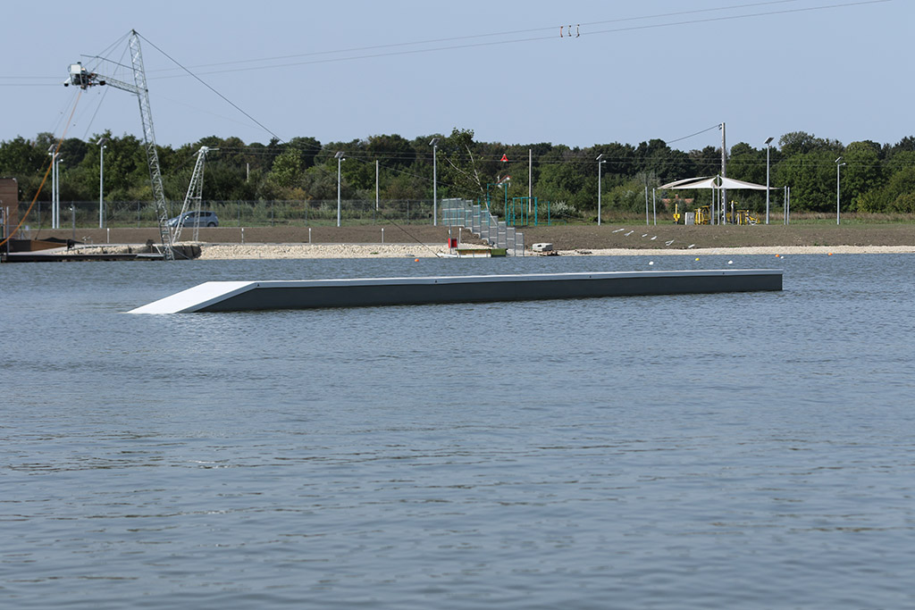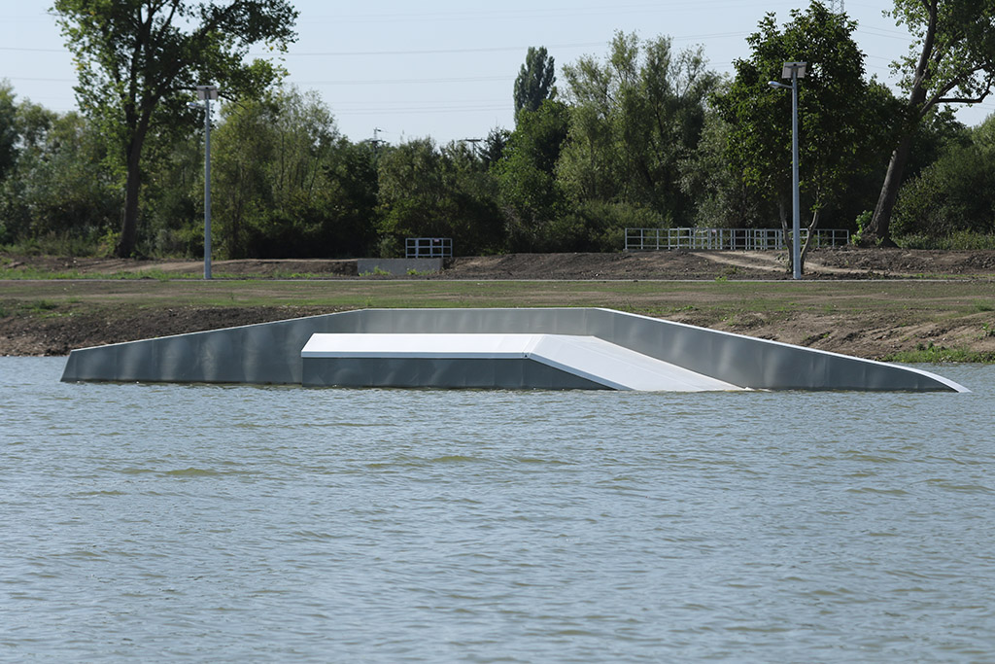
Flat box 20 m Funbox/A Frame
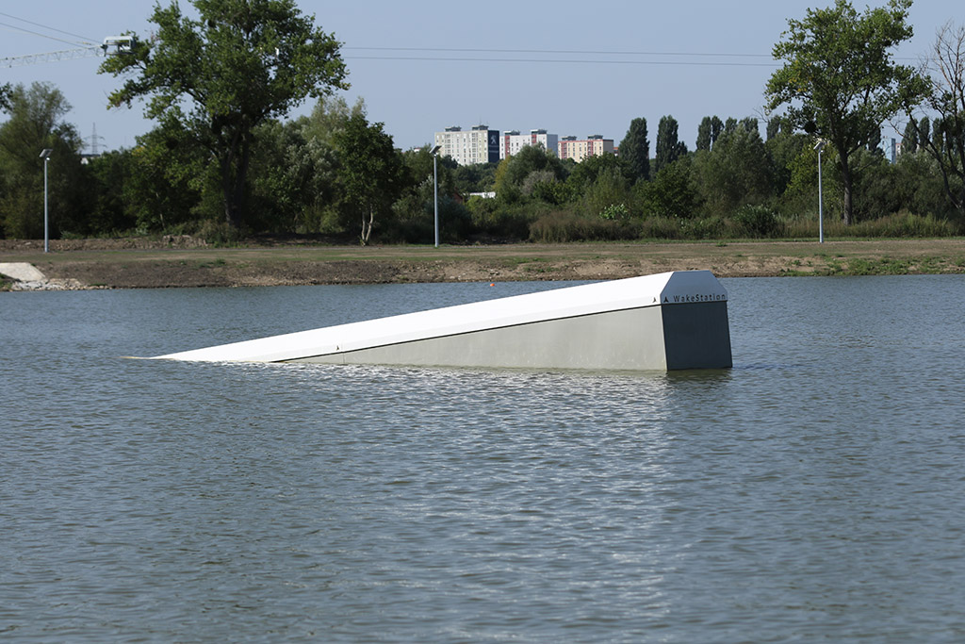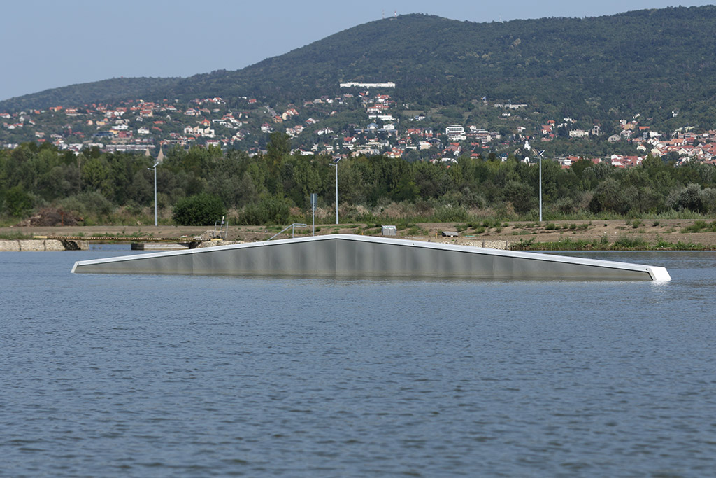
Incline 3D Rooftop
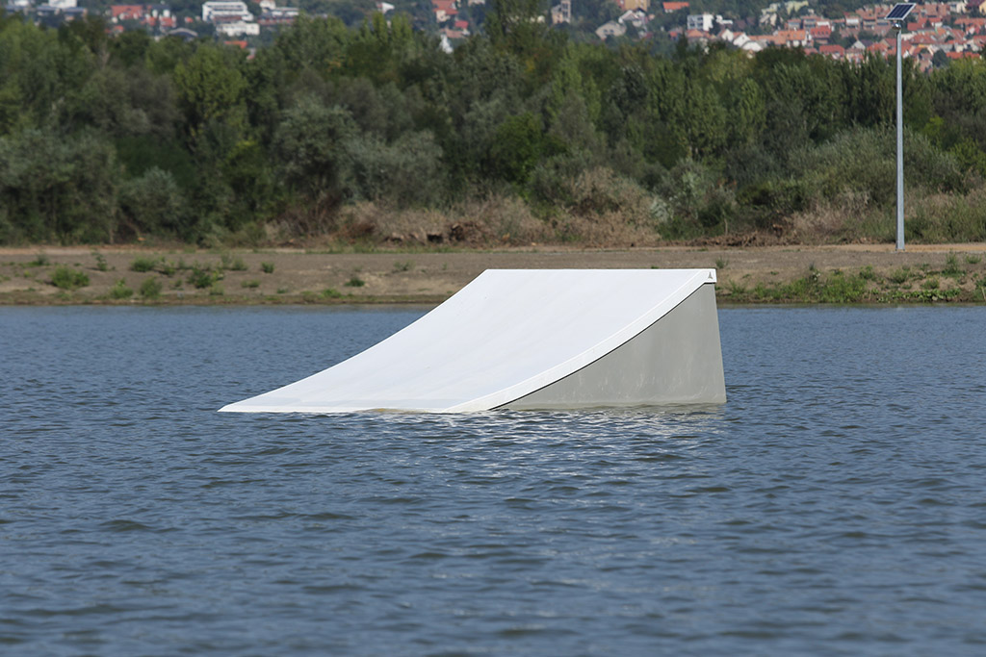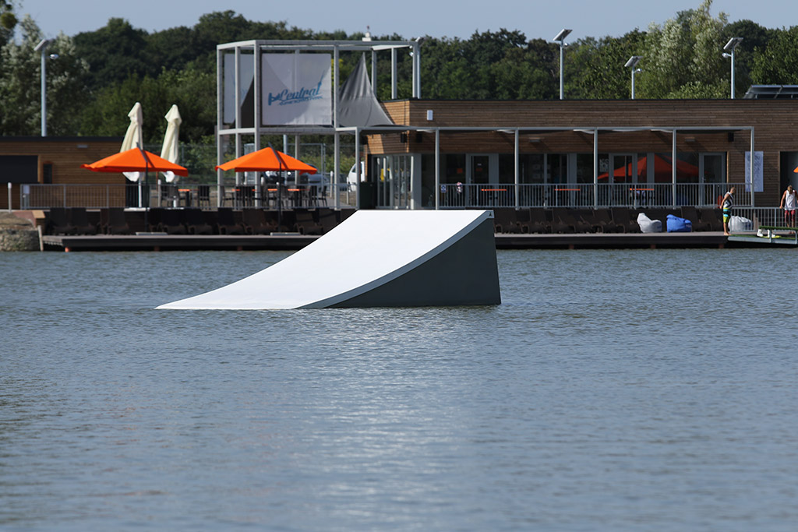
1 small kicker lefty 2 large kicker

Federation:

Hungarian Waterski and Wakeboard Federation

www.mvwsz.hu
https://www.facebook.com/groups/116122088431648/

Organizer:

Central Wakepark Pécs

http://www.centralwake.hu/hu/central-wakeboard-park-pecs
https://www.facebook.com/centralwake

Categories:

U 11 Mini Girls - Mini Boys 2007 or after ONLY PRACTICE
U 15 Boys 2003-2006
U 15 Girls 2003-2006
U19 Junior Men 2002-1999
U19 Junior Ladies 2002-1999

Judge panel:

Chief Judge: Kirsch György

Judges: Bodoki Roland
Magdacs Péter
Kersak Péter

Calculator: Csizmadia Katinka

Timetable:

Május 25. 15.00 registration
17.00-20.00 official practice
Május 26.
9.00 Qualification
12.00 LCQ
14.00 Final

Registration:
Please take the event on the /IWWF/ cablewakeboard.net website as usually and send your personal details /name, date of birth and home club/ to the tscherko@gmail.com email address at latest 48 hours before the competition.

ATTENTION: U11 PRACTICE CATEGORY DON'T NEED THE CABLEWAKEBOARD.NET REGISTRATION.

- we need a confirmation email from your federation about your status in your federation.

-we need a healthy confirmation that you are able to compete /sport doctor/

Entry fee:
All categories: 30 Euro
Pay the fee on the site before the event.

Dopping control:
There could be drog and dopping control on the event based on the international rules:
cwww.wada-ama.org, http://www.iwsf.com/AntiDoping/WEBpageinformation.htm weblapra.

Accomodation:
Bagolyvár Pécs Motel
http://www.bagolyvarpecs.hu/

Dominó Ház Pécs Hostel
http://dominohaz.com/

Joker Hostel Pécs
http://jokerhostel.hu/

Map:

