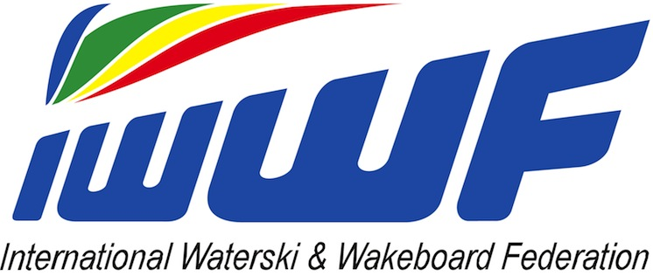

Rider’s Bank Details

Travel Subsidy and Prize Money, if any, will only be transferred to your bank account. You are required to submit your bank details by filling up and submitting this form to Manuel Orlando manuel@cablewakeboard.net by 20th April 2018:

Bank Details to be Typewritten
Your Name:
Your Full Address
(as per bank records):
Name of Bank:
City of Bank:
Bank Full Address:
Account Number:
Account Name (Beneficiary):
*Sort Code / BSB Code:
*Swift Address
*IBAN (Europe only)

Important Note: Due to new bank rules if you do not supply a SWIFT number, the transfer costs will be deducted from your compensation. For your bank transfer, you must fill in the fields marked by *. If it does not apply put in N/A (not applicable). All bank service fees charged, if any, due to inaccurate information provided will be deducted from your reimbursement.

