IWWF Golden Wake Tour 2018

18.-19. May 2018

Ski & Wake Park Terlicko, Czech Republic

OFFICIAL BULLETIN

Slovak Waterski Federation (SZVL) and Bratislava Wake Club (BWC), in cooperation with local organizer Vodni lyzovani a Wakeboarding Havirov z.s is pleased to invite all riders to 1st stop of IWWF Golden Wake Tour at Ski & Wake Park Terlicko, 18.-19. May 2018.

Version 2 – Second version of bulletin

ORGANIZER: | Vodni lyzovani a Wakeboarding Havirov z.s.
CONTACT: | Lukas Bystron  Competition manager  lukasbystron@seznam.cz  +420 736 137 710
CABLE PARK LOCATION: | Ski & Wake Park Terlicko  Dolni Terlicko 102  735 42  Terlicko  Czech Republic  www.skiwakepark.cz/  www.facebook.com/skiwakepark
COMPETITION TYPE: | IWWF 2-star International Competition  200 World Ranking Points
COMPETITION DATE: | Friday 18. May 2018 from 14:00 until dark  and Saturday 19. May 2018 from 7:30 until dark
OFFICIAL TRAINING: | Friday 18. May 2018 from 14:00 till 16:00  And Saturday 19. May 2018 from 7:30 till 9:30
CATEGORIES: | Wakeboard Men: U15, U19, Open, O30, O40  Wakeboard Ladies: U15, U19, Open  Wakeskate Men: Open  Wakeskate Ladies: Open  Seated Men: Open  It is required to have at least 3 riders to open category
RULES: | The competition will be carried out according to rules of IWWF Cable Wakeboard World Council.  Please note that you have to wear helmet and vest beginning official training until end of competition.
WAKE CUP RESULTS AND RULES: | www.bwc.sk/gwt
ENTRY FEE: | 500 czk/ 20 eur per rider and category
ENTRY FEE NOT INCLUDES: | Official Jersey (BIB). There is 25 EUR deposit for a BIB, which will be returned after competition once the BIB is turned back
REGISTRATION: | Riders must have IWWF registration on www.cablewakeboard.net and must be registered on competition home page:  myzone.cablewakeboard.net/en/116/?sub=6&comp=1624  Onsite registration starts on Friday 18. May at 12:00 and closes at 15:30. Dead line for online registration is 17.5.2018 23:59
PRIZES: | 200 World Ranking Points  Medals  40000czk in prizes and prize money 20000czk from sponsors and partners  It is required to have at least 6 riders in category to get prize money.  WB Open men: 1st – 5000czk, 2nd – 2500czk, 3rd – 1000czk  WB Open women: 1st – 2000czk, 2nd – 1000czk, 3rd – 500czk  WB Masters: 1st – 1500czk, 2nd – 1000czk, 3rd – 500czk  WS Open men: 1st – 3000czk, 2nd 1500czk, 3rd – 500czk
SPONSORS AND PARTNERS: | www.HYUNDAI.cz www.AUTHORITYSERVICE.com www.SNOWBOARD-ZEZULA.cz www.facebook.com/EXCELENTcz www.WASTELANDS.cz www.facebook.com/GOONCHBOARDS www.facebook.com/dzusyRELAX www.VEITSPORT.cz www.TALPARPF.cz www.SPBOARDING.com www.UMYJEMTO.cz www.PENZIONTAREM.cz www.SPOT.net.pl  www.GAZETACODZIENNA.pl
SCHEDULE: | Friday 18.05.2018  12:00 – 16:00 registration  14:00 – 16:00 official training  16:00 – 16:15 riders meeting  16:30 – 20:30 competition (qualifications masters, veterans, seated, wakeskate men and wakeskate women)  Saturday 19.05.2018  07:30 – 09:30 official training  09:30 – 09:45 riders meeting  10:00 – 19:30 competition (qualifications, LCQs, finals)  20:30 prize giving ceremony
LOCATION: | The Terlicko dam with cablepark is located next to town Havirov, approximately 30 minutes’ drive by car from Ostrava. You can find restaurants, beaches, many different sport activities and possibility to stay during night in your own tent on site.
ACCOMMODATION: | Camp:  Please, coordinate your stay in tent with competition manager Martin Kocur  martinkocur@seznam.cz  +420 608 863 067  Directly on site  Accommodation:  Hostinec v zatoce  http://hostinecvzatoce.cz  5 minutes drive or 5 minutes walk  Penzion Tarem  www.penziontarem.cz  2 minutes walk  Penzion Amerika  www.penzionamerika.cz  5 minutes drive  Jaskovska krcma  http://jaskovskakrcma.cz/  5 minutes drive  or  www.airbnb.com  www.booking.com
HOW TO REACH SITE: | By plane:  Katowice Airport (KTW)  www.katowice-airport.com  1,5 hours drive from cable park  Krakow Airport (KRK)  www.krakowairport.pl  2 hours drive from cable park  Ostrava Airport (OST)  www.airport-ostrava.cz  50 minutes drive from cable park  By train:  The closest train station is Havirov  10 minutes drive from cable park  By car:  GPS: 49.764288247086, 18.494067192078
CABLEWAY: |  | Motorsport VLV-X 001, manufacture year 1991  800 m length  4 pylons  8 carriers  8 m cable height  11 features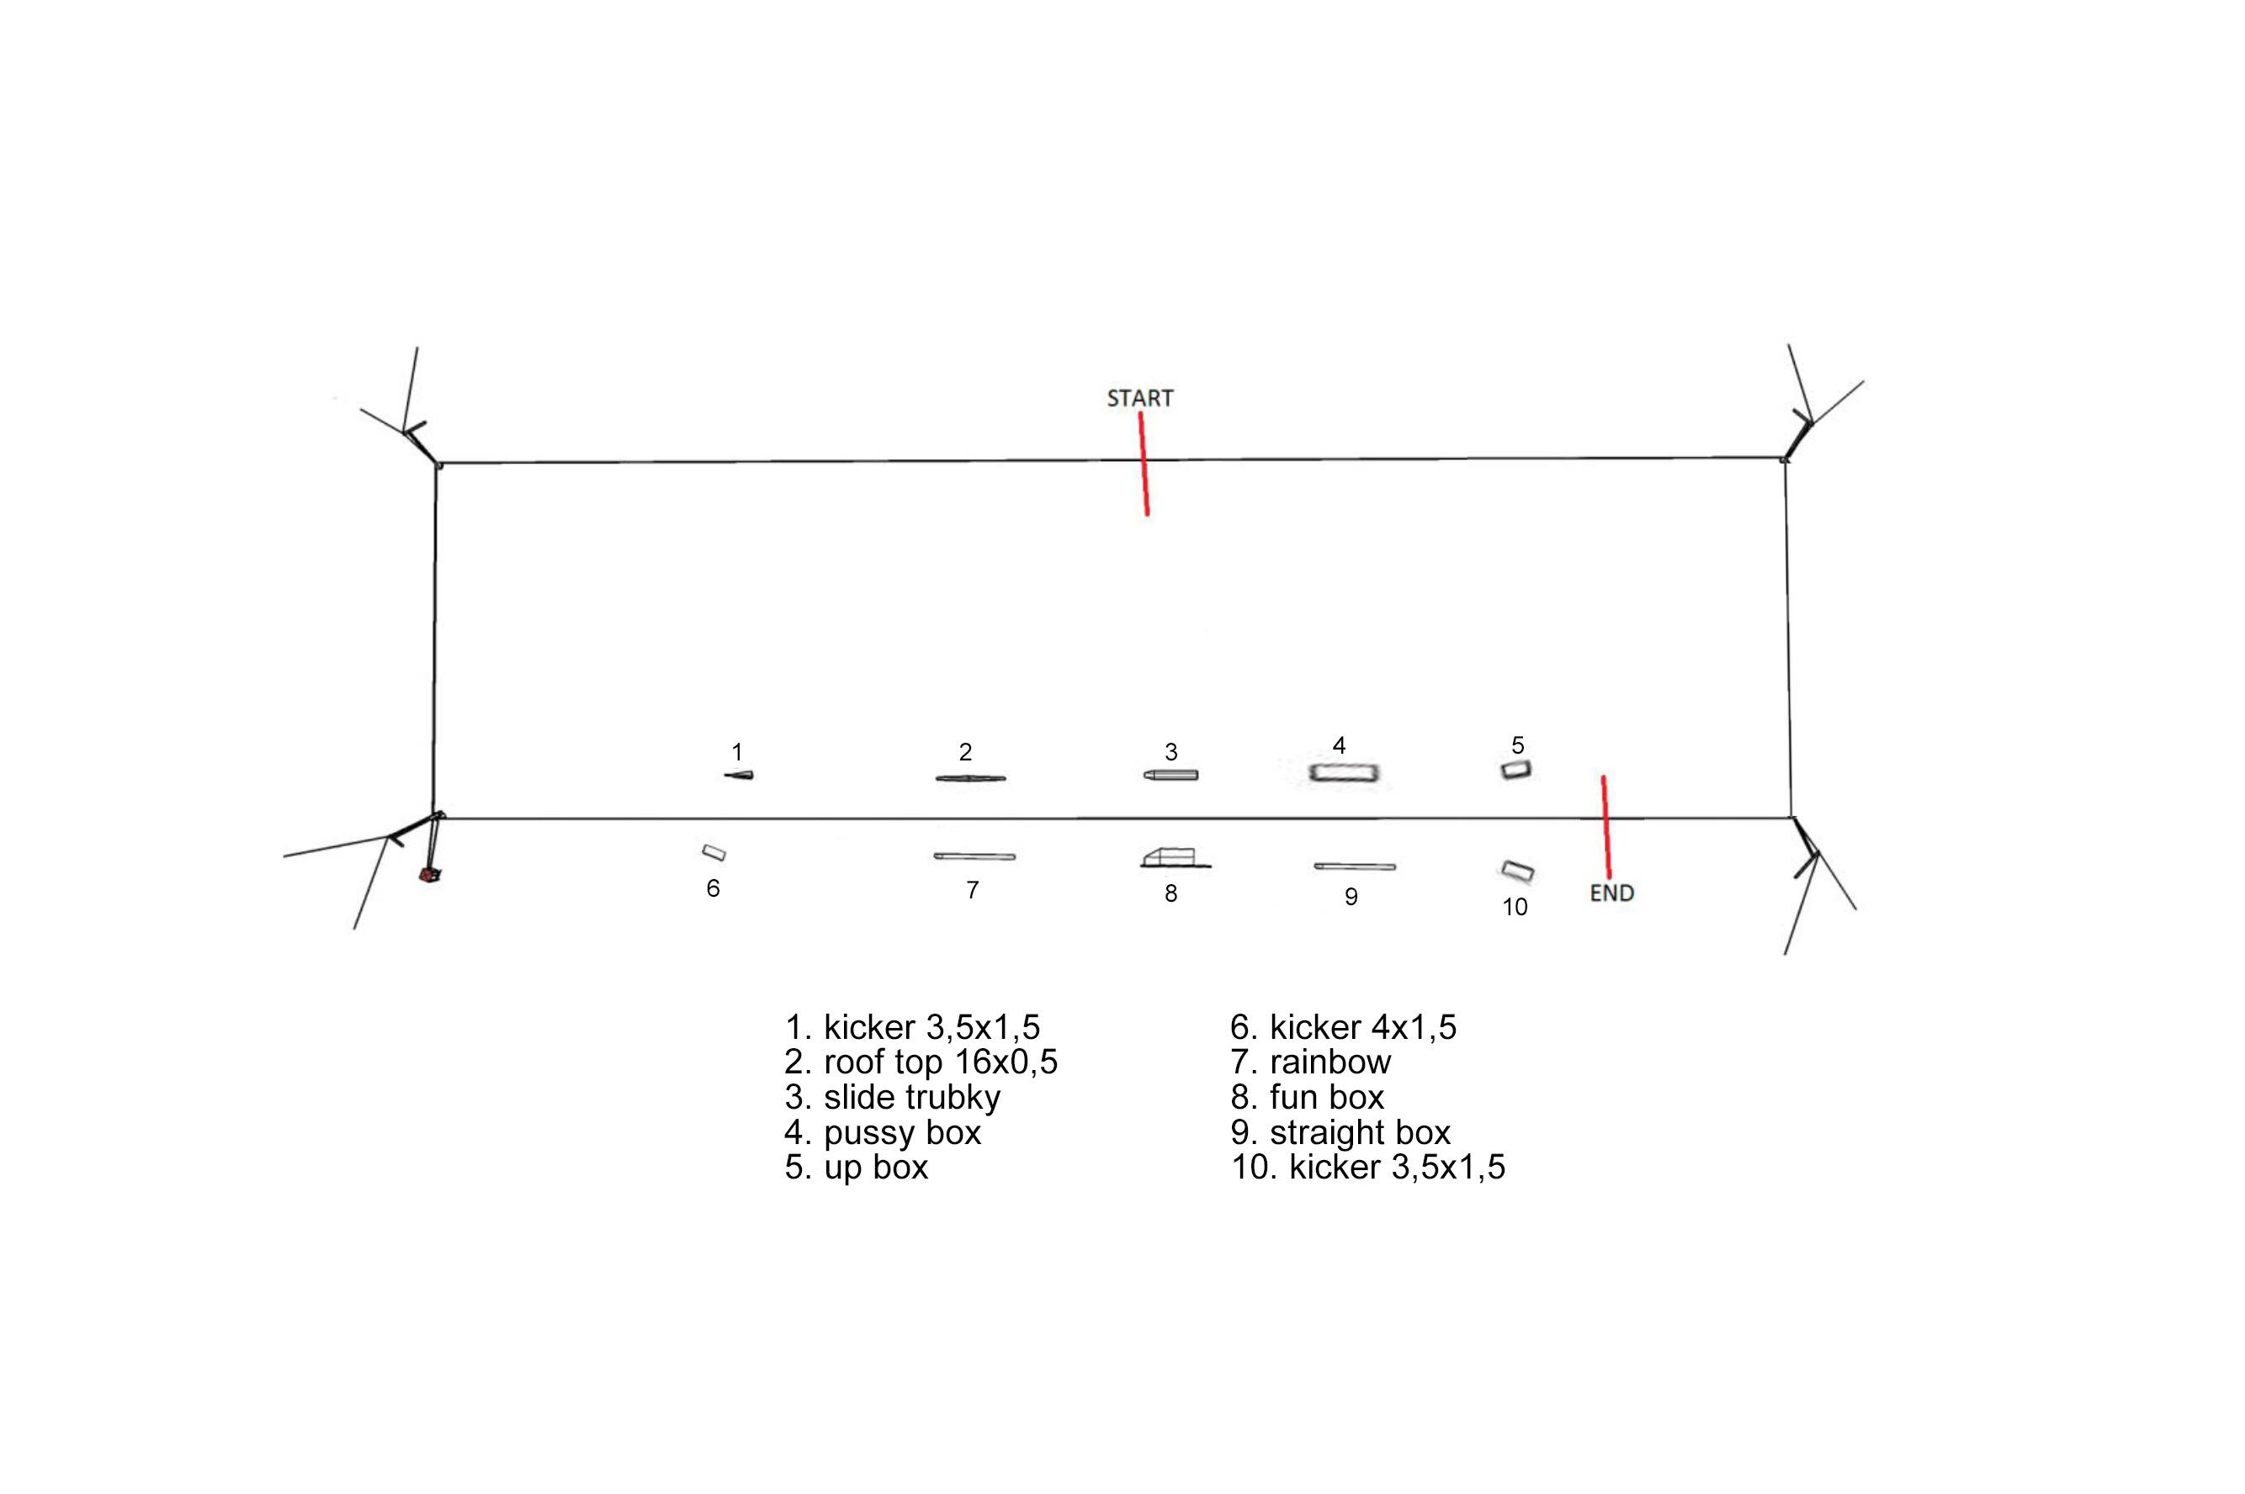

Useful information

Czech Republic is a member of the European Union and Schengen agreement.
For other Schengen agreement member countries, the entry requires no specific permit. A valid EU personal ID or Passport are sufficient for travel to Czech Republic. Some countries outside the European Union may be subject to visa requirements. For more information please consult the information provided by Ministry of Foreign Affairs.
The currency is Czech crown.
Official language is Czech.
For driving, there is zero tolerance for alcohol. Speed limits are 50 km/h in town, 90 km/h outside the town and 130 km/h on the highway. Highways require a toll that can be bought on all border crossings or petrol stations.
Minimum drinking age is 18.
In case of emergency call 112.
Time zone in Czech Republic is Central European Summer Time (CEST, GMT+2).
Mains electricity voltage is 230V. Socket is standard Euro plug.

Safety

All riders must wear an approved life vest and a helmet in the course at all times. All participants ride at their own risk.
Following is the Declaration, Waiver and Release form that is required for each rider. Riders younger than 18 years are required to provide the Declaration of Parent / Guardian

Declaration, Waiver and Release Form

For, and in consideration of, the International Waterski & Wakeboard Federation (the IWWF) accepting my application, and permitting me, to participate and compete in the International registered cable wakeboard event (the International event), I, the undersigned, for and on behalf of myself, my heirs, executors and administrators, do hereby irrevocably and unconditionally warrant, represent and undertake to the IWWF as follows:

Any and all information provided and/or disclosed by, or on behalf of, myself to the IWWF (including any officers, employees and representatives thereof) for the purpose of considering and evaluating my application for participation and competition in the International event is true, correct and accurate;

I have fully read and understood the rules and regulations of participation and competition in the International event (a copy of which has been made available to me) and I do hereby covenant with, and undertake to, the IWWF to at all times fully comply with, and abide by, the same;

I am in good physical and mental health and I am physically capable of competing and participating, and fully competent to participate and compete, as a competitor in the International event and that I have not been certified and/or advised otherwise by any qualified medical practitioner;

I do hereby authorize any and all physicians, paramedics and other medical personnel and practitioners procured by, or on behalf of, the IWWF to administer first aid treatment or any medical treatment, surgery or transportation in the event of any illness, accident or injury suffered and/or sustained by me at any time during my participation and competition in the International event (or any part thereof) and hereby indemnify, and shall keep fully and effectively indemnified, the IWWF (including all officers, employees and representatives thereof) upon demand from and against any and all claims, liabilities, demands, costs and expenses of whatsoever nature incurred and/or suffered by the same (or any of them) and arising from, and/or in connection with, the procurement and administration of such medical treatment and transportation in relation to any such illness accident or injury suffered and/or sustained by me;
I acknowledge, agree and confirm that participating and/or competing as a competitor in the International event (or any part thereof) involves inherent risks and dangers of accidents, personal and bodily injury and property loss or damage and that by signing and completing this Declaration, Waiver and Release Form, I fully understand and have considered and evaluated the nature, scope and extent of the risks involved, and voluntarily and freely choose to assume these risks;

I hereby grant to the IWWF (including its lawful successors and assigns) the sole and exclusive right and license, in perpetuity and throughout the world and without any compensation whatsoever to me, to use, reproduce, publish and/or exploit, my name, nickname, likeness, image, logos, get-ups, initials, voice, slogan and signatures developed from time to time, reputation, graphical representation, electronic, animated or computer generated representation and any other representation (in any medium whatsoever), right of association, biographical information and other indicia, and any other right or property in my performances, in any media whatsoever, for any purposes whatsoever relating to, and/or in connection with, the IWWF and/or the International event (or any part thereof) and I shall do all such things (including, without limitation, the execution of appropriate legal documentation) as the IWWF may, from time to time, require to give legal and binding effect to the aforementioned grant of rights;

I irrevocably acknowledge, agree and confirm that the IWWF reserves the right, at its sole and absolute discretion, to disqualify me from participation and/or competition in the International event (or any part thereof) if I am in breach of any of the warranties, representations and/or undertakings set out in this Declaration, Waiver and Release Form and/or for any reason whatsoever the IWWF considers just and proper, and in the event of any such disqualification, I shall not be entitled to any compensation of any nature whatsoever from the IWWF.

I hereby release, hold harmless, protect, indemnify and forever discharge the IWWF (including its officers, employees and representatives), the International event and all commercial partners thereof, from and against any and all claims, demands, liabilities, costs and expenses of any nature whatsoever, whether direct or consequential, suffered and/or incurred by the IWWF (including its officers, employees and representatives), the International event and/or all commercial partners thereof and arising from, and/or in connection with:

Any breach of any of the warranties, representations and/or undertakings given by me as set out hereunder; and/or my participation and/or competition in the International event (or any part thereof).

Declaration

I, (the Competitor), do hereby declare that I have read and fully understood the terms and conditions of this Declaration, Waiver and Release Form and that I have had the opportunity to discuss the same with my parent / guardian and that I agree to be bound by the said terms and conditions of the above agreement with the IWWF.

Place, Date Signature

Cable Wakeboard International Event

Declaration of Parent / Guardian
(Applicable only if the Competitor is, on the date of signing the Declaration, Waiver and Release Form, under the age of 18 years)

I, the undersigned, am the parent / guardian* of (the Competitor) and I do hereby irrevocably and unconditionally:

1 warrant, represent and undertake to the IWWF that I have read and fully understood the terms and conditions of the Declaration, Waiver and Release Form and have discussed with, and explained such terms and conditions to, the Competitor and I agree to, and will cause the Competitor to fully abide by, and comply with, all of the terms and conditions of the Declaration, Waiver and Release Form; and

2 covenant with, and undertake to, the IWWF not to take, nor permit to be taken, any action(s) nor omit to do anything that would assist or cause the Competitor to invalidate, renounce, negate, revoke or disclaim any part of the Declaration, Waiver and Release Form, and

3 warrant, represent and undertake to the IWWF that by signing the Declaration, Waiver and Release Form, neither the Competitor and/or myself is/are in breach of any other arrangement(s) (whether contractual or otherwise) with any third party, and

4 agree to be liable for, and will indemnify the IWWF (including its officers, employees and representatives), the International event and all commercial partners thereof from and against, any and all claims, demands, liability, loss, damages, costs, and expenses of any nature whatsoever, whether direct or consequential, suffered and/or incurred by the IWWF, the International event and all commercial partners thereof, whether direct or consequential, any arising from, and/or in connection with:

(a) any breach of any of the warranties, representations and/or undertakings given by the Competitor in the Declaration, Waiver and
Release Form; and/or
(b) the Competitor’s participation and/or competition in the International event (or any part thereof).

Signature

Name of Parent / Guardian*:
Date:

Signed in the presence of:
Witness:
Name:
Address:
Occupation:

* Delete as appropriate

