Guidance for Federations on the Approval Process for Cable Wakeboard Titled Events
This is a general guide on how to approve riders for Titled Cable Wakeboard events using Cablewakeboard.net, it also sets out the rules for approval.

Only approved Federation Users manage riders through Cablewakeboard.net, if you are unsure who has access to make approvals for your country, please refer to the appendices at the end of this document.

Before any federation can approve riders from their country to compete at a titled event, the riders must first have registered themselves onto www.Cablewakeboard.net as a rider. This can be done in the following way:

Go to: www.cablewakeboard.net
Click on Registration
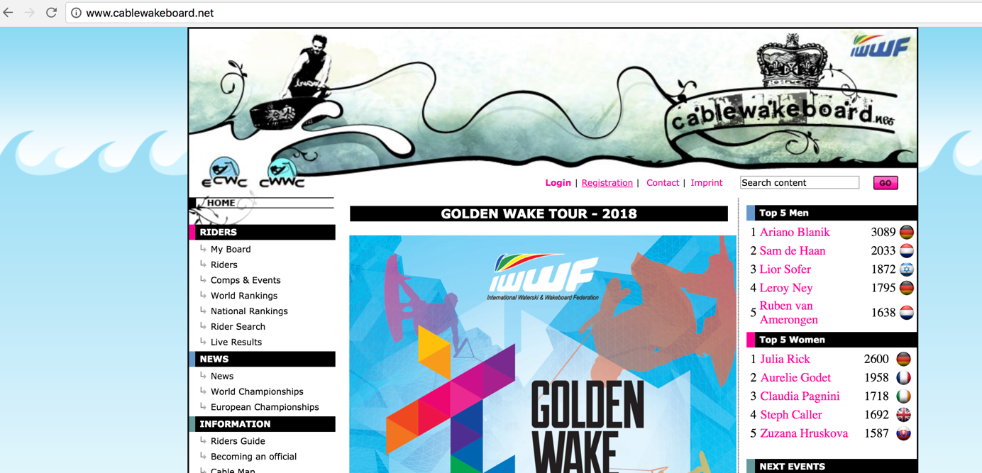

They must complete the required information on the attached sheet, please take note of the new GDPR guidelines when completing registration.

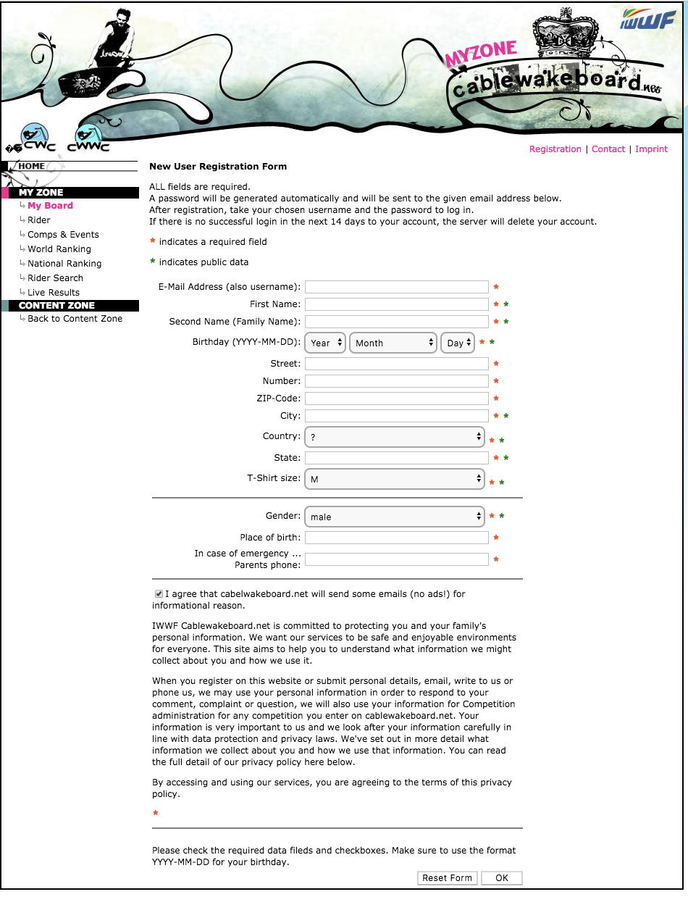

You will be emailed a password to enable you to login.

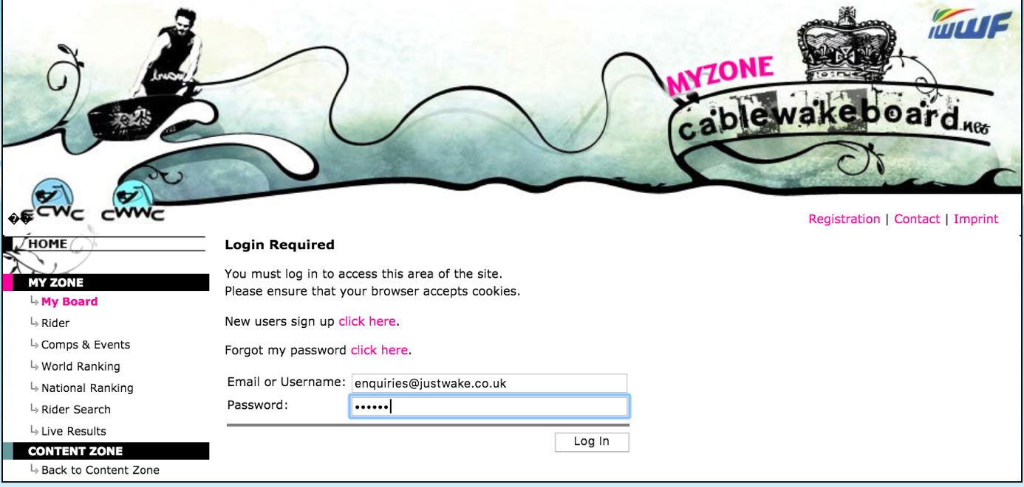

Get them to complete all the details required:

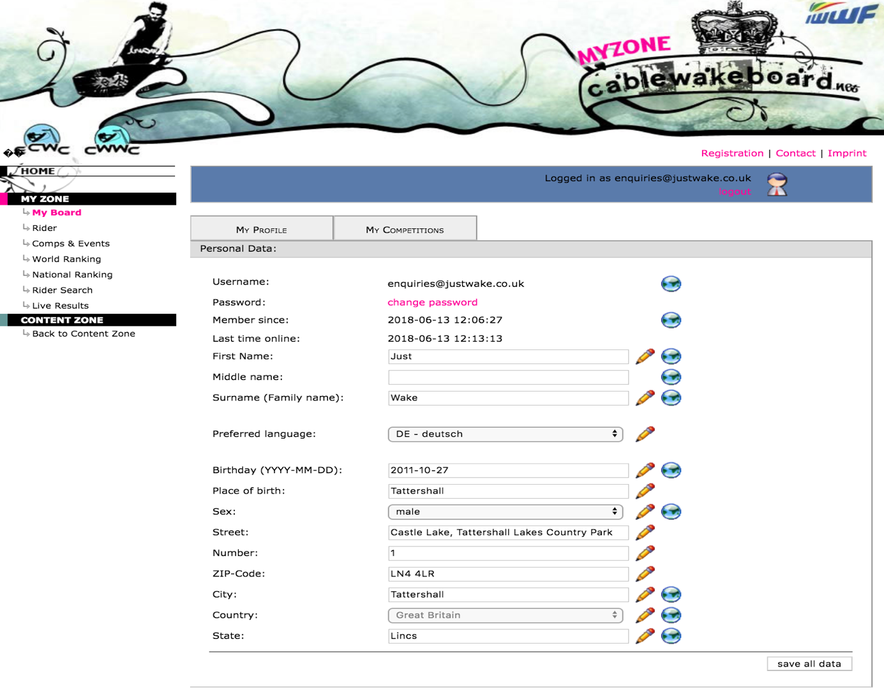
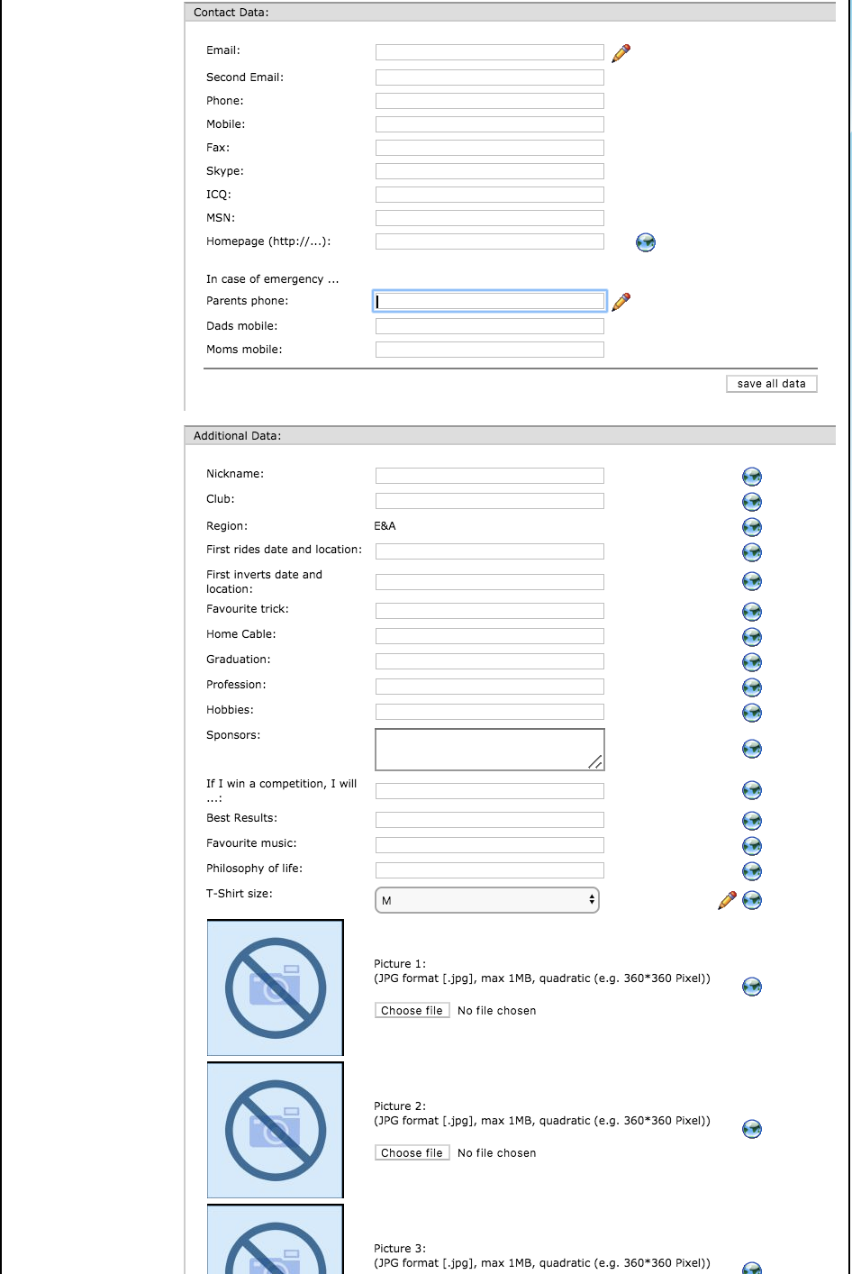
Save the data once completed.

As soon as they have completed their registration, they then need to enter the competition on cablewakeboard.net.
To do this, they need to go to: MY COMPETITIONS

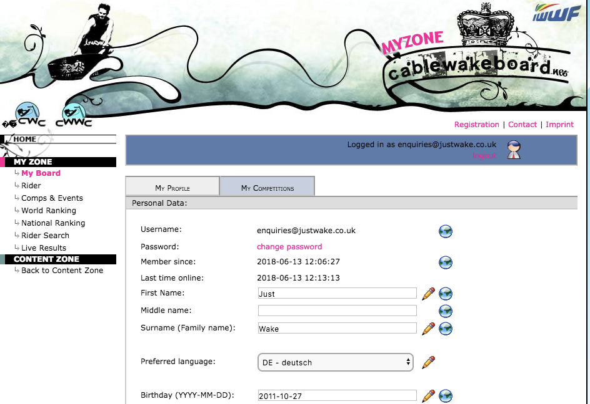

This will bring up a list of all the registered competitions during the year, they need to look to find the competition they want to enter:

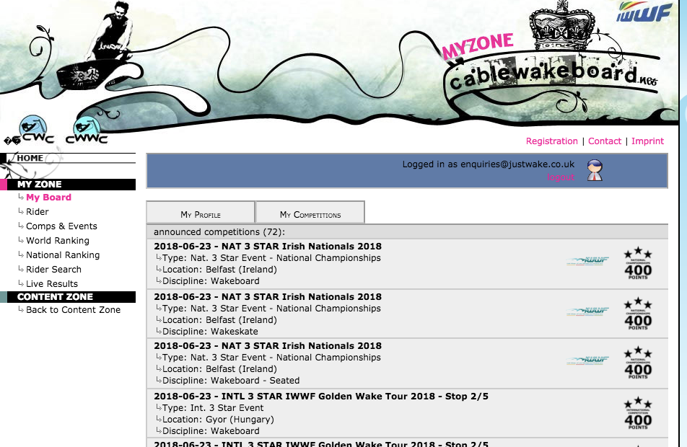
We are going to enter the E&A Youth and Senior Category Competition in this example:

Click on the competition, it expands it down:
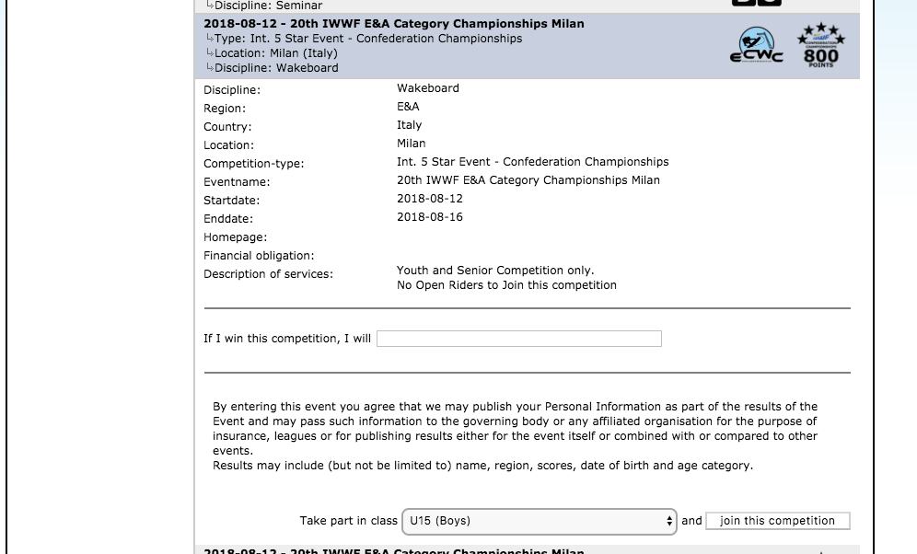

Answer the question about what you will do if you win the competition, and then enter the category you wish to compete in, and click join this competition.

FROM A RIDERS PERSEPCTIVE – THAT’S IT.
They have done everything they can to enter, its now down to the federation to complete the team entries.

Federation Approval for Team Entry at Titled Events

Please be aware of the following when you are approving your team riders to compete in Titled Events.

- It is your responsibility to ensure your athletes meet the entry requirements to complete.
  - There are minimum points required to enter, plus the ability to enter up to 2 riders per category using a wildcard (rider without minimum points)
  - OPEN RIDERS – Require 800 Points
  - MASTERS/VETERANS & JUNIOR Categories – Require 800 Points
  - BOYS/GIRLS (Under 15) – Require 400 Points
  - NO CHILD UNDER AGE 11 on the start date of the competition is allowed to compete in an INTERNATIONAL TITLED EVENT.
- All riders approved by the federation to enter the competition must have their entry paid. If the federation requires the riders to pay on site for their entry fee, and the rider does not turn up to registration, then then federation will be invoiced retrospectively to cover the entry fee.
  - The only exception to this rule is if the federation can show a doctors certificate showing a valid reason to why the athlete cannot compete
- Late entry fees are charged per athlete per day, for every day entered late after the closing date. Late entry fees will be charged to every federation unless contact has been made in advance of the Late Entry deadline. There are no exceptions to this rule. Contact must be made to: Office@cablewakeboard.net a minimum of 24hrs before the closing date.
- Team Training. This must be paid at registration or before by bank transfer. Any outstanding balances not paid at the event, will be invoiced to the federation retrospectively by IWWF.
- Payment by Bank Transfer in advance of the competition is encouraged payment details will be included in Bulletin 2 of the event.
- All riders should hold a valid passport showing their country of Nationality, any athlete competing for a different country must comply with the IWWF By-laws with regards to competing for another country.
- Failure to abide by the rules for entry, may result in your Athletes not being able to compete in future events.

Completing Team Entry on Cablewakeboard.net

Get your Federation user to sign into www.cablewakeboard.net, using their Username and password.

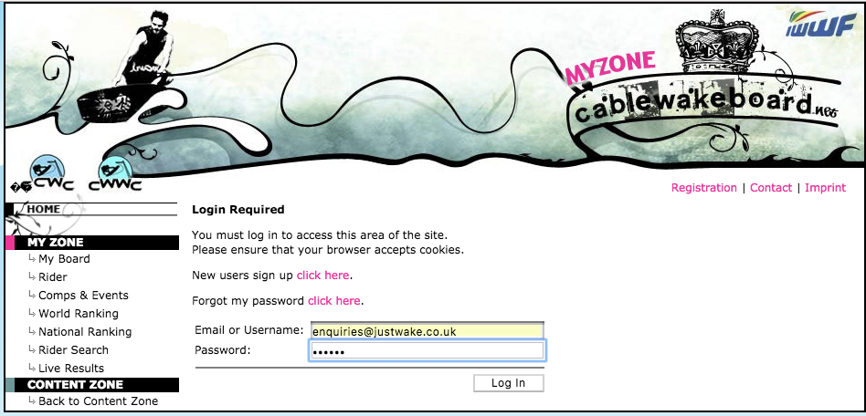

Click on the competition you are registering your riders for. Please be aware there are 2 competitions to enter. Open Championships and the Youth and Senior Category Championships. You need to approve athletes in both competitions.

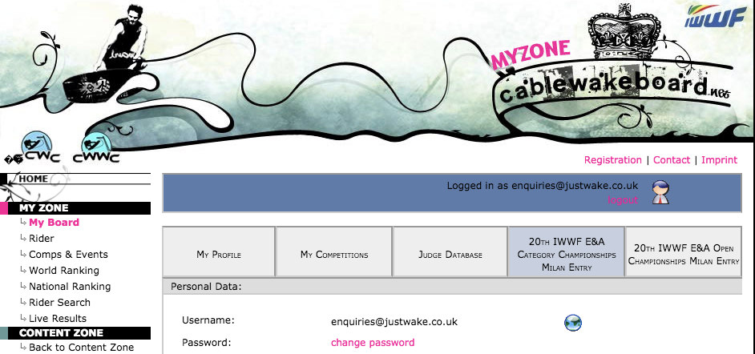
Click on the first one you want to approve riders for:

This will bring up the competition details:
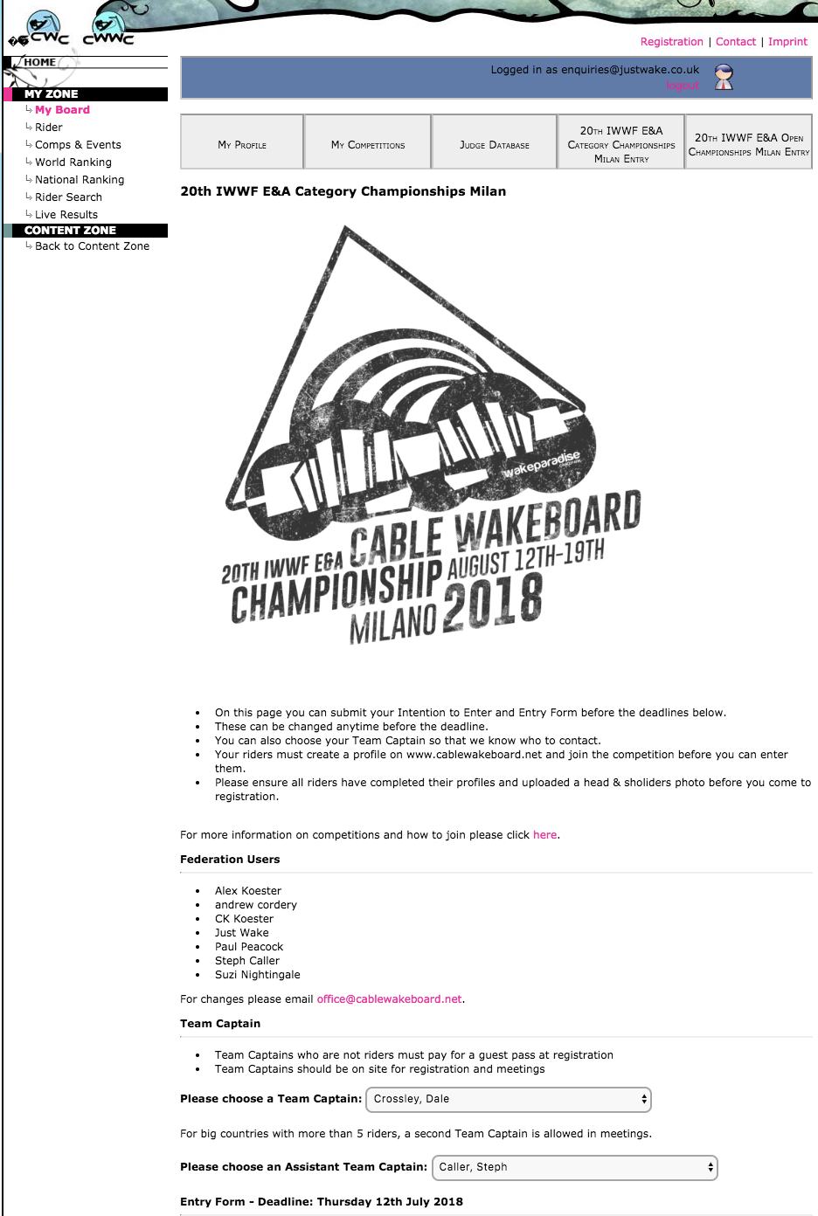

The details show you a list of approved federation users for your country. Complete the name of your Countries Team Captain, and if the team is large enough, your Asst Team Captain.

Check the Entry Deadline, this is the date you will be charged Late Entries from if not completed in time.

The system will bring up a list of all the riders that have registered to compete in the competition on Cablewakeboard.net. If any riders are missing, you will need to contact them and ask them to join the competition as per the details earlier.
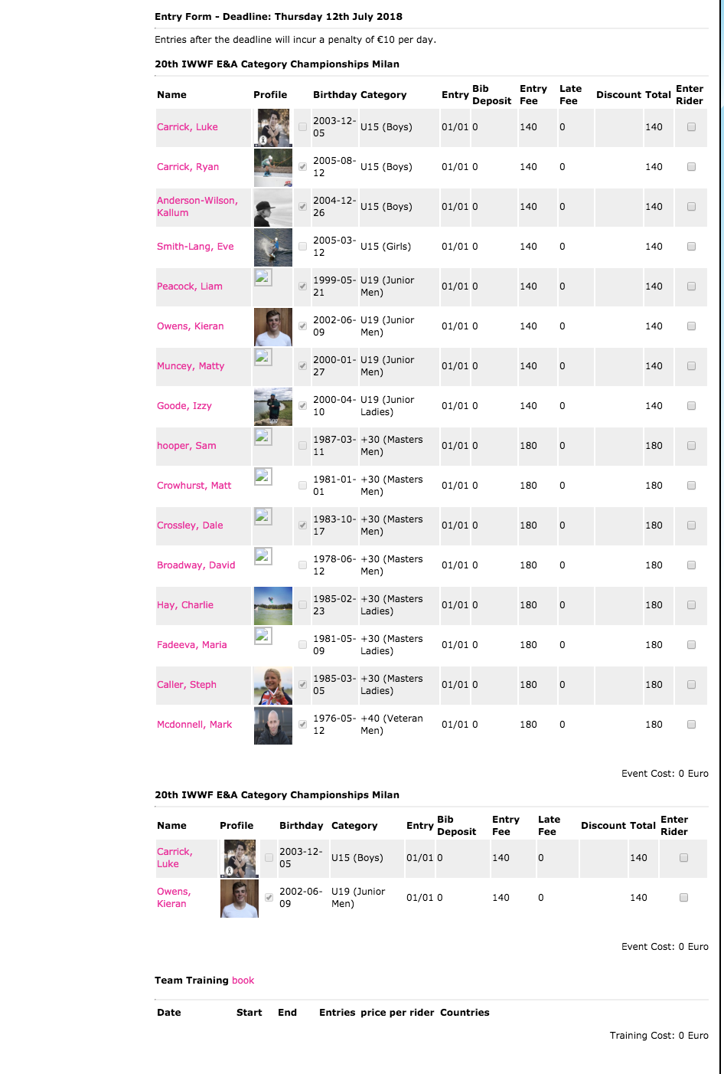
Go through the list of riders, any riders that do not have a tick box after their profile name, still have questions to complete on their Cablewakeboard profile. You will not be able to complete entry until these boxes have been completed. So ask them to complete all the questions.

For all the riders you want to enter, tick the tick box on the right hand side of the screen

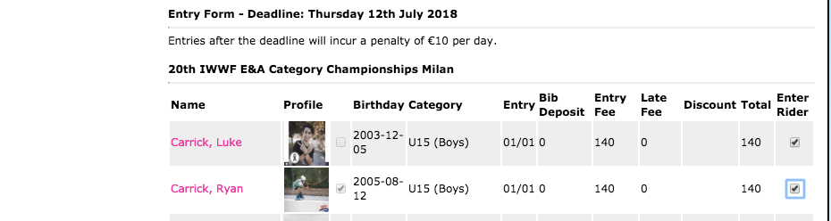

Then click the box on the bottom of the screen to update entries

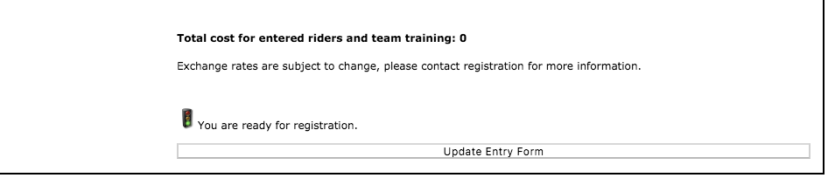

Once you have updated the Entry Form, the system will then tell you how much you have to pay for the Entry in the specific competitions:
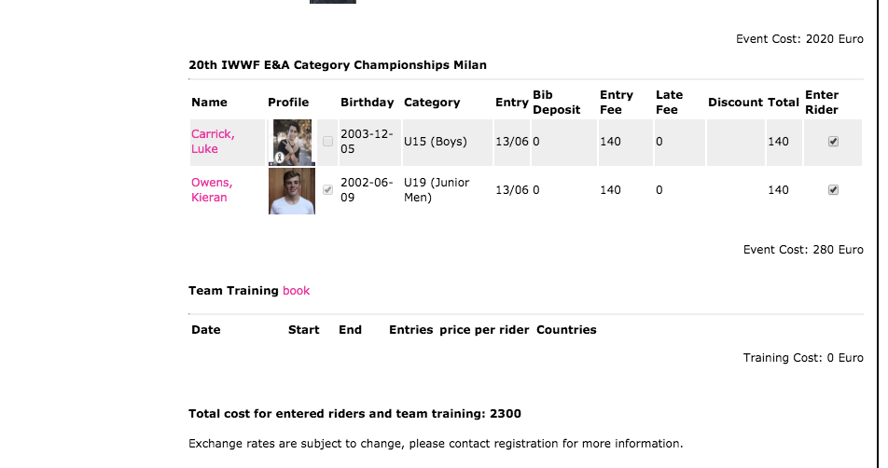
Please ensure that you enter your riders in the following:
Wakeboard Competition
Wakeskate Competition
Team Training.
You need to add all three costs together, to get the final figure required to enter your team.

Please double check the names entered, as you may get riders join the competition on cablewakeboard.net, who are not part of your squad, and you do not want to compete. DO NOT PUT A TICK BY THE SIDE OF THESE RIDERS, otherwise you will be charged for them.
If you make your bank transfer for your team athletes, please put the competition Number and your Country in the details part of the payment.

Once you have completed the YOUTH AND SENIOR Competition, please repeat for the OPEN COMPETITION
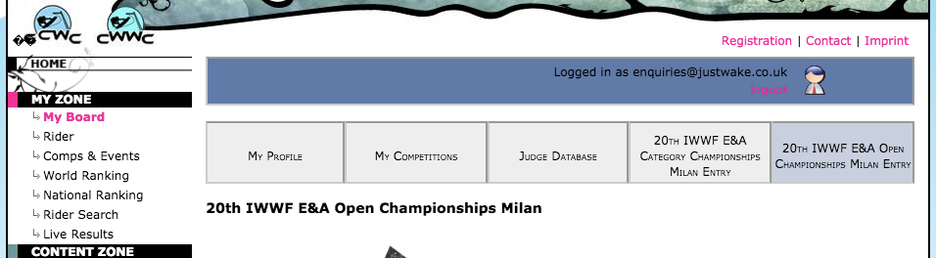

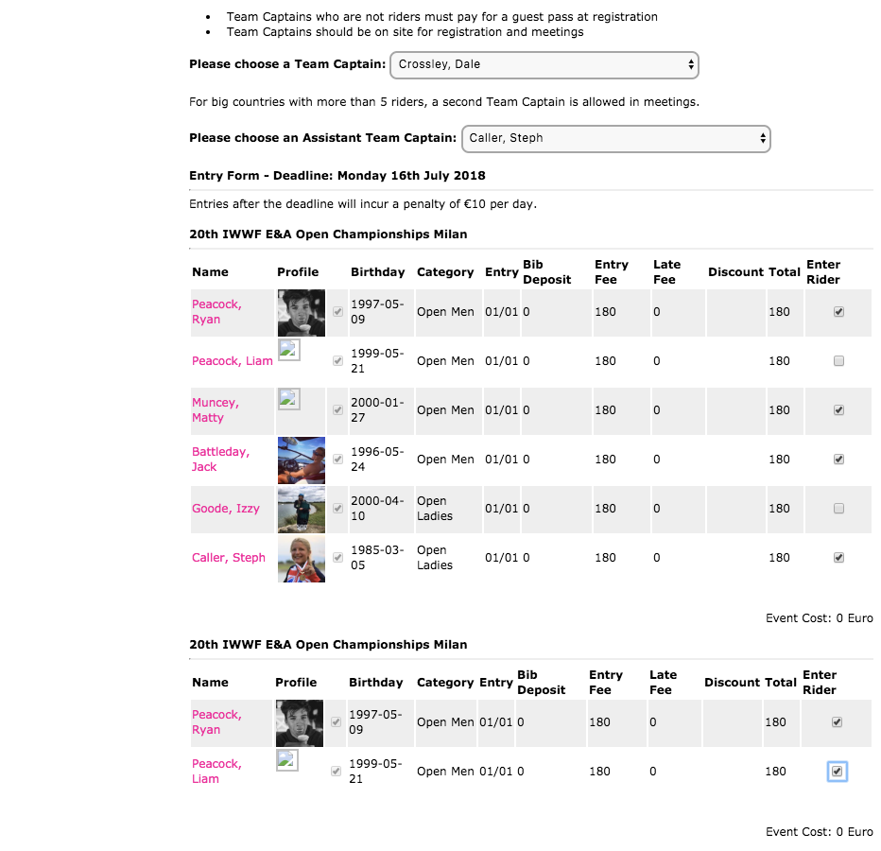
THAT’S IT – YOUR RIDERS ARE ALL REGISTERED AND APPROVED TO RIDE IN THE TITLED CHAMPIONSHIPS
APPENDICES 1
Users approved with Federation Access Rights on Cablewakeboard.net

Please check you are happy with the approved users for your federation, if changes or additions are required, please email office@cablewakeboard.net

Country name | First name | name
Argentina | Walter | Ditsch
Argentina | Rodrigo | AntĂłn
Australia | Dean | Mundy
Austria | Michael | Murg
Austria | Michael | Krikula
Belarus | Dmitry | Uzki
Belgium | Cedric | Vandermot
Brazil | Daniel | Garcia
Brazil | Vinicius | Barrado
Canada | Leslie | Sparkes
China | Chen | Li li
China | lili | chen
China | zhi na | zhu
Chinese Taipei | Annelie | Cheng
Colombia | Diego | Barragan
Colombia | Angelica | Cifuentes
Colombia | Diego | Restrepo
Croatia | Varna | Laco
Croatia | Lovro | Klepac
Croatia | Nikola | Vranesic
Croatia | Philip | Vranesic
Croatia | Marko | Gacic
Czech Republic | Rene | Krol
Czech Republic | Linda | KĂblovĂˇ
Denmark | Rasmus Mikkel | Soendergaard
Egypt | Karim | Soliman
Egypt | Ibrahim | El hady
Estonia | Ranno | Maasikmets
Finland | Juha | Halme
France | Carole | Marmonier
France | franck | chocun
Germany | Lucien | Gerkau
Germany | Aaron | Armborst
Germany | Adrian | Abeck

country_name | firstname | name
Great Britain | Steph | Caller
Great Britain | Alex | Koester
Great Britain | Suzi | Nightingale
Great Britain | Dale | Crossley
Guatemala | Katya | Castellanos
Hong Kong | Julian | SHAMDAS
Hungary | Laszlo | Papp
Ireland | Paul | Carroll
Ireland | Shane | Murphy
Israel | Omri | Bennatan
Italy | Alberto | Della Beffa
Italy | Manuel | Orlando
Italy | marco | pancaldi
Japan | Kazuyuki | Tsujimoto
Lithuania | Mantas | Zemgulis
Luxembourg | Patrick | Besch
Mexico | Jeronimo | Perez Priego Garza
Netherlands | Ferdie | Jansen
Netherlands | Sebastiaan | Huizinga
New Zealand | David | Kay
New Zealand | Kerry | Martin
Norway | Trudi | Andersen
Peru | Nicolas | Rebaza
Peru | Felix | Loreto
Philippines | Susan | Larsson
Poland | Marta | Wolska
Poland | Aleksandra | Laga
Republic of Korea | Taegon | Kim
Republic of Korea | San | Im
Russia | Alan | Sanakoev
Slovak Republic | Zuzana | Vrablova
Slovak Republic | Veronika | Pfundtnerova
Slovak Republic | Denisa | Oravcova
Slovenia | Robert | Pokovec
South Africa | Jeanu | Du Plooy
South Africa | Sean | Bacon

country_name | firstname | name
Spain | Simone | Sivieri
Spain | Lechevallier | Anthony
Sweden | Nicolai | Perdrup
Switzerland | Peter | Frei
Switzerland | Danilo | Gentile
Switzerland | Helik | SHRESTHA
Turkey | Baris | ozoral
Ukraine | Maria | Bulgakova
United Arab Emirates | Omeir | Saeed
USA | Denver | Jordan
USA | Kaitlyn | Adams
USA | Loren | Levine

