**IWWF Disabled & Cable Wakeboard Council**

**and Wakeboard Club Krk, Croatia**

**invite you to**

**Krk Handi Wake 2016**

**International *** Cable Wakeboard Competition**

**International *** Competition for Disabled**

**6-day Training Camp for Disabled**

**Monday, 30 May till Saturday, 4 June 2016**

|  |  |
| --- | --- |
| **Promoter:** | **International Waterski & Wakeboard Federation / Europe & Africa**  **Disabled Council**  President: Philippe Turchet  E-mail: [**philippe.turchet@wanadoo.fr**](mailto:philippe.turchet@wanadoo.fr)  Web site**:** [**www.waterskidisabled.eu**](http://www.waterskidisabled.eu) |
| **Organizer:** | **Croatian Waterski & Wakeboard Federation**  **Wakeboard Club Krk – Cable Krk**  Contact person: Lovro Klepac  Mobile: **+385 99 304 2288**  E-mail: [**wakeboardkrk@gmail.com**](mailto:wakeboardkrk@gmail.com)  Web site: [**www.wakeboarder.hr**](http://www.wakeboarder.hr) |
| **Cableway:** | 10mm cableway (5 pylon system), length 650 m |
| **Categories:** | **Wakeboard: Open Seated, Open Ladies, Open Men, Junior Ladies, Junior Men**  **Wakeskate: Open Ladies, Open Men** |
| **Competition format:** | The competition will be carried out in freeride format according to the cable wakeboard rules. Find rules and other docs at [www.cablewakeboard.net](http://www.cablewakeboard.net). |
| **Officials:** | 4 cablewakeboard judges with at least *** or **** international level  1 cablewakeboard scorer with at least *** international level |
| **Registration:** | **For competition register online at** [**www.cablewakeboard.net**](http://www.cablewakeboard.net)  Book accommodation via [**wakeboardkrk@gmail.com**](mailto:wakeboardkrk@gmail.com) |
| **Registration deadline:** | **Wednesday, 01.06.2016. until 20:00 online, Friday, 03.06. until 18:00 on site** |
| **Entry Fee:** | **40 EUR (50 EUR after online deadline). Cable use and competition entry for disabled riders are entirely free of charge. Please refer to section accommodation for booking and prepayments.**  **Entry fee for the members of Wakeboard klub Krk is 20 EUR.** |
| **Prizes:** | **Some good old cash, Cable Krk vouchers and cool presents from sponsors** |

**Schedule**

|  |  |  |
| --- | --- | --- |
| **Monday to Thursday, 30.5. – 2.6.2016.** | **Friday, 3.6.2016.** | **Saturday, 4.6.2016.** |
| Cable wakeboard camp for disabled  Every day:  09:00-10:00 training, cable is open exclusively for camp attendants  10:00-21:00 cable is open for public, camp attendants can ride throughout the day  **The entire camp is free of charge!!** | 14:00-17:00 Official training – wakeboard competitors  17:00-21:00 Wakeboard qualifications  ***Time schedule can be changed by organizers depending on weather and number of riders competing.*** | 09:00 – 13:00 – Wakeboard LCQs and Qualifications for disabled  13:00 – 16:00 – public hours  16:00 – 20:00 Finals – wakeboard and disabled  21:00 – Big afterparty at Cable Krk |

**Liability: The Organizer does not undertake any liability for damage to persons, material or property against competitors, Technical Official (TO), judges, official helpers and the other persons.**

**All competitors take part on their own risk in every respect even if they are engaged out of the competition, e.g. in any additional program. With the entry of the competition they give up any claim from cases of loss of any kind arising indirectly or directly during event. Actives ought to have effected a private accident insurance. Damage to a third party (e.g. spectators) is insured only within the limits of the organizers liability.**

**Location**

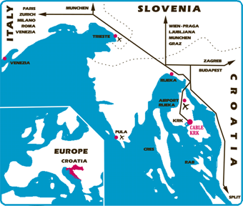

**Cable Krk**

Prvo more na Dunatu

Kornic bb

51500 Krk - Croatia

Tel: **+385 91 262 73 02**

E-mail: [**contact@wakeboarder.hr**](mailto:contact@wakeboarder.hr)

Web site: [**www.wakeboarder.hr**](http://www.wakeboarder.hr)

**GPS: 45° 2'15.0"N, 14°37' 0.0"E**

Cable Krk is located on the Northern Adriatic coast, on the island Krk, about 60 km from Croatia’s biggest port, Rijeka. The island is connected to the mainland by a bridge. Once you reached the bridge follow the main road for 28 km and there we are.

**Route planning**

If you're coming from Slovenia:

When you reach Croatia, follow the direction Zagreb-Split. It'll lead you around the city of Rijeka. Then follow the directions Crikvenica, Otok Krk.

If you're coming from Zagreb, take the exit Crikvenica, Otok Krk and follow the direction Otok Krk.

Hey, or just use the navigation :)

**Airports**

**Nearest airport**

Rijeka - located at island Krk (25 km) [www.rijeka-airport.hr](http://www.rijeka-airport.hr)

Rijeka airport offers flights from Hanover, Cologne, Stuttgart, Munich, Oslo, London and Zagreb.

|  |  |  |
| --- | --- | --- |
| **Other international airports in the area**  Zagreb (CRO) Pleso (175 km)  Ljubljana (SLO) Brnik (195 km)  Trieste (ITA) Ronchi dei Legionari (165 km) Venice (ITA) Treviso (280 km)  Venice (ITA) Marco Polo (280 km) |  | To find a flight to any of the listed airports, please surf to [www.dohop.com](http://www.dohop.com), they list all flights, including cheap carriers... |

Please inform us about your time and point of arrival one week in advance (by e-mail [contact@wakeboarder.hr](mailto:contact@wakeboarder.hr)), we can organize the shuttle from the airport for you.

**Accommodation**

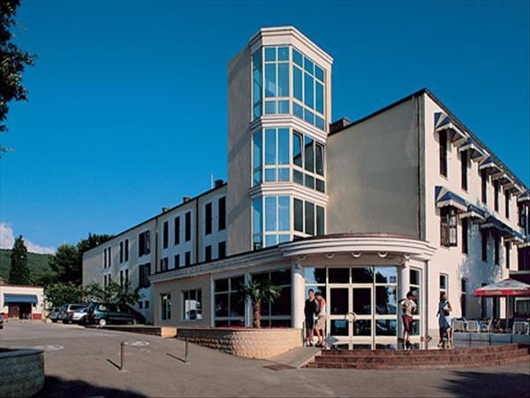

The official hotel of Krk Handi Wake 2016 is **\*\*\*** [**Hotel Park in Punat**](http://www.hoteli-punat.hr/eng/hotelpark/hotel), with the following prices for our guests:

* REGULAR PRICE: **36 €** per day / person in a double room, breakfast included.
* DISCOUNTED PRICE FOR DISABLED RIDERS: wheelchair accessible double and triple rooms **30 €** per day / person, breakfast included, **40 EUR** per day single room. To get a discounted price, please contact [wakeboardkrk@gmail.com](mailto:wakeboardkrk@gmail.com)

Hotel Park is situated at the coast in the center of town Punat, with shops, bars, restaurants, bank, tourist office, pharmacy etc. on walking distance.

Because of limited availability, we kindly ask you to **book as soon as possible**, latest **by 18 May 2016**, **prepayment of 120 € per person** is needed to confirm the booking.

Please write to [wakeboardkrk@gmail.com](mailto:wakeboardkrk@gmail.com), we'll send you a booking code and details for the prepayment.

If you don't need the wheelchair accessible accommodation...

Island Krk is entirely tourism oriented, hence a variety of hotels, apartments and camping spots in the area, as well as bars and restaurants. On the walk distance from the cable is a choice of nice apartments for reasonable price in a village Kornic. Few kilometers from the cable are towns Krk and Punat, with a number of hotels and apartments. Hotels are usually considerably more expensive than apartments.

We offer daily buffet breakfast at the cable for all guests. Daily price is 5€, one week special 30€. Buffet breakfast is open from 09-11, a coffee, juice and unlimited amount of variety of breakfast foods is available.

Dear skiers & riders,

This is the 12th time for Cable Krk to organize a camp and competition for disabled. A few seasons ago we decided to make this event bigger and organize it together with a wakeboard competition and we’re doing it again this season. Once more with this event we aim to present to Croatian public waterskiing and wakeboarding at the cable as a perfect summer recreation for disabled.

The entire facility is wheelchair accessible as also a plenty apartments and hotels in the area. If you're flying to Krk, apart from providing transportation from the airport, we'll also be at your service during the entire week for shuttles from cable to hotels and apartments.

The concept of camp is to gather both absolute beginners and advanced riders to train together one week with experienced instructors. Every evening we'll have video analysis sessions where all participants will see what they did right and wrong and how to improve. In conclusion, on Saturday everyone will have a chance to compete at Krk Handi Wake event.

So far we always had a great time. Join us and find out why!

Find out more about waterskiing and wakeboarding in Croatia and Cable Krk at [www.wakeboarder.hr](http://www.wakeboarder.hr).

For more information on waterskiing for disabled visit [www.waterskidisabled.eu](http://www.waterskidisabled.eu), the official web site of Disabled Council, or contact Mr. Philippe Turchet at [philippe.turchet@wanadoo.fr](mailto:philippe.turchet@wanadoo.fr).

Join the [Cable Krk facebook page](http://www.facebook.com/cablekrk) and stay tuned for more news!!

We hope you’ll join us soon in Krk, best regards,

|  |  |
| --- | --- |
| Marinko Zic  Wakeboard club Krk  ht1President | Philippe Turchet  E&A Disabled Council  ht2Chairman |

