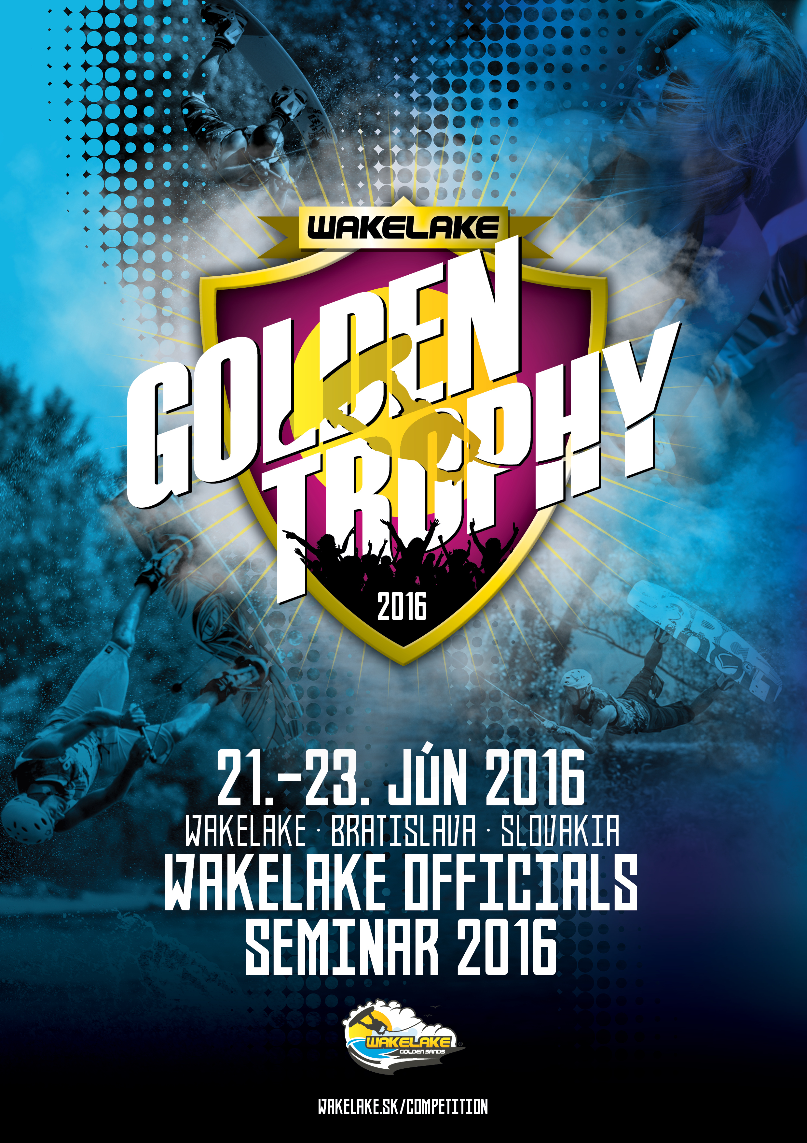

Dear Riders and Federations,
It’s a pleasure for us to invite you to the Wakelake Officials Seminar 2015, to be held on 23. - 25. June at Wakelake in Bratislava, Slovakia. This bulletin should help you to organize your trip to Slovakia and tell you more about the event. If you have any questions feel free to contact us (veron@wakelake.sk). We hope to see you at Wakelake.

General information

Organizer: IWWF and the Bratislava Wake Club (BWC)

Contact: veron@wakelake.sk

+421 918 GO WAKE (+421 918 46 9253), or
+421 904 506 040
Location: Wakelake (cable park)
Cesta na Senec 12 (Zlaté piesky)
Bratislava
Slovakia
http://wakelake.sk
https://www.facebook.com/wakelakegoldensands?ref=hl
http://instagram.com/wakelakegs

GPS: 48°11’21.36” N, 17°11’39.86” E

Seminar type: International Officials Seminar

Judges Seminar: 21. – 23. June 2016

Competition date: Wakelake Golden Trophy 2016 on 24. – 25. June 2016

Rules: The Officials seminar will be carried out according to rules of the IWWF Cable Wakeboard World Council.

You will find full copy here: http://www.cablewakeboard.net/userfiles/file/pdf/IWWF_CWWC_Rules_2015,_vMay6_non%20marked.pdf

Entry fee: 90 EUR

Registration details: Participant register through IWWF website on the seminar home page:
http://myzone.cablewakeboard.net/en/116/?sub=6&comp=1188

Participant must be registered before June 17th 2016 on:
http://www.cablewakeboard.net

If this is your first international event, first go to “registration” and create a profile. Once you have a profile, “login” and go to “My competition” where you can join the seminar.

All participants should be members of their respective country’s IWWF affiliated Federation with a Valid “Official/Competitor” wakeboard licence.

Transport options

By Plane Nearest airports:
Bratislava (BTS) – 10 minutes from the cable park. Free pick-up will be provided after previous arrangement (minimum 5 days)

Vienna (VIE) – 45 minutes from the cable park. There is bus connection to Bratislava airport. Just write me I will send you the schedule or I will help you with the transport. Bus cost cca 5 EUR. Private shuttle from 40 EUR.

Budapest (BUD) airport is 2 hours drive from the cable park.

By Train Train station Bratislava – main stations. Free pick-up possible after previous arrangement (minimum 5 days)

By Car Easily accessible on the D1 highway. Exit “Zlate Piesky”. On first traffic lights turn left, follow the street for 100 meters, make a legal U-turn
and return to to the main street in the opposite direction. In 400 meters turn right and follow the road until you reach the cable.

From Hungary and Austria – after crossing the border, continue direction Zilina. Then leave the highway on exit Zlate Piesky.

The approximate distance is: Budapest 2 hours, Gyor 1 hour, Vienna 45 minutes.

Accomodation options

Camping Camping 10 minutes walking from the cable park
http://www.intercamp.sk/en/

Caravan(trailer) Free of charge available at the cable park. To be able to park at the cable, please register your caravan one week before of your arrival at veron@wakelake.sk

Hostel (2+3 bed room) http://hotelprim.sk/en/cennik_ubytovna.html
10 EUR / day / person
5 minutes walking from the cable park

Budget hotel (2-bed room) http://www.hotelprim.sk/en/index.html
40 EUR / day / room
5 minutes walking from the cable park
Hotel (2-bed room) http://www.nh-hotels.de/hotel/nh-bratislava-gate-one
From 59 EUR/ day / room
5 minutes drive by car from cable park

Luxury hotel (2-bed room) http://www.kempinski.com/en/bratislava/hotel-river-park/overview/
120 EUR / day /room + breakfast
15 min drive by car from the cable
For booking this hotel please contact us.

Free WiFi available at all locations
For accommodation, please contact us in advance for reservation.
The capacity of offered hotels may be limited.

For any other options for accommodation contact us. (veron@wakelake.sk)

Seminar

The Seminar takes 3 days (Tuesday – Thursday). On Friday there will be 4 star international competition where you can already gain experience and help out.

Seminar contents: Introduction: Why is it important to become an Official, IWWF Structure, Officials levels

Organizing the competition: Crew for the competition

Before the competition: Chief judge duties, Safety, Timetable, Heat system

During the competition: Judging system, Trick lists, Grabs, Slider, Tricks Short cuts, Overview of the rules 2015 Changes to the rules, Protests, Video analysis

Scoring the Competition: Scoring System and Program

After the competition: Results, Paperwork

Practical exercises: Videos, Theoretical & Practical Examination, individual evaluation, announcement of results

Conditions: The seminar will be open to all registrants above 10 years who are speaking proper English. Until the Age of 16 You can only get 1STAR. To become 2 STAR you have to be over 16. 3STAR Level and higher you can get by the Age of 18 years and older.

You don't have to print the documents, printed copies will be handed to you during the program, but please study and prepare them so we can devote more time to the video sessions and practice.

 | Tuesday 21th of June 2016 |  | Time
9:00 | Welcome & Introduction |  | 15
9:15 | Why & How to become a CWWC Official
 | Officials Qualifications |  | 35
9:50 | Online registration & official website |  | 40
10:30 | Trick recognition video |  | 45
11:15 | Guidelines for judges & riders |  | 30
11:45 | IWWF structure |  | 15
12:00 | Lunch Break |  | 60
 | Participants Divided Into Two (2) Groups Based on Trick Recognition Level
 | Grassroots | Advanced
13:00 | Tricks & grabs, 2st video session | 2st video session | 35
13:35 | Rulebook | Rulebook | 35
14:10 | Running competitions, event administration | Running competitions, event administration & Title Events | 50
15:00 | 3nd video session | 3nd video session | 40
15:40 | End of Day 1
 | Wednesday 22th of June 2016
8:00 | Breakfast |  | 60
9:00 | Safety, medical crew |  | 30
9:30 | 4rd video session – two groups |  | 40
10:10 | Age categories, heat system & judging panels |  | 50
11:00 | Scoring, scoring program |  | 45
11:45 | Check the competition course and carrier System |  | 45
12:30 | Problem handling, protests |  | 35
13:05 | 5th video session – two groups |  | 60
14:05 | Problem handling, protests |  | 35
14:40 | Lunch Break |  | 60
15:40 | Question Booklet |  | 55
16:35 | Question & answer |  | 60
17:35 | End of Day 2
 | Thursday 23th of June 2016
8:00 | Breakfast |  | 60
9:00 | Practical exam – two groups |  | 60
10:00 | Theoretical Exam |  | 60
11:00 | Exam evaluation individual |  | 60
12:00 | Certificates, Feedback |  | 30
12:30 | End of seminar
Seminar schedule

Cableway information

Type: Rixen Cable, date of built: 2004
Overall length: 810 m
Carriers: 10
Pylons: 5
Height of cable: 8.4 m Length of tow rope: 19 m Obstacles: 8

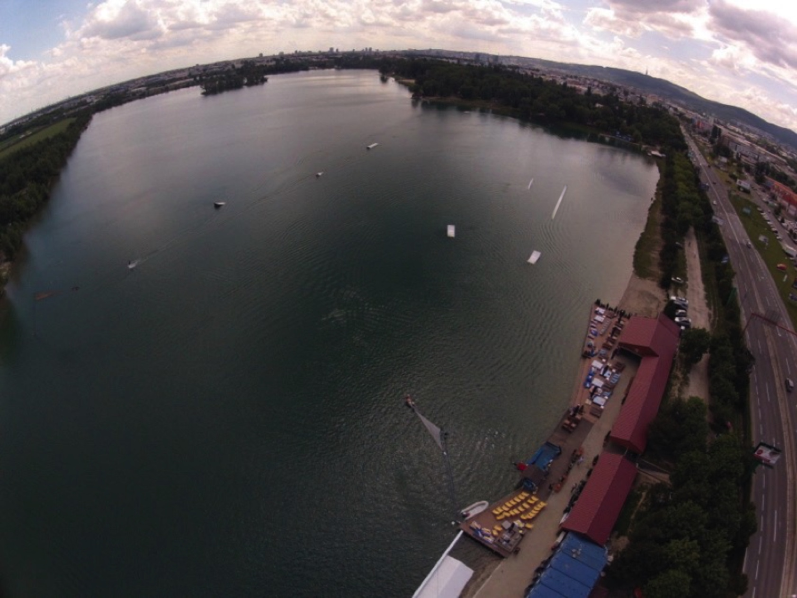

Useful information

Slovakia is a member of the European Union, Schengen agreement and Eurozone.

For other Schengen agreement member countries, the entry requires no specific permit. A valid EU personal ID or Passport are sufficient for travel to Slovakia. Some countries outside the European Union may be subject to visa requirements. For more informations please consult the information provided by Ministry of Foreign Affairs:
http://www.mzv.sk/web/en/consular_info

The currency in Slovakia is EURO.

Official language is Slovak. English is spoken quite commonly. German being the second most common.

For driving, there is zero tolerance for alcohol. Speed limits are 50 km/h in town, 90 km/h outside the town and 130 km/h on the highway. Highways require a ticket, that can be bought on all petrol stations.

Minimum drinking age is 18.
In case of emergency call 112.
Time zone in Slovakia is Central European Summer Time (CEST, GMT+2).
Mains electricity voltage is 230V. Socket is standard Euro plug.
Weather during the competition is expected to be warm and sunny with temperatures at or above 25 degrees. Water temperature is expected to be above 20 degrees.

