Dear Riders,

It’s a pleasure for us to announce another great event in Slovakia. We hope to see you again on the water at Wakelake.

In order and with permission of the Slovak Waterski Federation (SZVL) and the International Water- ski- and Wakeboard Federation (IWWF) the Bratislava Wake Club (BWC) invites you to the:

CWWC 4-Star World Tour Stop „Wakelake Golden Trophy 2016“

On June 24th – 25th, 2016 in Bratislava, Slovakia
600 World Ranking Points

Cable/Location: Wakelake Bratislava, Slovakia

Date: 24. – 25. June, 2016

The championship will be a wakeboard and wakeskate contest. You will have the chance to win prize money of total 4000 EUR:

 | Open men | Open ladies | Junior men | Junior ladies | Master men | Master ladies | Wakeskate men | Wakeskate women
1st | 800 € | 300 € | 300 € | 200 € | 0 € | 0 | 200 | 0
2nd | 500 € | 200 € | 200 € | 150 €
3rd | 400 € | 100 € | 100 € | 100 €
4th | 250 €
5th | 200 €

This first bulletin should give you an overview about the upcoming event and to help you to plan your trip to Bratislava, the capital city of Slovakia.

General information

Organizer: IWWF and the Bratislava Wake Club (BWC)

Contact: veron@wakelake.sk
+421 918 GO WAKE (+421 918 46 9253), or +421 904 506 040 www.wakelake.sk/wlgt

Cable park location: Wakelake
Cesta na Senec 12 (Zlate piesky) Bratislava
Slovakia
http://wakelake.sk
https://www.facebook.com/wakelakegoldensands?ref=hl
http://instagram.com/wakelakegs

GPS: 48°11’21.36” N, 17°11’39.86” E

Competition type: IWWF 4-stars International Competition
Part of CWWC World Ranking awarded 600 pts.

Competition date: 24. – 25. June 2016

Trainings available: 20. – 23. June 2016

Judges Seminar: 21. – 23. June 2016

Disciplines & categories: Wakeboard Men and Women: Juniors, Open, Masters
Wakeskate Men and Women: Open
Category minimum requirement is 3 riders

Rules: The competition will be carried out according to rules of the IWWF Cable Wakeboard World Council.
Please note that you have to wear a suitable helmet and vest in the wakeboard & wakeskate competition.
You will find full copy here: http://www.cablewakeboard.net/userfiles/file/pdf/IWWF_CWWC_Rules_2014,_March24.pdf

Prizes: International ranking points: 600 pts. for International Ranking
Prize money for the competition: 4000 EUR

Entry fee includes: Free riding in public hours and official trainings from June 17th 2016, 2 meals (Friday and Saturday diner), Official T-shirt, Afterparty, Free riding one week after competition.
Entry fee not includes: Official Jersey (Bib). There is 20 EUR deposit for a bib, which will be returned after competition.
For sooner or later possibilities of free riding please contact us. (veron@wakelake.sk)
Entry fee: 70 EUR per rider and category. Entry fee for second category is 50 eur.
The entry fee must be paid latest one day prior to the competition, else the participant has to pay a late fee of additional 30,00 EUR.
Riders must be registred untill Tuersday 23^{th.} June 2016 till 8 p.m.
Entry fee can be paid in two different ways:
- by wire transfer before 17th June on account:

NAME: BWC

IBAN: SK14 1100 0000 0029 2090 2858,

SWIFT/BIC: TATRSKBX
with title: EC, name of rider, nationality
Please email the copy of transefer made.
- In cash latest one day prior to the competition, else the participant has to pay a late fee of additional 30,00 EUR.

Registration details: The competition is registered as a part of CWWC World Rankings.
Riders must have IWWF license from their National federations. Riders register through IWWF website on the competition home page: http://myzone.cablewakeboard.net/en/116/?sub=6&comp=1186
Riders must be registered before June 15th 2016 on www.cablewakeboard.net

Local Registration at Wakelake starts on Thursday 23th at 10 a.m. untill 8 p.m..
For early local registration please contact us veron@wakelake.sk
Online registration will be available soon at www.wakelake.sk

Accomodation options

Camping Camping 10 minutes walking from the cable park
http://www.intercamp.sk/en/

Caravan(trailer) free of charge available at the cable park. To be able to park at the cable, please register your caravan one week before of your arrival at veron@wakelake.sk

Hostel (2+3 bed room) http://hotelprim.sk/en/cennik_ubytovna.html
10 EUR / day / person
5 minutes walking from the cable park

Budget hotel (2-bed room) http://www.hotelprim.sk/en/index.html
40 EUR / day / room
5 minutes walking from the cable park
Hotel (2-bed room) http://www.nh-hotels.de/hotel/nh-bratislava-gate-one
From 59 EUR/ day / room
5 minutes drive by car from cable park

Luxury hotel (2-bed room) http://www.kempinski.com/en/bratislava/hotel-river-park/overview/
120 EUR / day /room + breakfast
15 min drive by car from the cable
For booking this hotel please contact us.

Free WiFi available at all locations
For accommodation, please contact us in advance for reservation. The capacity of offered hotels may be limited.

For any other options for accommodation contact us. (veron@wakelake.sk)

Transport options

By Plane Nearest airports:
Bratislava (BTS) – 10 minutes from the cable park. Free pick-up will be provided after previous arrangement (minimum 5 days)

Vienna (VIE) – 45 minutes from the cable park. There is bus connection to Bratislava airport. Just write me I will send you the schedule or I will help you with the transport. Bus cost cca 5eur. Private shuttle from 40 eur.

Budapest (BUD) airport is 2 hours drive from the cable park.

By Train Train station Bratislava – main stations. Free pick-up possible after previous arrangement (minimum 5 days)

By Car Easily accessible on the D1 highway. Exit “Zlate Piesky”. On first traffic lights turn left, follow the street for 100 meters, make a legal U-turn
and return to to the main street in the opposite direction. In 400 meters turn right and follow the road until you reach the cable.

From Hungary and Austria – after crossing the border, continue direction Zilina. Then leave the highway on exit Zlate Piesky.

The approximate distance is: Budapest 2 hours, Gyor 1 hour, Vienna 45 minutes.

Schedule

Monday 08:00 – 10:00 Riders training
20.6. 12:00 – 14:00 Riders training

Tuesday 08:00 – 10:00 Riders training
21.6. 12:00 – 14:00 Riders training
21:00 Movie night

Wednesday 08:00 – 10:00 Riders training
22.6. 12:00 – 14:00 Riders training
21:00 – 23:00 Night riding photoshooting

Thursday 08:00 – 10:00 Riders training
23.6. 10:00 – 18:00 Registrations
12:00 – 14:00 Riders training
17:00 – 21:00 Official training
21:00 Poker night

Friday 08:00 – 08:30 Riders meeting
24.6. 08:30 – 18:00 Qualifications I
19:00 – 21:00 Official welcome dinner
21:00 WLGT 2015 Movie

Saturday 08:00 – 08:30 Riders meeting
25.6. 08:30 – 12:00 LCQ
13:00 – 19:00 Finals
19:00 Medals awarding ceremony
21:00 Farewell dinner
22:00 Goodbye party with DJs from Hed Kandi

Riders training times may be adjusted based on the number of present riders.
Riders trainings are reserved for registered riders only and are provided free of charge. Final schedule will be provided one week before the competition.

Opening party will be the unofficial start of the event.

The official Welcome dinner will be held on the end of the first competition day.
The afterparty with DJs from HED KANDI starts after medals awarding ceremony. All riders are welcome.

International Judges Seminar will be held at Wakelake from Tuesday to Thursday. Aspiring judges are welcome to join. Due to capacity limitations, please inform us in advance if you are planning to attend.

Cableway information

Type: Rixen Cable, date of built: 2004
Overall length: 810 m
Carriers: 10
Pylons: 5
Height of cable: 8.4 m Length of tow rope: 19 m Obstacles: 8

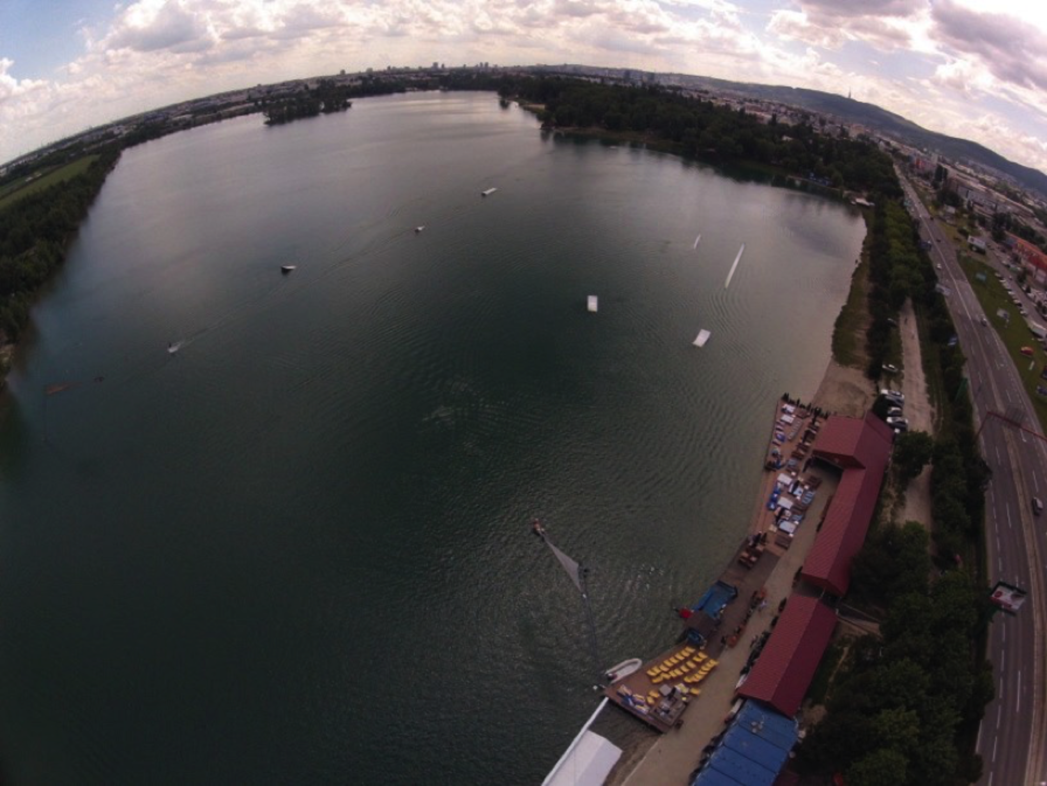

Obstacle park

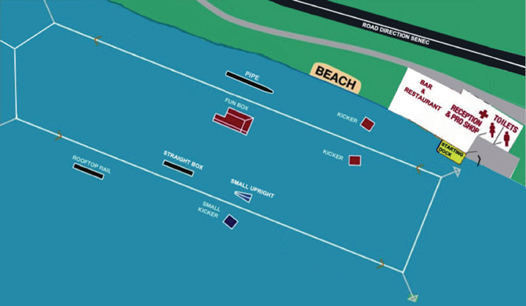

Kicker Height: 1.2 m
(inside and outside) Length: 5.5m
Width: 2m

Rooftop Height: 1.3m (outside) Length: 16m Width: 0.3m

Funbox Height: 1.6m (inside) Length: 15m Width: 2.3m

Pipe Length: 19m
(outside) Width: 0.9m

Grind box Height: 0.8m
(inside) Length: 12m
Width: 1m

Uprail Height: 1m
(inside) Length: 5.5m
Width: 0.3

Small Kicker Height: 1m
(outside) Length: 3.8m
Width: 2.3

Equipment storage: There will be a locked container at Wakelake area, where you can store your board and equipment overnight. No liability will be accepted by the event organisers for any damage or loss of property.

Free WiFi available on Wakelake.

Useful information

Slovakia is a member of the European Union, Schengen agreement and Eurozone.

For other Schengen agreement member countries, the entry requires no specific permit. A valid EU personal ID or Passport are sufficient for travel to Slovakia. Some countries outside the European Union may be subject to visa requirements. For more informations please consult the information pro- vided by Ministry of Foreign Affairs:
http://www.mzv.sk/web/en/consular_info

The currency in Slovakia is EURO.

Official language is Slovak, English is spoken quite commonly, German being the second most com- mon.

For driving, there is zero tolerance for alcohol. Speed limits are 50 km/h in town, 90 km/h outside the town and 130 km/h on the highway. Highways require a ticket, that can be bought on all petrol stations.

Minimum drinking age is 18. In case of emergency call 112.
Time zone in Slovakia is Central European Summer Time (CEST, GMT+2). Mains electricity voltage is 230V. Socket is standard Euro plug.
Weather during the competition is expected to be warm and sunny with temperatures at or above 25 degrees. Water temperature is expected to be above 20 degrees.

Safety

All riders must wear an approved life vest and a helmet in the course at all times. All participants ride at their own risk.
Following is the Declaration, Waiver and Release form that is required for each rider. Riders younger than 18 years are required to provide the Declaration of Parent / Guardian

:

Declaration, Waiver and Release Form

For, and in consideration of, the International Waterski & Wakeboard Federation (the IWWF) accepting my application, and permitting me, to participate and compete in the International registered cable wakeboard event (the International event), I, the undersigned, for and on behalf of myself, my heirs, executors and administrators, do hereby irrevocably and unconditionally warrant, represent and undertake to the IWWF as follows

Any and all information provided and/or disclosed by, or on behalf of, myself to the IWWF (including any officers, employees and represen- tatives thereof) for the purpose of considering and evaluating my application for participation and competition in the International event is true, correct and accurate;

I have fully read and understood the rules and regulations of participation and competition in the International event (a copy of which has been made available to me) and I do hereby covenant with, and undertake to, the IWWF to at all times fully comply with, and abide by, the same;

I am in good physical and mental health and I am physically capable of competing and participating, and fully competent to participate and compete, as a competitor in the International event and that I have not been certified and/or advised otherwise by any qualified medical practitioner;

I do hereby authorise any and all physicians, paramedics and other medical personnel and practitioners procured by, or on behalf of, the IWWF to administer first aid treatment or any medical treatment, surgery or transportation in the event of any illness, accident or injury suffered and/or sustained by me at any time during my participation and competition in the International event (or any part thereof) and hereby indem- nify, and shall keep fully and effectively indemnified, the IWWF (including all officers, employees and representatives thereof) upon demand from and against any and all claims, liabilities, demands, costs and expenses of whatsoever nature incurred and/or suffered by the same (or any of them) and arising from, and/or in connection with, the procurement and administration of such medical treatment and transportation in relation to any such illness accident or injury suffered and/or sustained by me;
I acknowledge, agree and confirm that participating and/or competing as a competitor in the International event (or any part thereof) involves inherent risks and dangers of accidents, personal and bodily injury and property loss or damage and that by signing and completing this Dec- laration, Waiver and Release Form, I fully understand and have considered and evaluated the nature, scope and extent of the risks involved, and voluntarily and freely choose to assume these risks;

I hereby grant to the IWWF (including its lawful successors and assigns) the sole and exclusive right and licence, in perpetuity and throughout the world and without any compensation whatsoever to me, to use, reproduce, publish and/or exploit, my name, nickname, likeness, image, logos, get-ups, initials, voice, slogan and signatures developed from time to time, reputation, graphical representation, electronic, animated or computer generated representation and any other representation (in any medium whatsoever), right of association, biographical information and other indicia, and any other right or property in my performances, in any media whatsoever, for any purposes whatsoever relating to, and/or in connection with, the IWWF and/or the International event (or any part thereof) and I shall do all such things (including, without limitation, the execution of appropriate legal documentation) as the IWWF may, from time to time, require to give legal and binding effect to the aforementioned grant of rights;

I irrevocably acknowledge, agree and confirm that the IWWF reserves the right, at its sole and absolute discretion, to disqualify me from par- ticipation and/or competition in the International event (or any part thereof) if I am in breach of any of the warranties, representations and/or undertakings set out in this Declaration, Waiver and Release Form and/or for any reason whatsoever the IWWF considers just and proper, and in the event of any such disqualification, I shall not be entitled to any compensation of any nature whatsoever from the IWWF.

I hereby release, hold harmless, protect, indemnify and forever discharge the IWWF (including its officers, employees and representatives), the International event and all commercial partners thereof, from and against any and all claims, demands, liabilities, costs and expenses of any nature whatsoever, whether direct or consequential, suffered and/or incurred by the IWWF (including its officers, employees and representa- tives), the International event and/or all commercial partners thereof and arising from, and/or in connection with:

Any breach of any of the warranties, representations and/or undertakings given by me as set out hereunder; and/or my participation and/or competition in the International event (or any part thereof).
Declaration

I, (the Competitor), do hereby declare that I have read and fully understood the terms and conditions of this Declaration, Waiver and Release Form and that I have had the opportunity to discuss the same with my parent / guardian and that I agree to be bound by the said terms and conditions of the above agreement with the IWWF.

Cable Wakeboard International Event

Declaration of Parent / Guardian
(Applicable only if the Competitor is, on the date of signing the Declaration, Waiver and Release Form, under the age of 18 years)

I, the undersigned, am the parent / guardian* of (the Competitor) and I do hereby irrevocably and unconditionally:

1 warrant, represent and undertake to the IWWF that I have read and fully understood the terms and conditions of the Declaration, Waiver and Release Form and have discussed with, and explained such terms and conditions to, the Competitor and I agree to, and will cause the Competitor to fully abide by, and comply with, all of the terms and conditions of the Declaration, Waiver and Release Form; and

2 covenant with, and undertake to, the IWWF not to take, nor permit to be taken, any action(s) nor omit to do anything that would assist or cause the Competitor to invalidate, renounce, negate, revoke or disclaim any part of the Declaration, Waiver and Release Form, and

3 warrant, represent and undertake to the IWWF that by signing the Declaration, Waiver and Release Form, neither the Competitor and/or myself is/are in breach of any other arrangement(s) (whether contractual or otherwise) with any third party, and

4 agree to be liable for, and will indemnify the IWWF (including its officers, employees and representatives), the International event and all commercial partners thereof from and against, any and all claims, demands, liability, loss, damages, costs, and expenses of any nature whatsoever, whether direct or consequential, suffered and/or incurred by the IWWF, the International event and all commercial partners thereof, whether direct or consequential, any arising from, and/or in connection with:

(a) any breach of any of the warranties, representations and/or undertakings given by the Competitor in the Declaration, Waiver and
Release Form; and/or
(b) the Competitor’s participation and/or competition in the International event (or any part thereof).

Signature

Name of Parent / Guardian*: Date:

Signed in the presence of: Witness:
Name: Address: Occupation:

* Delete as appropriate

