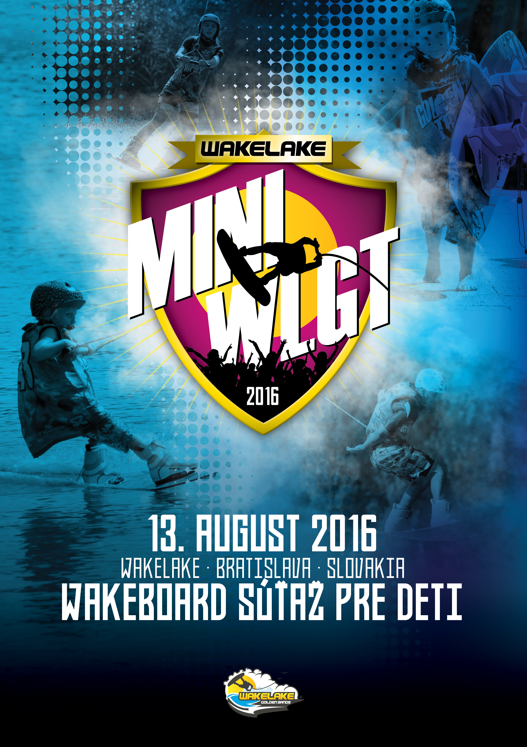

Dear Riders,

It’s a pleasure for us to announce another great event in Slovakia. We hope to see you on the water at Wakelake in Bratislava.

In order and with permission of the Slovak Waterski Federation (SZVL) and the International Water- ski- and Wakeboard Federation (IWWF) the Bratislava Wake Club (BWC) invites you to the:

1 Star Mini Wakelake Golden Trophy 2016
On 13th of August, 2016 in , Slovakia
100 International Ranking Points

Cable/Location: Wakelake
Bratislava, Slovakia

Date: 13. August 2015

The competition will be a wakeboard contest. You will have the chance to win 100 points into international ranking.

This first bulletin should give you an overview about the upcoming event and to help you to plan your trip to Bratislava to Mini Golden Trophy 2016.

General information

Organizer: IWWF and the Bratislava Wake Club (BWC)

Contact: veron@wakelake.sk
+421 918 GO WAKE (+421 918 46 9253), or +421 904 506 040 www.wakelake.sk/wlgt

Cable park location: Wakelake
Cesta na Senec 12 (Zlate piesky) Bratislava
Slovakia
http://wakelake.sk
https://www.facebook.com/wakelakegoldensands?ref=hl
http://instagram.com/wakelakegs

GPS: 48°11’21.36” N, 17°11’39.86” E

Competition type: IWWF 1-stars International Competition
Part of CWWC World Ranking awarded 100 pts.

Competition date: 13. August 2016

Trainings available: 13. August 2016

Disciplines & categories: Wakeboard girls and boys: U15 Girls/boys
minimum age is 2005 or earlier
Category minimum requirement is 3 riders

Rules: The competition will be carried out according to rules of the IWWF Cable Wakeboard World Council.
Please note that you have to wear a suitable helmet and vest in the wakeboard & wakeskate competition.
You will find full copy here: http://www.cablewakeboard.net/userfiles/file/pdf/IWWF_CWWC_Rules_2014,_March24.pdf

Prizes: International ranking points: 100 pts. for International Ranking

Entry fee: 10 EUR per rider and category.
Registration details: The competition is registered as a part of CWWC World Rankings.
Riders must have IWWF license from their National federations. Riders register through IWWF website on the competition home page: http://myzone.cablewakeboard.net/en/116/?sub=6&comp=1180

Riders must be registered latest one week prior to the competition on www.cablewakeboard.net

Local Registration at Wakepark - Wakelake starts on Saturday 13th from 8 a.m. until 9 a.m.

Schedule

Saturday 08:00 – 09:00 Warm-up
13.8. 09:00 – 12:00 Contest
13:00 Medals awarding ceremony

Accomodation options

Camping Camping 10 minutes walking from the cable park
http://www.intercamp.sk/en/

Caravan(trailer) free of charge available at the cable park. To be able to park at the cable, please register your caravan one week before of your arrival at veron@wakelake.sk

Hostel (2+3 bed room) http://hotelprim.sk/en/cennik_ubytovna.html
10 EUR / day / person
5 minutes walking from the cable park

Budget hotel (2-bed room) http://www.hotelprim.sk/en/index.html
40 EUR / day / room
5 minutes walking from the cable park
Hotel (2-bed room) http://www.nh-hotels.de/hotel/nh-bratislava-gate-one
From 59 EUR/ day / room
5 minutes drive by car from cable park

Luxury hotel (2-bed room) http://www.kempinski.com/en/bratislava/hotel-river-park/overview/
120 EUR / day /room + breakfast
15 min drive by car from the cable
For booking this hotel please contact us.

Free WiFi available at all locations
For accommodation, please contact us in advance for reservation. The capacity of offered hotels may be limited.

For any other options for accommodation contact us. (veron@wakelake.sk)

Transport options

By Plane Nearest airports:
Bratislava (BTS) – 10 minutes from the cable park. Free pick-up will be provided after previous arrangement (minimum 5 days)

Vienna (VIE) – 45 minutes from the cable park. There is bus connection to Bratislava airport. Just write me I will send you the schedule or I will help you with the transport. Bus cost cca 5eur. Private shuttle from 40 eur.

Budapest (BUD) airport is 2 hours drive from the cable park.

By Train Train station Bratislava – main stations. Free pick-up possible after previous arrangement (minimum 5 days)

By Car Easily accessible on the D1 highway. Exit “Zlate Piesky”. On first traffic lights turn left, follow the street for 100 meters, make a legal U-turn
and return to to the main street in the opposite direction. In 400 meters turn right and follow the road until you reach the cable.

From Hungary and Austria – after crossing the border, continue direction Zilina. Then leave the highway on exit Zlate Piesky.

The approximate distance is: Budapest 2 hours, Gyor 1 hour, Vienna 45 minutes.

Cableway information

Type: Rixen Cable, date of built: 2004
Overall length: 810 m
Carriers: 10
Pylons: 5
Height of cable: 8.4 m Length of tow rope: 19 m Obstacles: 8

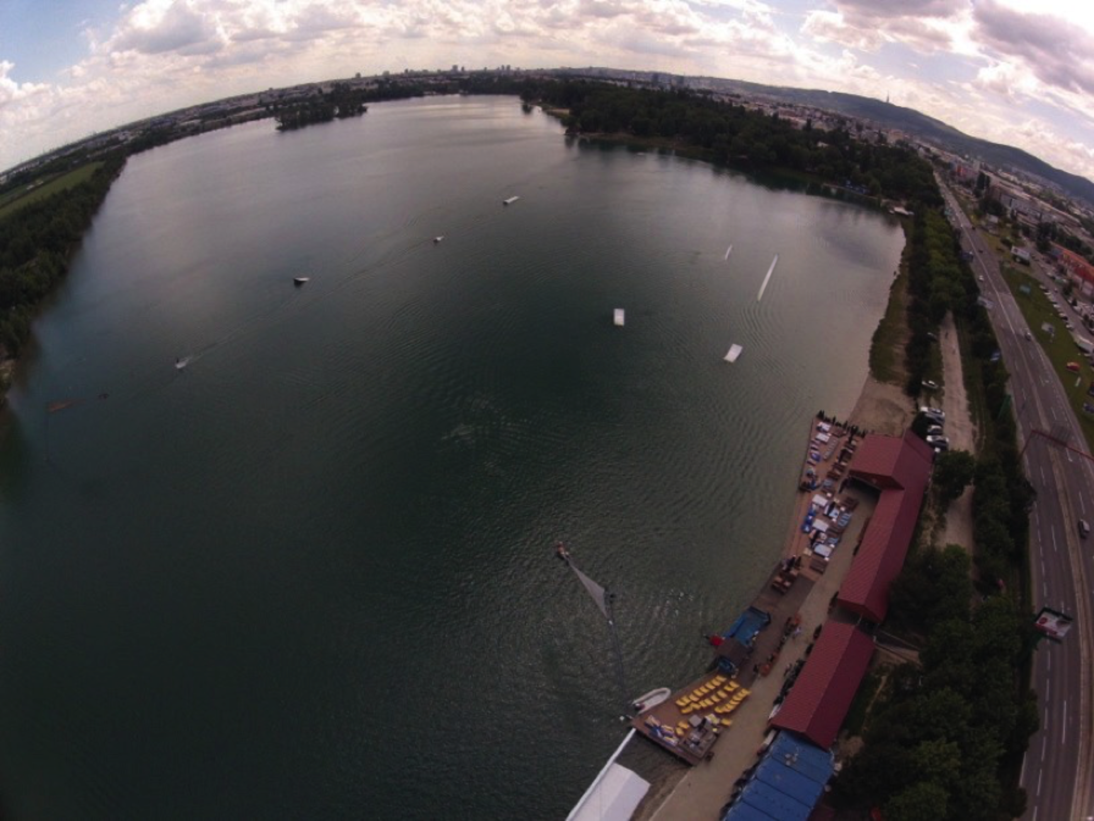

Obstacle park

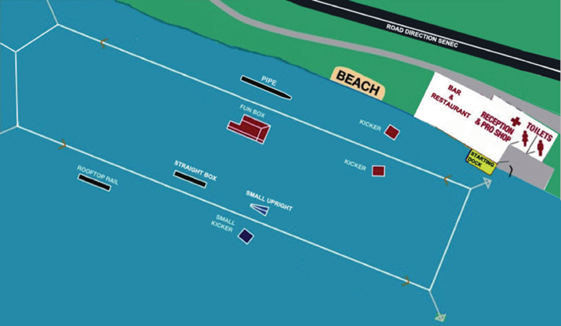

Kicker Height: 1.2 m
(inside and outside) Length: 5.5m
Width: 2m

Rooftop Height: 1.3m (outside) Length: 16m Width: 0.3m

Funbox Height: 1.6m (inside) Length: 15m Width: 2.3m

Pipe Length: 19m
(outside) Width: 0.9m

Grind box Height: 0.8m
(inside) Length: 12m
Width: 1m

Uprail Height: 1m
(inside) Length: 5.5m
Width: 0.3

Small Kicker Height: 1m
(outside) Length: 3.8m
Width: 2.3

Equipment storage: There will be a locked container at Wakelake area, where you can store your board and equipment overnight. No liability will be accepted by the event organisers for any damage or loss of property.

Free WiFi available on Wakelake.

Useful information

Slovakia is a member of the European Union, Schengen agreement and Eurozone.

For other Schengen agreement member countries, the entry requires no specific permit. A valid EU personal ID or Passport are sufficient for travel to Slovakia. Some countries outside the European Union may be subject to visa requirements. For more informations please consult the information pro- vided by Ministry of Foreign Affairs:
http://www.mzv.sk/web/en/consular_info

The currency in Slovakia is EURO.

Official language is Slovak, English is spoken quite commonly, German being the second most com- mon.

For driving, there is zero tolerance for alcohol. Speed limits are 50 km/h in town, 90 km/h outside the town and 130 km/h on the highway. Highways require a ticket, that can be bought on all petrol stations.

Minimum drinking age is 18. In case of emergency call 112.
Time zone in Slovakia is Central European Summer Time (CEST, GMT+2). Mains electricity voltage is 230V. Socket is standard Euro plug.
Weather during the competition is expected to be warm and sunny with temperatures at or above 25 degrees. Water temperature is expected to be above 20 degrees.

Safety

All riders must wear an approved life vest and a helmet in the course at all times. All participants ride at their own risk.
Following is the Declaration, Waiver and Release form that is required for each rider. Riders younger than 18 years are required to provide the Declaration of Parent / Guardian

:

Declaration, Waiver and Release Form

For, and in consideration of, the International Waterski & Wakeboard Federation (the IWWF) accepting my application, and permitting me, to participate and compete in the International registered cable wakeboard event (the International event), I, the undersigned, for and on behalf of myself, my heirs, executors and administrators, do hereby irrevocably and unconditionally warrant, represent and undertake to the IWWF as follows

Any and all information provided and/or disclosed by, or on behalf of, myself to the IWWF (including any officers, employees and represen- tatives thereof) for the purpose of considering and evaluating my application for participation and competition in the International event is true, correct and accurate;

I have fully read and understood the rules and regulations of participation and competition in the International event (a copy of which has been made available to me) and I do hereby covenant with, and undertake to, the IWWF to at all times fully comply with, and abide by, the same;

I am in good physical and mental health and I am physically capable of competing and participating, and fully competent to participate and compete, as a competitor in the International event and that I have not been certified and/or advised otherwise by any qualified medical practitioner;

I do hereby authorise any and all physicians, paramedics and other medical personnel and practitioners procured by, or on behalf of, the IWWF to administer first aid treatment or any medical treatment, surgery or transportation in the event of any illness, accident or injury suffered and/or sustained by me at any time during my participation and competition in the International event (or any part thereof) and hereby indem- nify, and shall keep fully and effectively indemnified, the IWWF (including all officers, employees and representatives thereof) upon demand from and against any and all claims, liabilities, demands, costs and expenses of whatsoever nature incurred and/or suffered by the same (or any of them) and arising from, and/or in connection with, the procurement and administration of such medical treatment and transportation in relation to any such illness accident or injury suffered and/or sustained by me;
I acknowledge, agree and confirm that participating and/or competing as a competitor in the International event (or any part thereof) involves inherent risks and dangers of accidents, personal and bodily injury and property loss or damage and that by signing and completing this Dec- laration, Waiver and Release Form, I fully understand and have considered and evaluated the nature, scope and extent of the risks involved, and voluntarily and freely choose to assume these risks;

I hereby grant to the IWWF (including its lawful successors and assigns) the sole and exclusive right and licence, in perpetuity and throughout the world and without any compensation whatsoever to me, to use, reproduce, publish and/or exploit, my name, nickname, likeness, image, logos, get-ups, initials, voice, slogan and signatures developed from time to time, reputation, graphical representation, electronic, animated or computer generated representation and any other representation (in any medium whatsoever), right of association, biographical information and other indicia, and any other right or property in my performances, in any media whatsoever, for any purposes whatsoever relating to, and/or in connection with, the IWWF and/or the International event (or any part thereof) and I shall do all such things (including, without limitation, the execution of appropriate legal documentation) as the IWWF may, from time to time, require to give legal and binding effect to the aforementioned grant of rights;

I irrevocably acknowledge, agree and confirm that the IWWF reserves the right, at its sole and absolute discretion, to disqualify me from par- ticipation and/or competition in the International event (or any part thereof) if I am in breach of any of the warranties, representations and/or undertakings set out in this Declaration, Waiver and Release Form and/or for any reason whatsoever the IWWF considers just and proper, and in the event of any such disqualification, I shall not be entitled to any compensation of any nature whatsoever from the IWWF.

I hereby release, hold harmless, protect, indemnify and forever discharge the IWWF (including its officers, employees and representatives), the International event and all commercial partners thereof, from and against any and all claims, demands, liabilities, costs and expenses of any nature whatsoever, whether direct or consequential, suffered and/or incurred by the IWWF (including its officers, employees and representa- tives), the International event and/or all commercial partners thereof and arising from, and/or in connection with:

Any breach of any of the warranties, representations and/or undertakings given by me as set out hereunder; and/or my participation and/or competition in the International event (or any part thereof).
Declaration

I, (the Competitor), do hereby declare that I have read and fully understood the terms and conditions of this Declaration, Waiver and Release Form and that I have had the opportunity to discuss the same with my parent / guardian and that I agree to be bound by the said terms and conditions of the above agreement with the IWWF.

Cable Wakeboard International Event

Declaration of Parent / Guardian
(Applicable only if the Competitor is, on the date of signing the Declaration, Waiver and Release Form, under the age of 18 years)

I, the undersigned, am the parent / guardian* of (the Competitor) and I do hereby irrevocably and unconditionally:

1 warrant, represent and undertake to the IWWF that I have read and fully understood the terms and conditions of the Declaration, Waiver and Release Form and have discussed with, and explained such terms and conditions to, the Competitor and I agree to, and will cause the Competitor to fully abide by, and comply with, all of the terms and conditions of the Declaration, Waiver and Release Form; and

2 covenant with, and undertake to, the IWWF not to take, nor permit to be taken, any action(s) nor omit to do anything that would assist or cause the Competitor to invalidate, renounce, negate, revoke or disclaim any part of the Declaration, Waiver and Release Form, and

3 warrant, represent and undertake to the IWWF that by signing the Declaration, Waiver and Release Form, neither the Competitor and/or myself is/are in breach of any other arrangement(s) (whether contractual or otherwise) with any third party, and

4 agree to be liable for, and will indemnify the IWWF (including its officers, employees and representatives), the International event and all commercial partners thereof from and against, any and all claims, demands, liability, loss, damages, costs, and expenses of any nature whatsoever, whether direct or consequential, suffered and/or incurred by the IWWF, the International event and all commercial partners thereof, whether direct or consequential, any arising from, and/or in connection with:

(a) any breach of any of the warranties, representations and/or undertakings given by the Competitor in the Declaration, Waiver and
Release Form; and/or
(b) the Competitor’s participation and/or competition in the International event (or any part thereof).

Signature

Name of Parent / Guardian*: Date:

Signed in the presence of: Witness:
Name: Address: Occupation:

* Delete as appropriate

